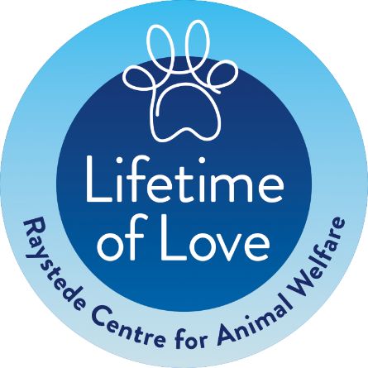

Lifetime of Love FAQs
If you are thinking about putting a plan in place and asking us to take care of your pet when you pass away, we understand that you’re likely to have a few questions about the Lifetime of Love scheme.
Here are the answers to some of the most common questions we get asked:
What pets qualify for the scheme?
The scheme is generally for pets that Raystede rehomes frequently, so cats and dogs and small pets.
Currently we accept Cats, Dogs, Rabbits, Guinea Pigs, Hamsters, Gerbils, Degus, Rats, Chinchillas, Mice and Hens (not cockerels)
Applications to the scheme are considered on a case by case basis.

Can you take all breeds of dogs?
Unfortunately Section 1 of the Dangerous Dogs Act 1991 means that we cannot rehome any of the four banned breeds – Pit Bull Terrier, Japanese Tosa, Dogo Argentino, or Fila Braziliero. So dogs cannot be included in the scheme if listed under the DDA as dangerous or a banned breed.

What if I have more than one pet?
We can usually take up to four (4) pets from one home. There may be difficulties in finding space at short notice for a large number of pets so if you do have a larger number of pets that you’d like to register, please contact us to discuss if / how we can help.
How will you know that my pet needs to come to Raystede?
In the event of your death, the Executor of your Will or family member or friend, will need to contact Raystede to let us know that your pet needs to be rehomed.
To ensure this happens we strongly advise that, as well as including instructions in your Will (suggested wording below), you tell the relevant people of your wish for your pets to be taken to Raystede. Please also make sure that your Will and any other relevant paperwork is up to date and easy to access.
If you are able to appoint a temporary guardian for your pet who knows your wishes and would be happy to care for your pet whilst arrangements are made, this will ensure a smooth transition for your pet to Raystede.

What wording do you recommend for my Will?
If you would like to include your pet(s) in the Lifetime of Love Scheme we suggest that you ask your solicitor to use the following wording:
“In the event that any pet animal of mine survives me and I have made no other provisions for its care, I direct my Executors to notify Raystede Centre for Animal Welfare of The Broyle, Ringmer, East Sussex, BN8 5AJ (registered charity number 237696) as soon as practicable after my death and to request Raystede Centre for Animal Welfare both relieve them of responsibility for the animal and to endeavour to place it in a suitable home as soon as practicable; Raystede Centre for Animal Welfare having absolute discretion to deal with the welfare of the animal as it considers fit and I direct also that (Raystede Centre for Animal Welfare having accepted such a request) the animal shall not form part of my residuary estate.”

Why doesn’t the scheme include other animals or birds that live onsite at Raystede?
Lifetime of Love is essentially a way to ensure your pet is rehomed in a loving environment after your death. Unfortunately we cannot make an open-ended, long-term promise to take in aviary birds, tortoises, horses etc to be cared for by Raystede for the rest of their lives. We would do our best to signpost you to other organisations that might be able to help if your pet is not one that normally qualifies for our scheme.

Does my pet need to be microchipped?
As well as being a legal requirement for all dogs in England, a microchip will help identify your dog or cat should they need to come to Raystede but it is not a requirement of our scheme.

What if my pet has a medical condition, behavioural problems or is simply elderly?
Every pet that comes to Raystede is treated with compassion and dignity and is assessed by our veterinary team and behavioural assessors. If your pet has a medical condition that can be managed and our veterinary team are happy that they still have a good quality of life, then they can be rehomed.
Very rarely, our veterinary team may determine that an animal’s medical condition cannot be treated or managed, and is having a negative effect on their wellbeing. In these cases, it may be decided that the kindest action is to put that animal to sleep.
If an animal has behavioural problems, such as aggression with other dogs, we assess whether the problem can be resolved with time, training and care. If the problems persist and we cannot be confident of rehoming them safely and responsibly, Raystede may take the sad but necessary decision to put the animal to sleep. We care deeply for all the animals we look after and such decisions are never taken without serious thought.
We welcome pets of all ages and people do come to us looking to rehome one of our more senior residents. We know these animals still have much life and love to give so we would work hard to find your pet the perfect home to enjoy their retirement years.

Would Raystede ever send my pet somewhere else to be rehomed?
We rehome most pets from our site, however we do have a network of other organisations that we work closely with just in case help is needed to give an animal the best possible chance of finding their perfect home. We would only take this step if we truly believed it was the best thing for the welfare of your pet.

What if I get a new pet?
To make sure we're there to take in your pet and find them a loving new home, you'll need to submit an application form to register them onto the scheme. Please contact us to let us know and we will send out a form for you to complete and return.

Will you take my pet if I am hospitalised or in an emergency?
Lifetime of Love is essentially a way to ensure your pet is rehomed in a loving environment after your death so it doesn't cover a change in circumstance which means you cannot look after your pet during your lifetime. However, please do contact us if you need a temporary or permanent new home for your pet as we may be able to help under one of the other services that Raystede offers.

How much will it cost?
The service is free of charge.
We are grateful that many of our supporters who sign up to the service have chosen to leave a gift in their Will to Raystede as a thank you for promising to take care of their treasured pet and to make sure we’re here for all the abandoned, unwanted and surrendered animals that will need us in the future.

If you have a question that is not covered or would like more information, please contact Emily Nickels on 01825 627086 or enickels@raystede.org.

