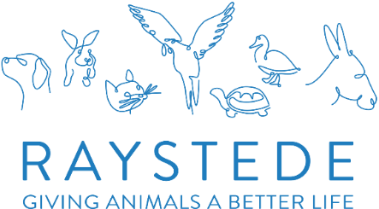

Warehouse VOLUNTEER

A bit about the role:
We’re incredibly fortunate to receive generous donations to help raise money for our wonderful animals in need. Our warehouse is at the heart of this effort, where donated items are sorted, checked, and prepared for sale in our charity shops.
As a Warehouse volunteer, you’ll be part of a friendly and fun-loving team, enjoying a good rummage while ensuring all stock is in great condition and ready for distribution. If you love working with others, have an eye for quality, and want to make a real difference, we’d love to have you as part of our Team.

Location
Raystede Warehouse, Newhaven, East Sussex

Team
Warehouse Team

Time Commitment
You can give as much or as little time as you want. The warehouse will be operating over 5 days a week, between the hours of 9am-3pm Monday to Friday.

What you can expect to be doing
Sorting and preparing donated goods for all the shops.
If you are P.A.T testing trained, you will be helping pat test all electrical items for the shops.

This role will suit you if you:
Like to make new friends and be part of a great team for a much-loved local animal charity
Have an interest in all things retail including fashion, clothing and much more
Have a polite and engaging manner
Can cope with some light lifting and carrying
Have your own transport to and from the Warehouse

How you will make a difference
You will be a vital part of a small team within our warehouse. You will be raising much-needed funds for the wonderful animals whilst in our care.

What we can offer you:
- A welcoming and enjoyable experience and the chance to meet new, like-minded people.
- Being part of a friendly and loyal team.
- Recognition and appreciation for your contribution
- Uniform, induction and role specific training with ongoing support
- The option of reimbursement of local travel costs between home and volunteering location
- All tea and coffee you can drink (not forgetting the cake and biscuits).

