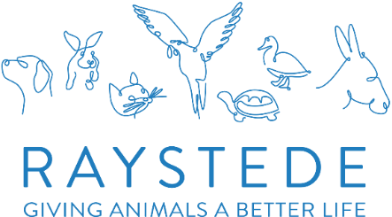
ESTATES WATER SYSTEM (L8) VOLUNTEER

A bit about the role:

As part of our commitment for Health & Safety at our main site we must undertake a Water Risk Assessment every 2 years, to comply with the L8 Legionnaires' Disease: ACoP for Legionella Bacteria in Water Systems Regulations. This involves regular weekly, monthly and quarterly checks on our water system to ensure we are compliant.

One of these checks is running our external taps, (designated ‘Little Used Outlets’), each week when they are not used regularly over a 7-day period. As you can imagine we have a lot of these taps that have the potential to have to be run each week.

Location:

On site - Raystede Centre for Animal Welfare, Ringmer, East Sussex

Time commitment:
- Flexible, any day or time between 10am – 4pm. Monday to Friday
- Completing & recording records to show we are compliant with L8
- Reporting any issues found when running the taps to the Estates Manager/ Facilities Manager
This role will suit you if you:
- Able to cope with a physical role involving some light lifting, carrying and bending.
- Happy to work outdoors in all weather
- Can be the friendly face of Raystede, with an engaging manner and happy to talk to our visitors
- Are reliable in attendance and dependable
- Able to work effectively without supervision
- Have own transport to get to and from Raystede

How you will make a difference:
- Help prevent a significant risk to people using our premises
- Help with regular remedial work (when necessary) to avoid any legal ramification
- Help keep our water systems safe from legionella
- Help prevent fines from HSE, which could significantly tarnish our reputation

What we can offer you:
- The opportunity to get to know the Estates Team and understand their role at Raystede
- A welcoming and enjoyable experience and the chance to meet new, likeminded people
- Recognition and appreciation for your contribution
- Complimentary lunch and a hot drink whilst volunteering
- 50% Discount off food and drink in our Café whilst volunteering
- Uniform, induction and role specific training programme with ongoing support
- The option of reimbursement of local travel costs between home and volunteering location

