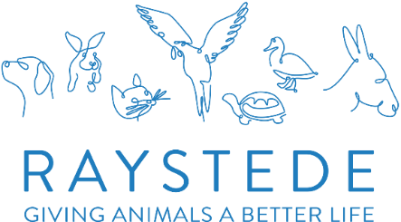
CORPORATE TOUR GUIDE VOLUNTEER

A bit about the role:
Raystede offers Corporate Volunteering days to companies twice a week from April to September, the groups arrive for 9am health and safety briefing and spend the day helping on our beautiful site, these run on Tuesday & Wednesday, during term time the groups work on the main site and Wednesday at Peaceways, during school holidays the group solely work at Peaceways, as thank you for all their hard work and an opportunity to find out more about who we are and what we do they have a tour of the main site between 2.30 on the main site and 3pm on the days worked at Peaceways, We are looking for passionate volunteers who are willing to learn an overall knowledge of Raystede and the animal residents, who can then present these facts and stories in an engaging way to our wonderful corporate volunteers on the Thank you tours after the volunteering day,

Location:

On site, as part of our Corporate Fundraising Team - Raystede Centre for Animal Welfare, Ringmer, East Sussex

Time commitment:
Tuesday during term time 2.30 till 3.30
Tuesday during school holidays 3pm to 4pm
Wednesday 3pm to 4pm up to the end of September.

What you can expect to be doing:

To arrive in time to commence tours at either 2.30pm or 3pm, meet the group outside the café after commencing the tours and take the group around main site, visiting all main areas of the site, engaging with the volunteering during the tour.

At the end of the tour ask if any questions. liaise with Mikayla after each tour and how the tour went.

This role will suit you if you:
- Have excellent interpersonal skills and be the friendly face of Raystede
- Are able to speak passionately about animal welfare and the individual stories at Raystede.
- Be able to engage and work with our corporate volunteers
- Understand how businesses can get involved and make a real difference to Raystede
- Are reliable in attendance and dependable
- Able to work effectively without supervision
- Able to safeguard confidential information about Raystede
- Have own transport to get to and from Raystede

How you will make a difference:

You will help to deliver animal welfare and husbandry education, thereby helping to improve animal welfare knowledge and standards amongst future generations. This will also raise awareness amongst the public of the work that Raystede does which encourages further support for the charity.

What we can offer you:
- Training on the tour and type of information we would like you to share.
- A welcoming and enjoyable experience and the chance to meet new, likeminded people
- Recognition and appreciation for your contribution
- Complimentary lunch and a hot drink whilst volunteering
- 50% Discount of food and drink in our Café whilst volunteering
- Uniform, induction and role specific training programme with ongoing support
- The option of reimbursement of local travel costs between home and volunteering location

