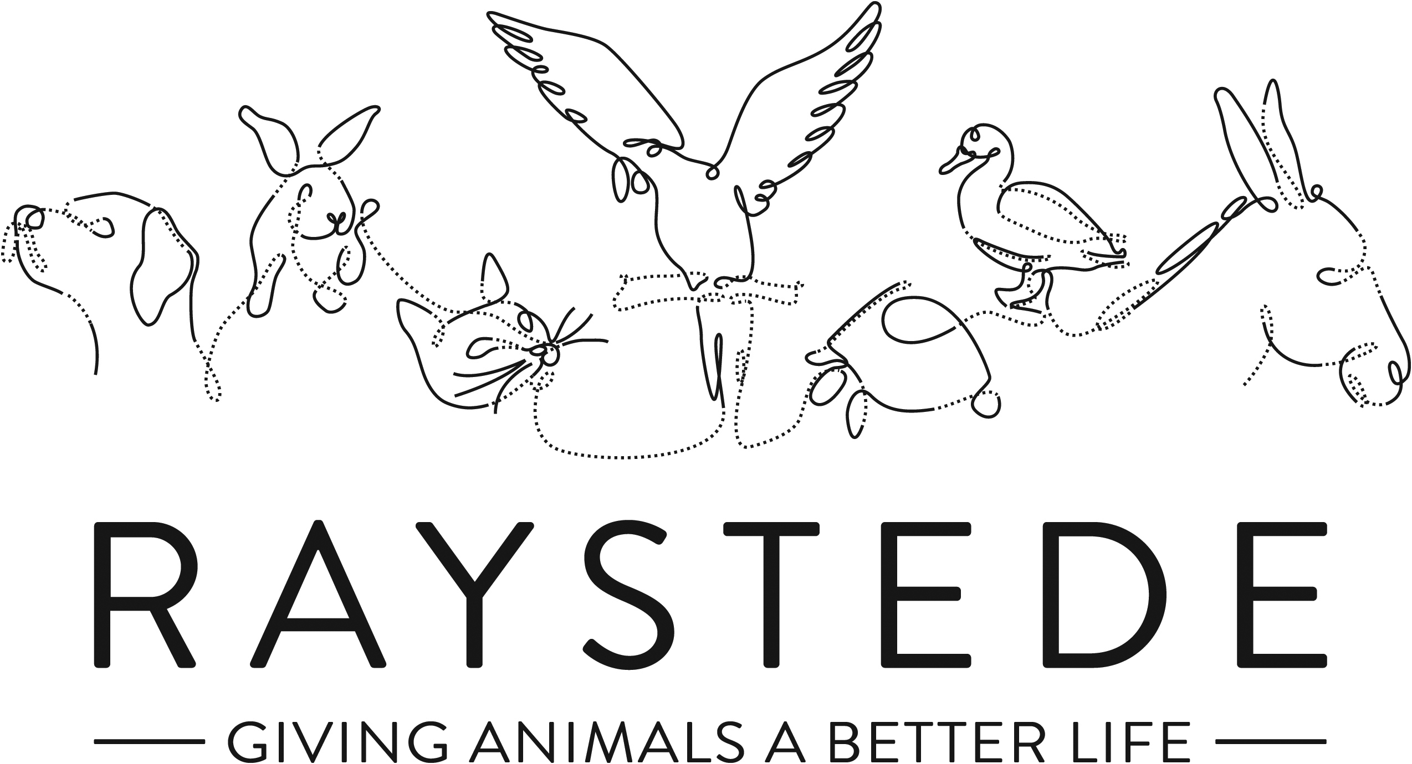
Raystede Centre for Animal Welfare

Job Description

Job Title: | Trusts Fundraiser
Responsible to: | Fundraising Partnerships Manager
Location: | Raystede Animal Centre
Hours of work: | Part time, approx. 3 days per week/ circa 22.5 hours, to be agreed with successful candidate. Occasional evening and weekend work may be required.
Holidays: | 24 days holiday excluding Bank holidays, pro rata
Probationary period: | 6 months
Contract Type: | Permanent
Salary Grade : | E1

Background information

Raystede Centre for Animal Welfare was established as a charity in 1952. We now have a 43- acre site and we care for over 2,000 animals a year, rehoming 1,000 animals and providing sanctuary to even more. We are one of the most diverse rescue centres in the UK because we care for so many different species of animals. Our services and activities include the Peaceways pet crematorium, our teams of veterinary and animal care staff, education & learning activities and our commercial and visitor operations.

The Fundraising team generates income for Raystede through donations, legacies, events and many other sources and activities. The Trusts Fundraiser works to create inspiring and engaging proposals, to generate core and restricted income from a variety of Trusts, Foundations and Grant making bodies. The Trusts Fundraiser will build on and develop the current Trust research and established pipeline of Trusts.

Main Purpose of the role:
- To secure financial support for Raystede from Trusts, Foundations and grant making bodies focusing on core costs and fundraising for capital and other projects as required.
- To research projects, compile and write compelling applications to Trusts and Foundations with the potential to financially support Raystede’s work.
- To develop the prospect pipeline by undertaking research into a wide range of Trusts and organisations, seeking prospects with aligned aims to Raystede and with the capacity to give.
- To develop a stewardship programme for Trusts, providing excellent stewardship by sending timely and inspiring reports and updates, event invitations and arranging meetings or project visits.
- To network and develop relationships with Trustees through a peer-to-peer approach.

Key Tasks

Report Writing
- Research, collate, prepare, and submit engaging funding applications to Trusts and other grant making funders, in a timely manner.
- Liaise with Trusts on application criteria, process, and funding timelines to maximise possibility for successful applications.
- Understand and adhere to the funding criteria of each Trust; present tailored applications to meet the funder’s objectives.
- Accurately evaluate and report back on successful project funding to the funding body in an engaging way, and to agreed timeframes.
- Liaise with teams across the organisation to gather information required to achieve reporting requirements, including Education and Rehoming departments, and the Head of Animal Welfare. Builds strong internal relationships.
- Provide reports on performance of campaigns and activity and written plans at intervals, for internal meetings and to the Fundraising Partnerships Manager and/or Head of Fundraising.

Strategy and Planning
- Develop and implement a strategy to build and review the pipeline of prospects scheduling applications throughout the year to ensure a consistent income stream, and future growth opportunities.
- In agreement with the Fundraising Partnerships Manager, strategically select projects relevant to each funder.
- Awareness of funding rounds; strategic planning and decision making to maximise opportunities based on existing and future funding needs.
- Create and implement an effective strategic stewardship plan for Trusts.
- Resolution management; works with Trust trustees and administrators to agree a new funding plan in the event that the project requirements have evolved between application and grant award.
- Identify and develop new processes to support the expansion of Trust Fundraising area; takes an innovative approach.
- Keep up to date with legislation, trends and fundraising or stewardship engagement strategies, and applies these to Trust Fundraising at Raystede.
- Keep up to date with Raystede’s fundraising priorities, balancing the importance of core funding with Trust objectives.

Research
- Work with the Fundraising Partnerships Manager to research and develop cases for support for a wide range of core costs and project funding proposals.
- Works with colleagues across the organisation to secure accurate financial projections and costings for funding proposals.
- Proactively research Trusts and funding bodies to develop the prospect pipeline.
- Develop the prospect pipeline by identifying new Trust prospects, undertaking prospect research and creating effective cultivation and solicitation plans.
- Work well with Raystede senior stakeholders and the Major Donor & Corporate Fundraisers to network map, and discover new Trusts prospects.

Stewardship
- Ensure strong stewardship plans are in place to maximise funder engagement.
- Build and maintain relationships with Trusts, Foundations and grant funders including Trustees, senior and administrative staff.
- Provide opportunities for senior Raystede Stakeholders to steward high-level relationships with Trusts, in addition to seeking opportunities to endorse new approaches to funders.
Database and Compliancy
- Ensure that all relevant activity is accurately recorded on the database (Access ThankQ) including key contacts, correspondence, applications and invitations.
- Regularly analyses the database and other data sources to ensure all opportunities to identify prospects and engage other supporters through their Trust connections are utilised.
- Develop a good hands-on understanding of our fundraising database and how funder details are stored and used.
- Develop Raystede Trust and Foundations prospect and supporter database.

Other
- Maintain an excellent understanding of the grant making sector, and stay informed of sector developments, research and trends.
- As a key member of the Fundraising Partnerships Team, assist with and attend events and meetings as required.
- Work closely with the whole fundraising team and especially with colleagues working with Corporate Supporters and Major Donors to ensure all activity and messaging is integrated.
- Prepare a Trusts income and expenditure budget every year.
- Represent Raystede at a higher level to key external stakeholders, Trust trustees, and at events.
- Maintain and develop positive relationships external stakeholders.
- Supervise key volunteers as appropriate.

General
- At all times ensure and maintain a compassionate, professional and efficient public image for the charity.
- Participate in supervision, appraisal, and learning and development and take personal responsibility for maintaining the knowledge and skills required for the role.
- Take responsibility for ensuring own health and safety and that of others who may be affected by your acts and omissions. Report any health and safety risks to your manager.
- Work within the policy framework of Raystede Centre for Animal Welfare and adhere to the terms laid out in the employee handbook.
- To support the wider aims of the charity and from time-to-time carry out other general duties as may reasonably be required by the Fundraising Partnerships Manager, Head of Fundraising, and/or Chief Executive.
Key Working Relationships
- Fundraising Development Team - work closely with colleagues in immediate team to share cases for support and project insights to maximise opportunities for Raystede. Contribute to the team plans and strategy. Liaises with the team to understand fundraising needs, priorities and strategy for securing funding from all sources.
- Fundraising Team – contribute to the team plans and update on Trusts activity. Cross-selling and promotion of other fundraising areas or products, where appropriate. Working with colleagues to identify supporters with connections to Trusts.
- Database Fundraising Manager – work closely with the Database Fundraising Manager to ensure that donor data is captured, recorded and processed quickly, briefing a range of reports and KPIs to be set up.
- Trusts, Foundations, and their trustees and employees – relationship manager for a portfolio of Trusts and Foundations, able to network, inspire and influence. Can manage complex funding bids, manage expectations and resolve any conflicts effectively.
- Senior Raystede Stakeholders – works effectively with the Senior Management Team, staff and trustees to draw on contacts and relationships to develop the Trusts area. .
- Fundraising Volunteers – supervise one specialist volunteer
- Marketing – work closely with the Fundraising Partnerships Manager and the marketing team to produce marketing and promotional materials and planned campaigns.
- Finance – work with finance to monitor donations pledged; ensure correct coding of Trusts income.
Scope and Accountability
Decision making and limits of authority | - Instigate and develop the Trust Fundraising strategy working with the Fundraising Partnerships Manager.  - Researches and evaluates each prospective Trust, making funding decisions autonomously to maximise potential funding success based on Trust criteria and Raystede funding needs and long term plans.  - Decision making on timing and projects – strategic planning of when and what project to apply for, looking at longer term funding goals within the considerations of Trusts funding cycles.
Financial resources | - Responsible for an income target of up to £200k and an expenditure budget of up to £3k.
Material assets | - NA
Information and communication resources | - Accurately represents Raystede’s work through extensive report writing.  - Collates and agrees a wide variety of statistics, data and financial information about Raystede in conjunction with the Fundraising Partnerships Manager. Ability to interpret, comprehend and use data precisely and to present Raystede positively through data.  - Responsible for inputting data on to database.  - Sets up and agrees data processing, coding, report and KPI briefs with the Fundraising Database Manager.  - Works with Marketing to produce materials; writes marketing briefs; provides content across multiple marketing channels.  - Writes individual presentations and communications; drafts invitations and tailored communications from senior Raystede stakeholders.  - All marketing activity and mass communications are signed off by Head of Fundraising and Head of Marketing.  - Able to persuade and influence people at senior levels to take action in support of Raystede.
People management | - Supervises one specialist volunteer
Legal, regulatory and compliance responsibility

Person Specification
 | Essential | Desirable
Education and Qualifications
Knowledge and Experience | - 2-3 years fundraising experience; or experience of producing tender or sales documents, report writing and evaluation in a professional capacity.  - Experience of meeting significant activity, business or income targets.  - Empathy for and knowledge of the issues regarding domestic animals in an animal welfare charity.  - Experience of good record keeping and administration. | - Experience of applying to Trusts, Foundations or Statutory Funders.  - Experience of capital appeals  - Experience of writing cases for support  - Experience of developing relationships in a professional capacity.  - Understanding of charity related legislation and fundraising codes of practice.  - Good knowledge of data protection.
Key Skills and Abilities | - Excellent written communication and presentation skills  - Able to writing inspiring and persuasive cases for support tailored to match Trust Funders requirements  - Able to understand, interpret and present data in a factual and compelling manner.  - Good at identifying and pursuing opportunities.  - Excellent numerical skills able to interpret and analyse financial information.  - Strong organisational and administrative skills – able to plan and manage own time to meet goals and deadlines.  - Able to reflect on and evaluate own work.  - Target and results orientated.  - Enjoys working with others and good at building working relationships with colleagues.  - Strategic thinker; ability to see the bigger picture.  - Good IT skills including CRM databases, and MS Office applications. | - Experience of data analysis, database research and interrogation  - Experience in budget management and projections.
Personal Attributes | - Organised and efficient, with good attention to detail, and the ability to forward plan.  - Works collaboratively with colleagues.  - Proactive and self-motivated with the ability to think creatively.  - A positive outlook and a “can do” attitude.  - Dedication, commitment and tenacity.  - Empathy and understanding of the love for animals.  - A commitment to equal opportunities and anti-discriminatory practice.
Other | - To have a flexible approach to working hours.  - Availability of own vehicle for work use and in possession of a current, clean driving licence.

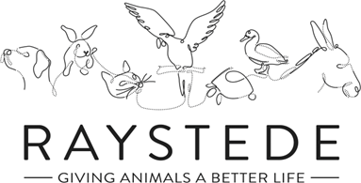
Fundraising Department Structure

