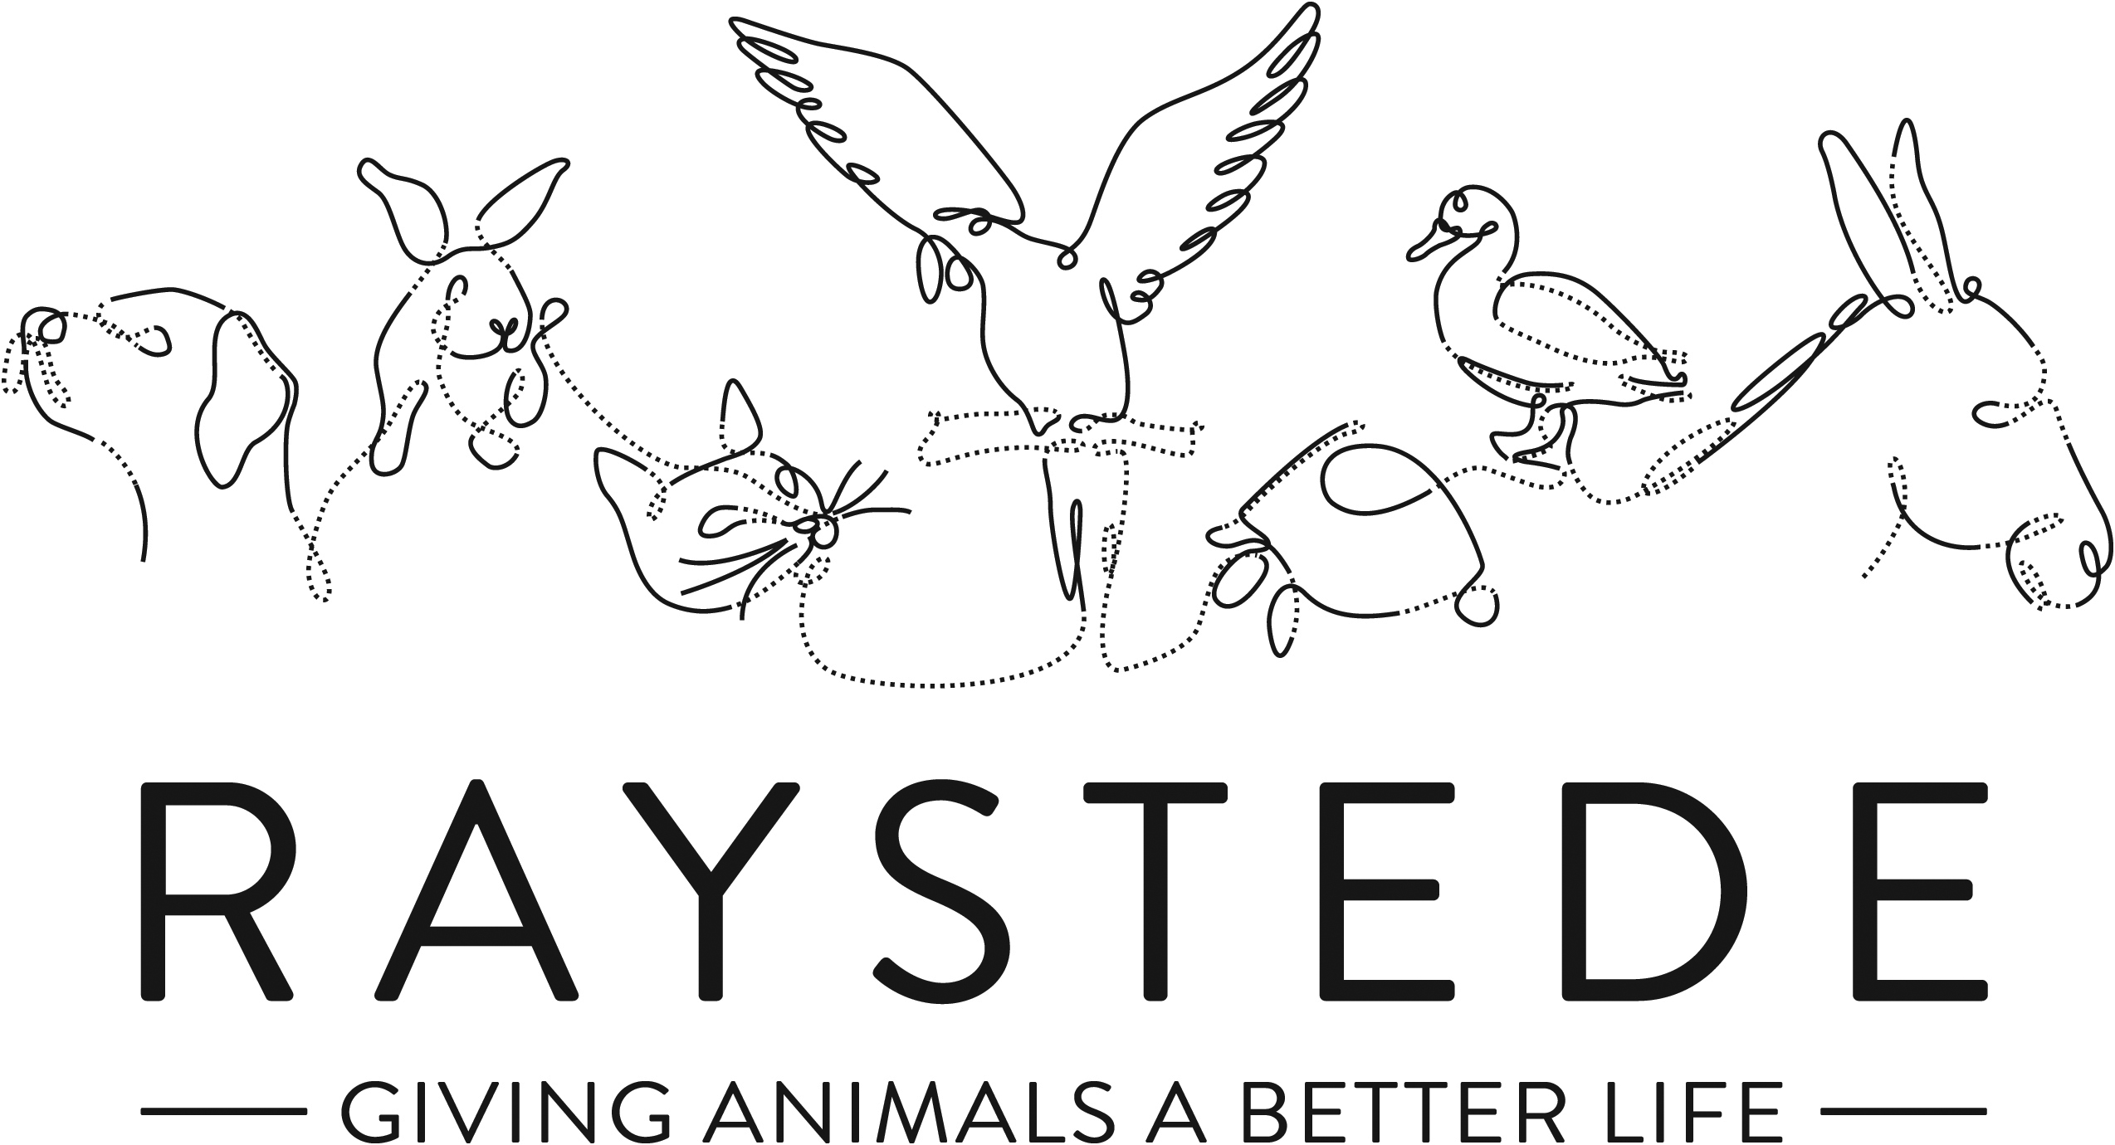
Raystede Centre for Animal Welfare

Job Description

Job Title: | Retail Assistant – part time
Responsible to: | Retail Manager
Location: | Raystede Charity Shop, Lewes
Hours of work: | Various shifts available over a 7-day trading week, SHIFTS 15 TO 23 HOURS
Holidays: | Pro rata on 30 days per year including bank holidays.
Probationary period: | 3 months
Contract Type: | Permanent
Grade and Salary: | £8.71 per hour

Background information

Raystede Centre for Animal Welfare, established in 1972, is a charity that aims to give animals a better life through rehoming, rehabilitation and sanctuary, and give people the support and knowledge they need to treat animals with care and respect. We care for more than 400 animals every day, including cats, horses, dogs, rabbits, hens and exotic birds. We help most of the animals find new homes but also provide life-long sanctuary for those animals that cannot be rehomed. Our beautiful 43 acre site is open for visitors to get a unique glimpse into a working animal welfare centre.
Animals are at the heart of everything we do but we could not care for them without our expert and dedicated team of staff and volunteers. Surrounded by animals, lakes, trees and fields with a café, shops, parking and many other benefits, Raystede is an uplifting and rewarding place to work.

The retail team are part of the Commercial and Visitor Operations department. Upholding high standards and a friendly caring approach we help and encourage people to donate and buy goods from our charity shop. Every penny of our profits go directly into helping the animals in Raystede’s care.

Main Purpose of the role:
Support the Manager and Assistant Manager across the Retail charity shop operation, maintaining consistently high standards throughout the shop and storerooms. Deliver excellent customer service to internal and external customers. Serving customers and accepting donated goods.

Key Tasks
1. Maintain consistently high standards in the shop, processing room and throughout the stock room areas.
2. Manual handling – movement of donated goods such as books, clothing, toys etc.
3. Deliver excellent customer service in the Shop at all times.
4. Support the Manager to wholly deliver compliance regimes.

General
At all times ensure and maintain a compassionate, professional and efficient public image for the charity
  - Participate in supervision, appraisal, and learning and development and take personal responsibility for maintaining the knowledge and skills required for the role
  - Take responsibility for ensuring own health and safety and that of others who may be affected by your acts and omissions. Report any health and safety risks to your manager.
  - Work within the policy framework of Raystede Animal Centre and adhere to the terms laid out in the employee handbook

Key Working Relationships
General public, giving people the best experience in our shop through excellent customer service
Colleagues, team working is essential
Commercial and Visitor Ops team, being part of a bigger team to maximise efficiencies and share best practice

Scope and Accountability

Decision making and limits of authority | - Carry out duties as per job description  - Defer to assistant manager or manager for anything over and above
Financial resources | - Cash handling, cashing up tills
Material assets | - Accurate stock control and date rotation to minimize waste
Information and communication resources | - Maintain records as instructed
People management | - Work closely alongside a team of volunteers
Legal, regulatory and compliance responsibility | - Comply with instructions over Gift Aid and GDPR laws

Person Specification

 | Essential | Desirable
Education and Qualifications
Knowledge and Experience | • Retail experience  • Good customer service skills  • Well organised and able to work in a tidy manner  • Good numeracy and literacy skills  • Ability to work effectively within a team  • Good communication skills, ability to positively interact with different groups of people, both internal and external customers  • High standards of personal hygiene | Charity shop experience
Key Skills and Abilities | • Proven communication skills, written and oral.  • Excellent attention to detail.
Personal Attributes | - Personal, sociable and people orientated  - Commitment to equality, diversity and inclusion and understanding of how it applies to own role  - Empathy and interest in animals and their welfare
Other | • To have a flexible approach to working hours.

