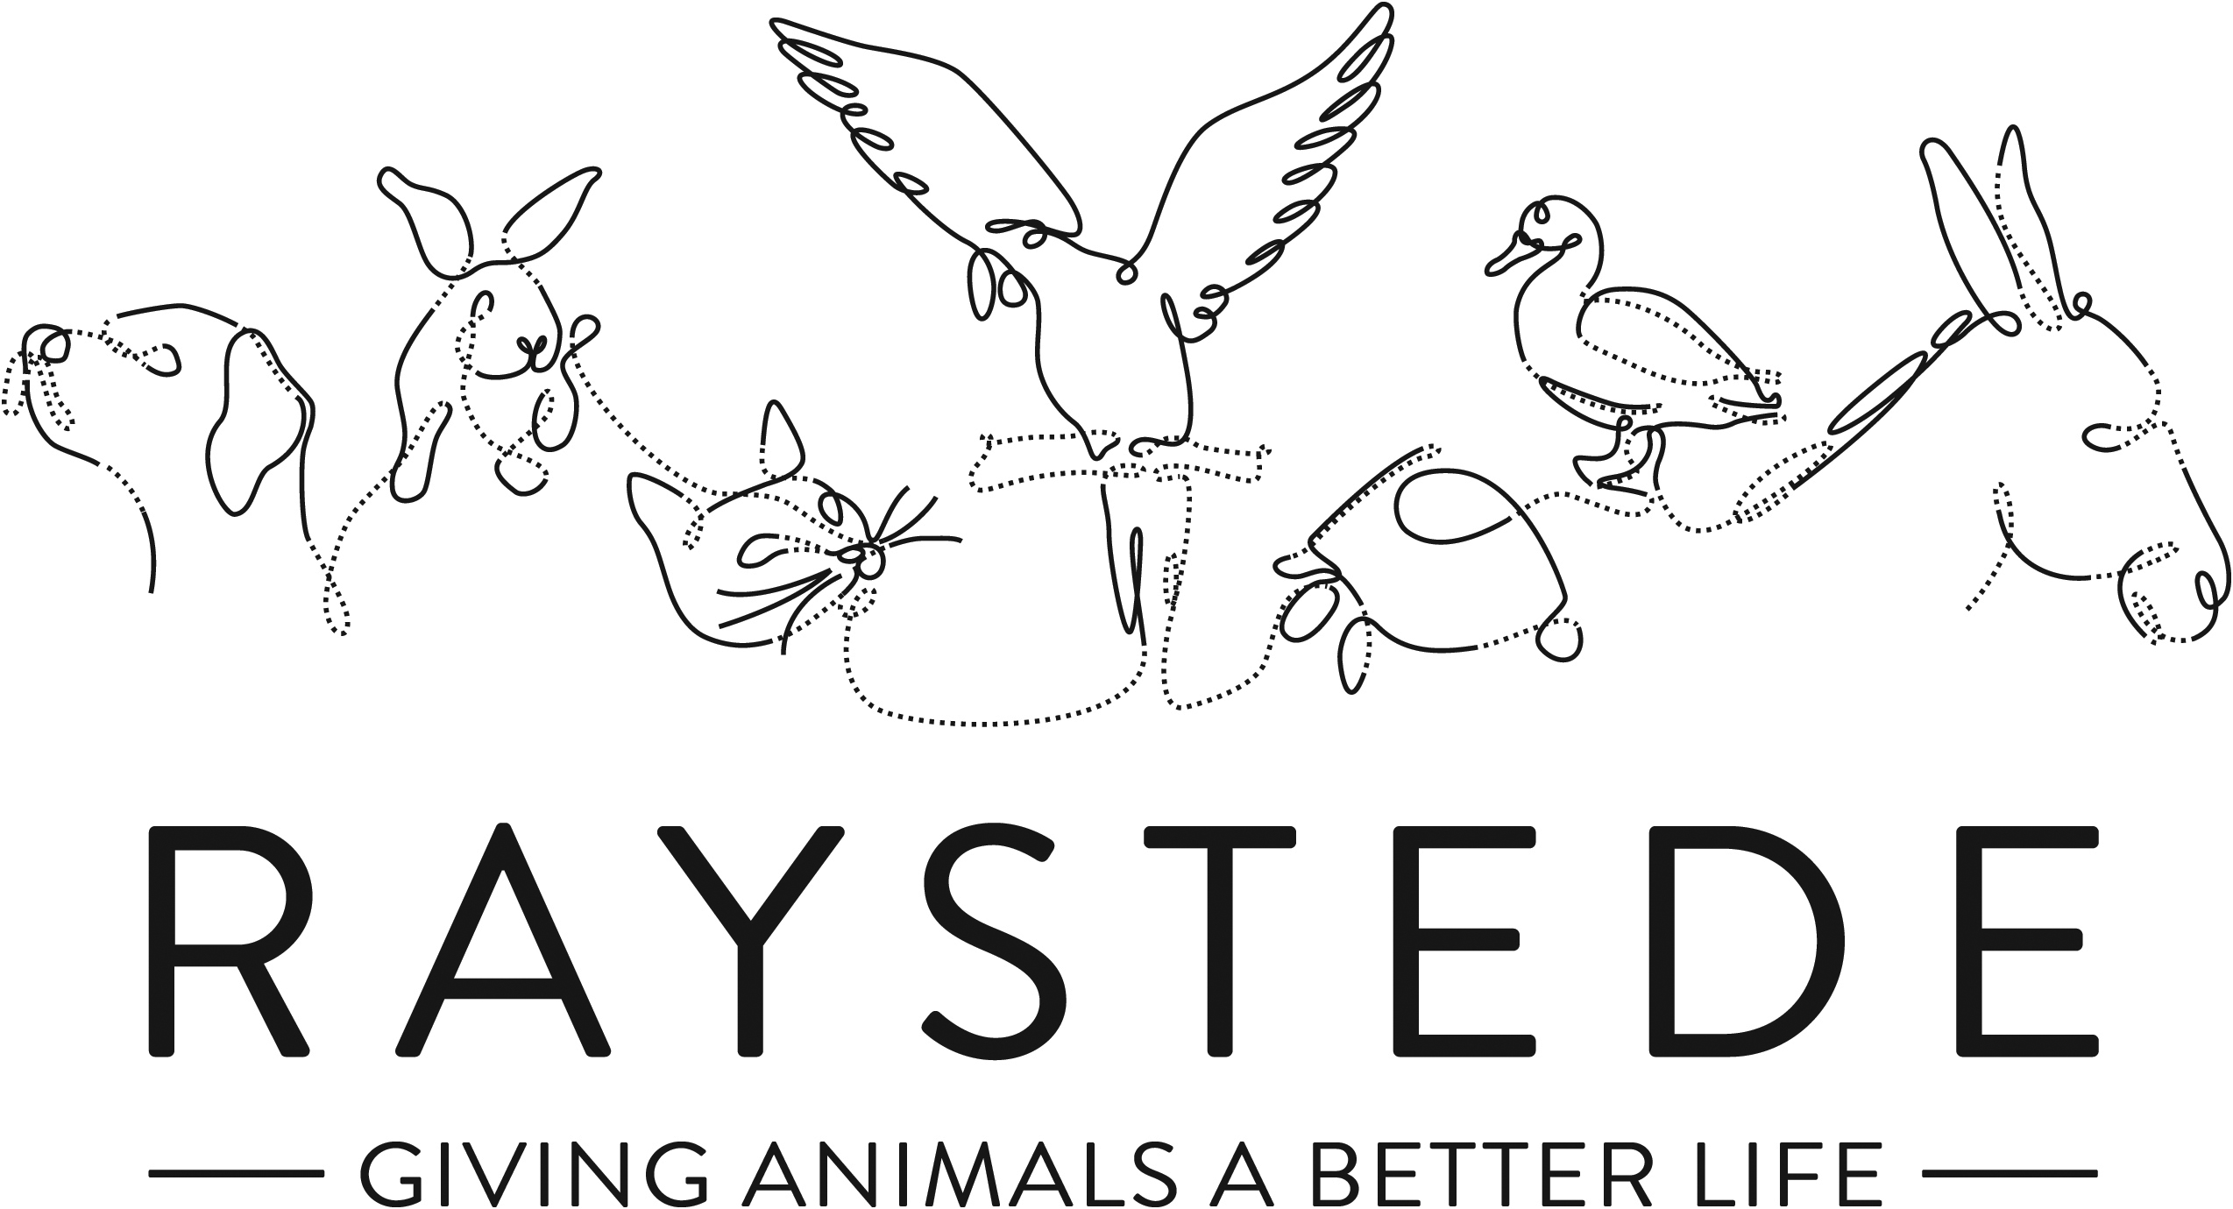
Raystede Centre for Animal Welfare

Job Description

Job Title: | Retail Assistant Manager
Responsible to: | Retail Manager
Location: | Raystede Charity Shop, Lewes
Hours of work: | 37.5 hours, 5 days a week over a 7 day trading week
Holidays: | Pro rata on 30 days per year including bank holidays.
Probationary period: | 3 months
Contract Type: | Permanent
Grade and Salary: | Circa £18,000 pa

Background information

Raystede Centre for Animal Welfare, established in 1972, is a charity that aims to give animals a better life through rehoming, rehabilitation and sanctuary, and give people the support and knowledge they need to treat animals with care and respect. We care for more than 400 animals every day, including cats, horses, dogs, rabbits, hens and exotic birds. We help most of the animals find new homes but also provide life-long sanctuary for those animals that cannot be rehomed. Our beautiful 43 acre site is open for visitors to get a unique glimpse into a working animal welfare centre.
Animals are at the heart of everything we do but we could not care for them without our expert and dedicated team of staff and volunteers. Surrounded by animals, lakes, trees and fields with a café, shops, parking and many other benefits, Raystede is an uplifting and rewarding place to work.

The retail team are part of the Commercial and Visitor Operations department. Upholding high standards and a friendly caring approach we help and encourage people to donate and buy goods from our charity shop. Every penny of our profits go directly into helping the animals in Raystede’s care.

Main Purpose of the role:
Support the Manager across the Retail charity shop operation, maintaining consistently high standards throughout the shop and storerooms, including stock management and staff rota. Deliver excellent customer service to internal and external customers.
Deputise in Manager’s absence. Lead and instruct the team, to deliver on targets and standards of service. Able to work flexibly across all retail tasks

Key Tasks
1. Maintain consistently high standards in the shop, processing room and throughout the stock room areas.
2. Lead and instruct the team to deliver consistently on pre-agreed high standards.
3. Manual handling – movement of donated goods such as books, clothing, toys etc.
4. Deliver excellent customer service in the Shop at all times, engaging customers and seeking opportunities to improve.
5. Manage daily priorities and ensure day to day routines are carried out & recorded appropriately.
6. Ensure an accurate till operation, including end of day routines, cash procedures and till information
7. Communicate positively and appropriately with the Commercial & Retail team.
8. Lead by example, presenting a proactive, professional and friendly approach to visitors/customers, colleagues and Managers, face to face and on the telephone.
9. Follow policies and protocols at all times
10. Monitor and maintain due diligence actions & records, including risk assessments and training
11. Plan and manage efficient resourcing including work planning, staff rotas, payroll,
17, Complete all recruitment, induction and training processes, ensuring accurate and timely delivery of HR protocols and staff performance management.
12. Seek opportunities to continually improve in all aspects of the business development.
13. Deliver 100% accurate stock management processes inc stock take and stock ordering.
14. Ensure all equipment is maintained appropriately
15. Support the Manager to wholly deliver compliance regimes.

General
At all times ensure and maintain a compassionate, professional and efficient public image for the charity
  - Participate in supervision, appraisal, and learning and development and take personal responsibility for maintaining the knowledge and skills required for the role
  - Take responsibility for ensuring own health and safety and that of others who may be affected by your acts and omissions. Report any health and safety risks to your manager.
  - Work within the policy framework of Raystede Animal Centre and adhere to the terms laid out in the employee handbook

Key Working Relationships
General public, giving people the best experience in our shop through excellent customer service
Colleagues, team working is essential
Commercial and Visitor Ops team, being part of a bigger team to maximise efficiencies and share best practice

Scope and Accountability

Decision making and limits of authority | - Deputise in the retail manager’s absence for day to day operational needs to ensure smooth running of cafe  - Defer to one of the Commercial managers at the main site for anything over and above
Financial resources | - Cash handling, cashing up tills and daily banking
Material assets | - Accurate stock control and date rotation to minimize waste
Information and communication resources | - Use of department PC and email to be conducted in line with policy and procedure
People management | - Line manage up to 2 staff plus a team of volunteers
Legal, regulatory and compliance responsibility | - Comply with Gift Aid and GDPR laws  - Maintain accurate H&S records

Person Specification

 | Essential | Desirable
Education and Qualifications | - Full Driving Licence
Knowledge and Experience | • 2 years retail experience in a supervisory role  • Good customer service skills  • Positive and supportive of new ideas and processes that help service and offer continually improve.  • Well organised and able to work in a tidy manner  • Accurate till operation and cash handling procedures  • Good numeracy and literacy skills  • Ability to work effectively within a team  • Good communication skills, ability to positively interact with different groups of people, both internal and external customers  - Good basic IT skills  • High standards of personal hygiene  • Knowledge of health and safety best practice. | Charity shop experience
Key Skills and Abilities | • Proven communication skills, written and oral.  • Ability to work within a diverse team, and build excellent working relationships.  • Ability to manage personal deadlines and prioritise a demanding workload.  • Ability to manage relationships with tact and diplomacy.  • Excellent attention to detail.
Personal Attributes | - Personal, sociable and people orientated  - Commitment to equality, diversity and inclusion and understanding of how it applies to own role  - Empathy and interest in animals and their welfare
Other | • To have a flexible approach to working hours.

