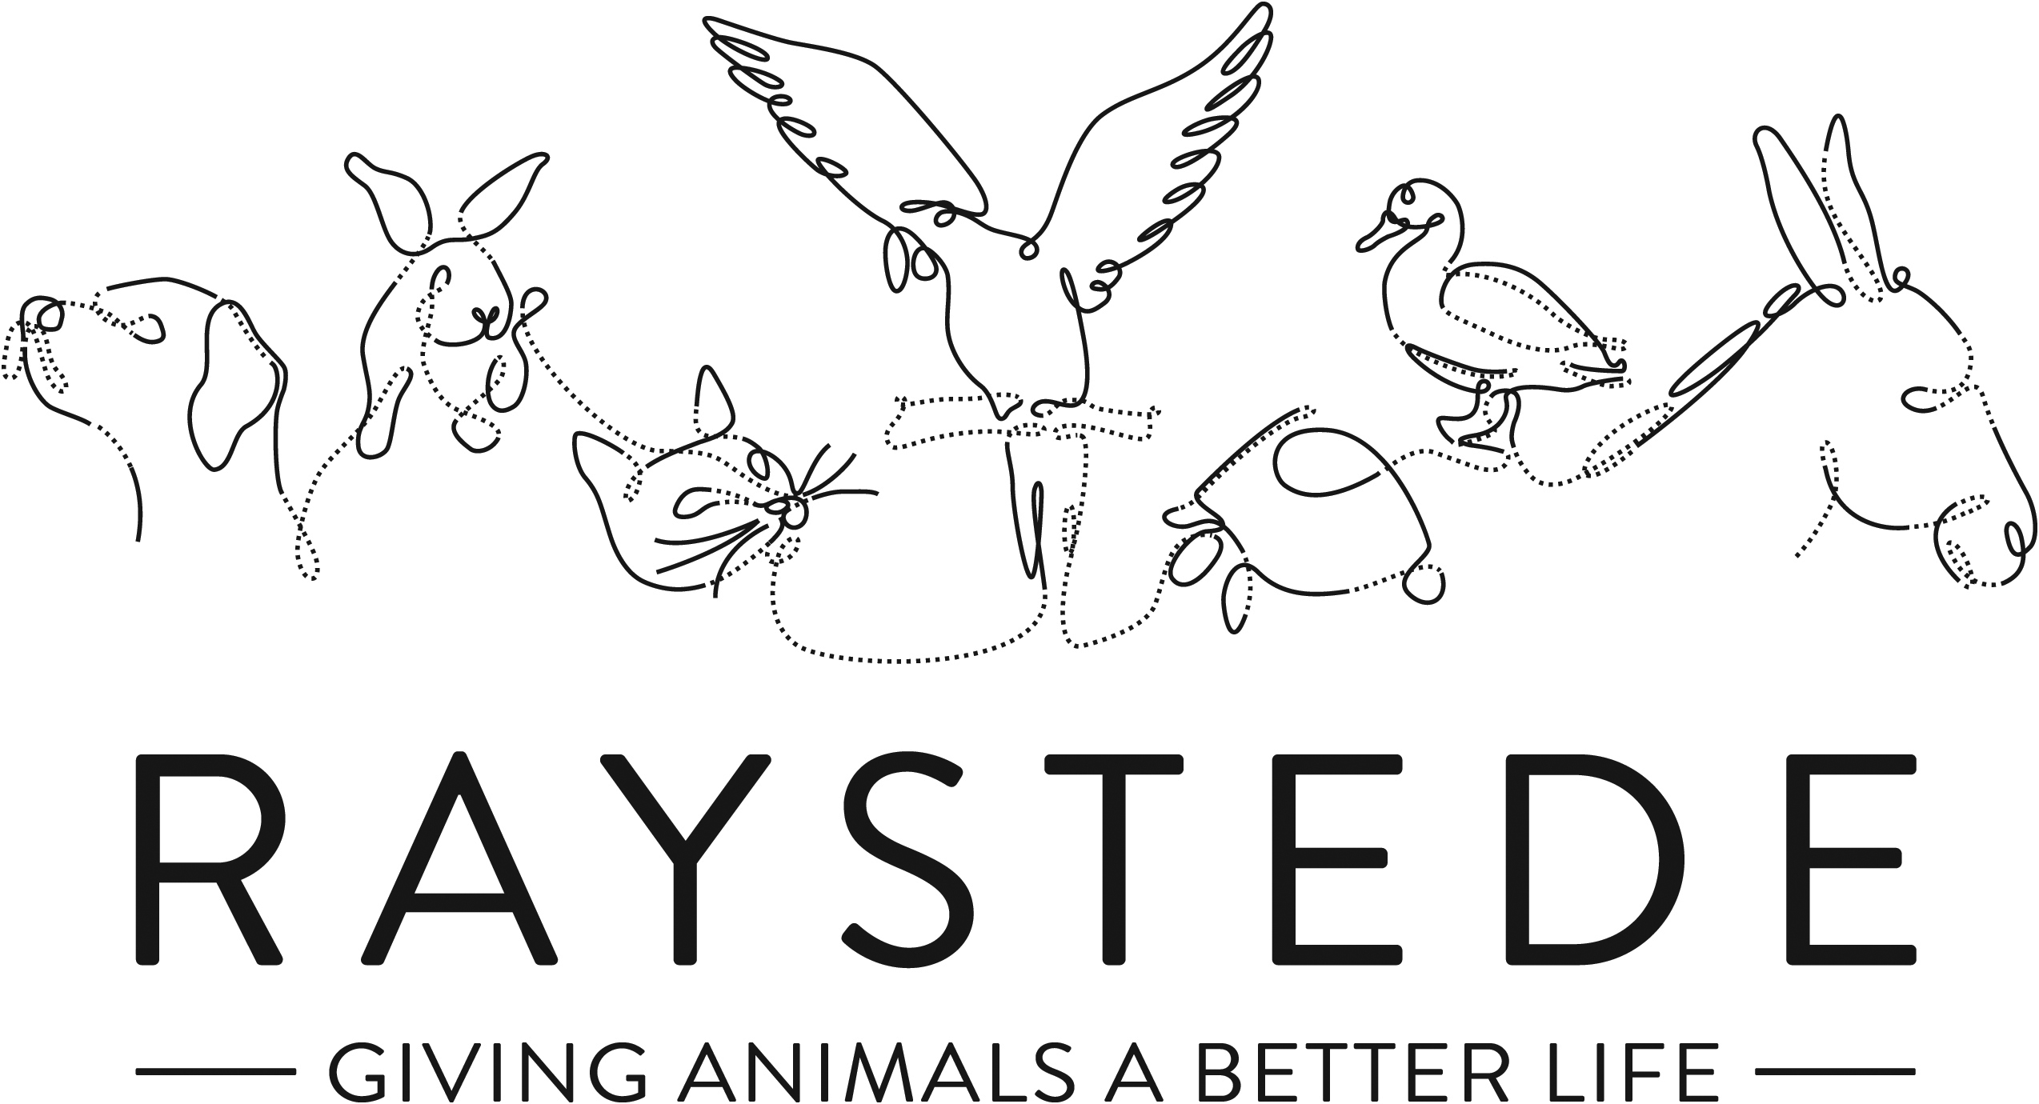
Raystede Centre for Animal Welfare

Job Description

Job Title: | Rehoming Assistant
Responsible to: | Rehoming Manager
Location: | Raystede Centre for Animal Welfare
Hours of work: | 37.5 hours including alternate weekends
Holidays: | 30 days per year including bank holidays
Probationary period: | 3 months
Contract Type: | Permanent
Grade and Salary: | Grade B - £18,896

Background Information

Raystede Centre for Animal Welfare, established in 1952, is a charity that aims to give animals a better life through rehoming, rehabilitation and sanctuary, and give people the support and knowledge they need to treat animals with care and respect. We care for more than 400 animals every day, including cats, horses, dogs, rabbits, hens and exotic birds. We help most of the animals find new homes but also provide life-long sanctuary for those animals that cannot be rehomed. Our beautiful 43 acre site is open for visitors to get a unique glimpse into a working animal welfare centre.
Animals are at the heart of everything we do but we could not care for them without our expert and dedicated team of staff and volunteers. Surrounded by animals, lakes, trees and fields with a café, shops, parking and many other benefits, Raystede is an uplifting and rewarding place to work.

The Rehoming team is responsible for providing the first point of contact for the admission of, and assisting with the adoption of, animals at Raystede. The Rehoming team forms a key part of our animal welfare service.

Main Purpose of the role:

- To work as part of a team delivering first-class customer service, answering queries, and carrying out rehoming appointments to a high standard.
- Taking an active part in managing our volunteer foster network including recruiting and retaining new fosterers to support our Break Away and Home from Home foster schemes.
- To ensure the highest standards of animal care and welfare for animals housed within Raystede’s foster network.
- To educate potential new owners and the general public in the care and welfare of their animals.
- To promote Raystede services and maximise adoption opportunities.

Key Tasks
- Administration
  - Complete and maintain all standard and electronic files and documentation relating to the animals; including documents on the surrender and adoption of animals, microchip, and vaccination records, ensuring records are accurate, up to date, legible and comply with any legislative requirements.
  - Maintain and monitor animal records for those animals in foster care.
  - Complete and maintain all standard and electronic files and documentation relating to foster carers ensuring they are up to date, legible and comply with any legislative requirements.
  - Produce promotional material to generate support.
  - Maintain and monitor foster animal records.
  - Support Section Manager with stock rotation, stock taking, and ensuring stock levels.
  - General admin duties.
- Customer Service
  - Welcome, receive, and care for visitors within the section and on site.
  - Home or site visits will be required to members of the public.
  - Attend to the needs of the adopters/general public face to face, via electronic communication or via the telephone providing a caring and non-judgemental service in what may be difficult circumstances.
  - Liaise with colleagues in other departments to ensure accurate, timely and relevant information is disseminated as required.
  - Work collaboratively with external colleagues in other welfare and similarly relevant organisations.
- Animal care and welfare, including fostering:
  - Implement and monitor plans to ensure the health and welfare of animals in foster care.
  - Assist in coordinating the care of animals within section.
  - Evaluate the match between foster carers and animals and support them through the process.
  - Recruit, train, supervise, and retain foster carers and other section volunteers.
  - Provide advice and guidance on the care of animals to prospective owners and foster carers.
  - Carry out and co-ordinate monitoring visits.
  - Co-ordinate the collection and delivery of animals. This may be from environments where risk from members of the public is present.
  - Liaise with agencies such as Police, Refuge, social care, and housing departments on fostering referrals.
  - Maintain relationship and contact with owners of Break Away animals.
  - Clean, disinfect, and maintain to a standard of cleanliness and bio-security set by management, all admission and adoption areas, and transportation.
  - Plan, supervise, and control the movement of animals between locations safely.
  - Assist with the inspection and or treatment of animals by a Veterinary Surgeon, or other authorised person including the administration of first aid and medication and assistance in euthanasia procedures
  - Follow the correct procedures for intake, assessment, rehoming, and euthanasia of animals.
  - Recognise, report, and record any signs of illness, disease, injury, unusual condition, unusual activity, or abnormal behaviour of animals.
  - Ensure animals are provided with effective opportunities to exercise, maintain good physical and behavioural functioning, and where appropriate to exercise freely.
  - Responsible for monitoring and responding to enquiries about Break Away including assessment of individuals’ personal circumstances and remote assessment of animals to determine suitability for the scheme.
  - Support sales and sell pet goods during adoption process.
- Enrichment
  - Provide information on how to maintain the behaviour, health, and welfare of animals to members of the public and volunteers.
  - Support and promote centre enrichment protocols.
- Financial
  - Taking payment and donations and using a point-of-sale terminal during admissions, adoptions, and events.
  - Maintain the cost effective and efficient running of the section with the support of Section Manager.
- Contribute to Fundraising, Educational and Commercial activities
  - Promote fundraising and publicity opportunities at the Centre through the establishment of good relations with the fundraising team, volunteers, and general public.
  - Contribute to and attend fundraising and commercial events
  - Actively promote Raystede services onsite
- Personal development
  - Maintain and develop personal performance.
  - Participate in all training as required.
  - Establish and maintain effective working relationships and good working practices with colleagues and volunteers.
- Physical requirements
  - Frequent bending, lifting, reaching, kneeling, walking, and standing for 4 to 6 hours or more per day.
  - Exposure to disinfectant solutions for cleaning.
  - Exposure to various weather conditions.
  - Potential exposure to animal bites and scratches.
  - Continual exposure to animals and animal allergens.
  - Ability to work with animals of all sizes including some in excess of 900kg.
- Other
- Expected to deal with often harrowing animal welfare issues.
- Maintain to a standard of cleanliness set by management all offices and staff facilities including toilets within your section.
- Ensure buildings, exercise areas, and all other facilities as appropriate are secure at all times.
- General
- At all times ensure and maintain a compassionate, professional and efficient public image for the charity
- Participate in supervision, appraisal, and learning and development. Take personal responsibility for maintaining the knowledge and skills required for the role.
- Take responsibility for ensuring own health and safety and that of others who may be affected by your acts and omissions. Report any health and safety risks to your manager.
- Work within the policy framework of Raystede Animal Centre and adhere to the terms laid out in the employee handbook.
Key Working Relationships

- Rehoming team and all animal care teams to ensure collaborative team working on site.
- Animal care teams to arrange and enable rehoming appointments facilitating intake, adoption, and fostering of animals.
- Raystede veterinary team to ensure the health and welfare of animals in our care.
- General public to arrange the surrender and adoption of animals. Also to provide information and guidance on Raystede and its activities.
- Foster carers to enable and arrange the care of animals for which the Charity is responsible off site.
- Break Away service users.
- External veterinary services to enable out of hours and specialist veterinary care where applicable.
- External organisations and agencies to facilitate effective animal welfare outcomes.
- Specialist external groups, bodies, and organisations to further knowledge of husbandry and care at Raystede, and to promote our reputation.
- All other departments within Raystede to assist with and facilitate the successful and efficient operation of Raystede and its services.
Scope and Accountability

Decision making and limits of authority | - Decisions re health and welfare of animals must be taken to match them to appropriate foster homes and decide whether to refer to Rehoming Manager or our veterinary surgery if there is any concern about animal health or overall wellbeing.  - Decisions re intake of animals onto our Break Away scheme will be taken with support of Rehoming Manager.  - There is no financial authority in this role.
Financial resources | - No responsibility for financial resources.  - Regular cash handling and taking of payments.
Material assets | - Responsible for ensuring the cleanliness and security of departmental and wider assets where necessary.  - Expected to report issues and defects with material assets, equipment, buildings, fixtures, and fittings to Section Manager when recognised.  - Expected to report perceived issues with stocks or supplies to Section Manager and rectify such issues when required.
Information and communication resources | - Expected to use the Anilog database and other departmental filing systems.  - Responsible for using databases and filing systems in a secure manner compliant with all applicable data protection legislation and internal protocols.
People management | - Regular oversight of volunteers.  - Oversight of contractors when required by Section Manager.
Legal, regulatory and compliance responsibility | - Responsible for ensuring all tasks carried out are done so in accordance with applicable animal welfare legislation and regulations.  - Responsible for ensuring own health and safety following set procedures and using equipment provided.

Person Specification

 | Essential | Desirable
Education and Qualifications | - Full, clean, manual driving licence.  - Minimum Level 2 Certificate in Animal Care | - Level 3 Certificate in Animal Care.  - Other specialist animal care qualifications.
Knowledge and Experience | - Working with members of the public or within a visitor environment.  - Evidence of care and welfare of animals.  - Experience of making critical animal welfare decisions.  - Proven application of sound and effective customer care skills.  - Administrative skills including confidence using IT. | - Experience of managing or supervising a team.  - Experience in an animal welfare environment.  - Charity fund raising e.g. on/off-site events.  - Experience of exposure to unpleasant odours and noises.
Key Skills and Abilities | - Proven communication skills, written and oral.  - Able to demonstrate excellent customer service skills.  - Ability to work within a diverse team and build excellent working relationships.  - Ability to manage personal deadlines and prioritise a demanding workload.  - Ability to manage relationships with tact and diplomacy.  - Able to deal with difficult and emotional animal welfare issues  - Ability to objectively assess and respond to emotive situations based upon resource available.  - Excellent attention to detail.  - Proven experience of handling animals. | - Ability to handle a variety of animals.
Personal Attributes | - Personable, sociable and people oriented.  - Proactive and self-motivated with the ability to think creatively.  - A positive outlook and a “can do” attitude.  - Dedication, commitment, and tenacity.  - A change orientated approach to work.  - Ability to make decisions when dealing with often constant and conflicting demands on time.  - Highly committed and able to work flexibly to achieve performance targets.  - Able to assist the wider team when required taking a flexible approach to occasionally unplanned organisational demands.  - Commitment to equality, diversity and inclusion and understanding of how it applies to own role.  - Empathy and interest in animals and their welfare.
Other | - To have a flexible approach to working hours.  - Availability of a vehicle for work use.  - Flexibility of circumstances and willingness to visit national and regional venues for CPD. This may involve some overnight stays, occasional work in the evenings, and at weekends.

