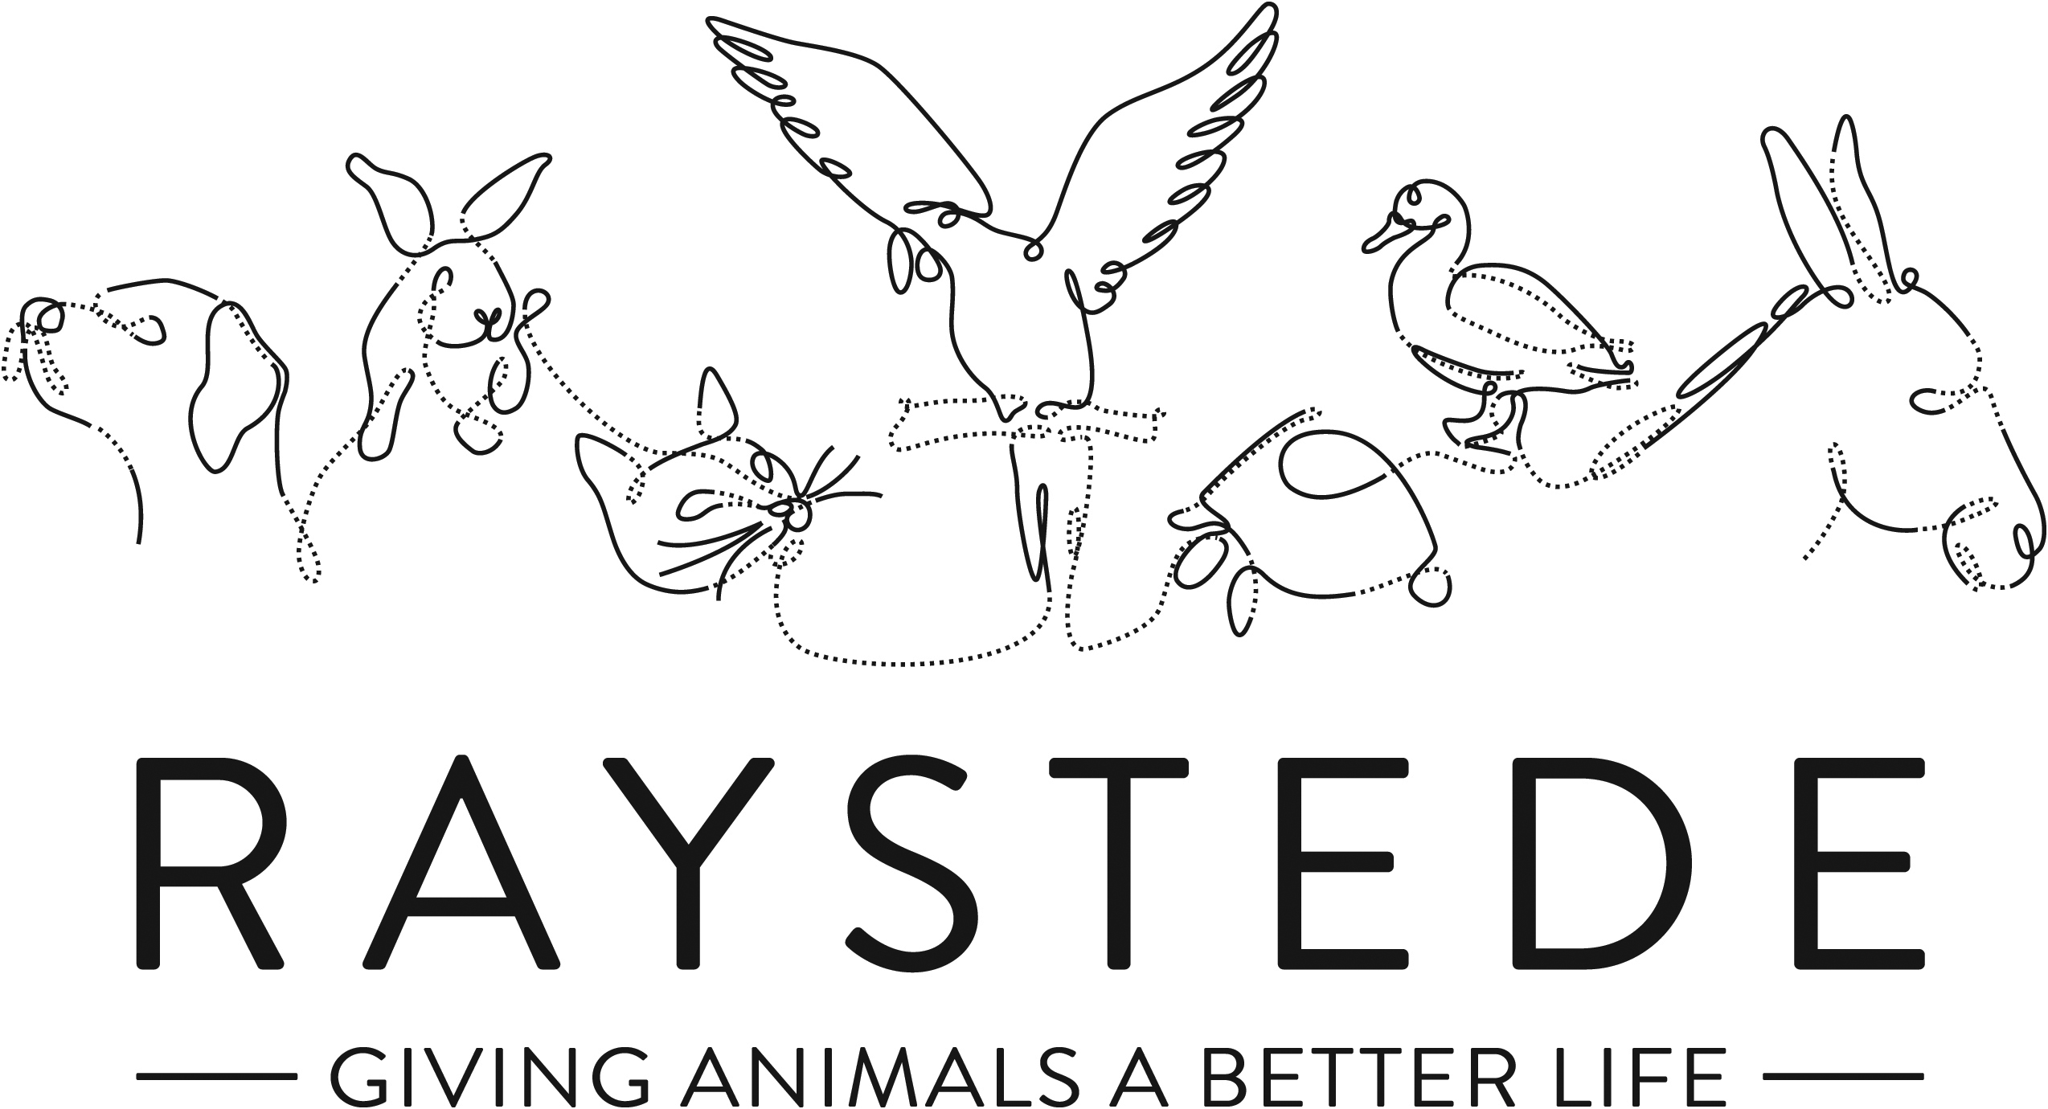
Raystede Centre for Animal Welfare

Job Description

Job Title: | Veterinary Surgeon
Responsible to: | Head of Animal Welfare
Location: | Raystede Centre for Animal Welfare
Hours of work: | 32 hours per week over four days
Holidays: | 26.5 days per year including bank holidays
Probationary period: | 6 months
Contract Type: | Permanent
Salary: | Circa £50,000 pro rata

Background Information

Raystede Centre for Animal Welfare, established in 1952, is a charity that aims to give animals a better life through rehoming, rehabilitation and sanctuary, and give people the support and knowledge they need to treat animals with care and respect. We care for more than 400 animals every day, including cats, horses, dogs, rabbits, hens, and exotic birds. We help most of the animals find new homes but also provide life-long sanctuary for those animals that cannot be rehomed. Our beautiful 43-acre site is open for visitors to get a unique glimpse into a working animal welfare centre.
Animals are at the heart of everything we do but we could not care for them without our expert and dedicated team of staff and volunteers. Surrounded by animals, lakes, trees and fields with a café, shops, parking and many other benefits, Raystede is an uplifting and rewarding place to work.

The Surgery team is responsible for all aspects of managing and running the on-site surgery. It provides the highest standards of animal care and welfare for the animals. The Surgery team forms a key part of our animal welfare service.

Main Purpose of the Role:

- To ensure the effective operation of the veterinary clinic within its position in the wider organisation. This includes being responsible for all veterinary and pharmaceutical registrations including those for the premises.
- To be responsible for the day to day running of the veterinary clinic and provide veterinary care including performance of surgery to support of a range of small animal species including aviary birds and chelonia.
- Apply shelter medicine principles in line with Raystede policies and procedures.
- Performance of on-site laboratory work.
- Line-manage a veterinary nurse to support the role as well as any other resources that may work within the Surgery such as work experience students, or volunteers.
- Provide advice to the Chief Executive, senior management team, and animal care managers on a range of animal welfare issues as required.

Key Tasks

- Provide veterinary care
  - Apply shelter medicine principles in line with Raystede policies and procedures.
  - Infectious disease control.
  - Carry out examinations, vaccinations, treatment, surgical procedures, dental work, imaging, and other veterinary procedures as necessary.
  - Make decisions to ensure the best welfare outcomes for both individual and groups of animals on site when required.
  - Anaesthesia – apply, monitor, and document anaesthesia.
  - Ensure appropriate post operative care.
  - Stabilising and making animals fit to rehome as soon as is practically possible.
  - Euthanasia of animals where it is deemed necessary and agreed as per internal processes.
  - Ensure that all findings and recommendations are communicated to Animal Section Manager and other resources as necessary to ensure the welfare of animals.
  - Clean, disinfect and maintain to a standard of cleanliness and biosecurity all isolation units, surgical areas, stores, and treatment facilities.
  - Control and restraint of animals.
  - Organising and providing veterinary care to animals rehomed by Raystede when care has not been discharged prior to rehoming, and for occasional external clients assessed in line with Raystede’s external welfare policy.
  - Respond to queries from animal carers, the public, wider organisational staff, and volunteers on any relevant matter if necessary.
  - Recognise, report, and record any unusual activity or abnormal behaviour of animals.
- Surgery management
  - Responsible for managing the clinic, its staff, and all necessary registrations following VMD inspection standards with appropriate records maintained and all paperwork dealt with effectively and efficiently.
  - To ensure the correct ordering, prescription, dispensing, handling, storage, stock control, disposal, recording and auditing of Veterinary Medicinal Products (POM-V, POM-VPS, NFA-VPS, AVM-GSL and human-licensed products according to the cascade), in line with legislation and best practice.
  - Responsible for ensuring that any necessary or requested inspections, such as those of the VMD, are carried out as required and that the organisation remains compliant at all times.
  - To act as Raystede’s Radiation Protection Supervisor and undertake all duties in relation to this role.
  - To ensure that all case reports are documented on the medical record (date, history, details of examination, investigations, provisional diagnosis and treatments, prescriptions, lab results, and clinical notes from animals seen off site e.g. referrals or out of hours), communicated to the animal care teams, and information provided for prospective owners.
  - To organise and liaise with suitable out of hours veterinary providers to ensure continued service to Raystede’s animals.
  - To ensure appropriate use of equipment by suitably trained individuals, and to ensure adequate maintenance and servicing of all equipment in the veterinary surgery.
  - Ensure the agreed Surgery budget is adhered to where possible, contribute to the determination of the Surgery budget, and ensure cost savings are achieved where possible.
  - To work with Health and Safety and Estates departments on all relevant issues pertaining to the veterinary clinic to ensure the health and safety of all staff and visitors and to keep appropriate records up to date.
  - To ensure laboratory samples are taken, handled, and posted appropriately by trained individuals and to ensure in-house tests are run safely and appropriately by trained individuals and equipment is suitably maintained and assurance safety tests performed.
  - To ensure appropriate disposal of all waste produced by the veterinary clinic, including pharmaceutical, hazardous, and non-hazardous waste.
  - To comply with the RCVS Guide to Professional Conduct including ensuring appropriate CPD is organised, undertaken, and recorded for all permanent Surgery staff.
  - To ensure that veterinary cover for all scheduled absences (Vet and VN) has been suitably organised, that appropriate induction and support is given to locums, and that all work is up to date prior to scheduled absences.
  - To write copy, provide clinic data, and undertake research projects as directed by the Head of Animal Welfare.
  - Welcome, receive, and care for visitors who are returning to the veterinary clinic on site.
  - Liaise with colleagues in other departments to ensure accurate, timely, and relevant information is disseminated.
  - Organise and promote veterinary events such as vaccination, microchipping, or neutering days.
  - General administration duties associated with management of a veterinary clinic.
- Personal development
  - To comply with all sections of the RCVS Guide to Professional Conduct including ensuring appropriate CPD is organised, undertaken, and recorded.
  - Establish and maintain effective working relationships and good working practices with colleagues, volunteers, and contractors.
- Physical requirements
  - Exposure to disinfectant solutions for cleaning.
  - Potential exposure to animal bites and scratches.
  - Continual exposure to animals and animal allergens.
  - Ability to work with animals of all sizes including some in excess of 900kg.
- Contribute to fundraising, educational and commercial activities
  - Assist with Educational talks, tours, and activities.
  - Contribute to and attend fundraising and commercial events.
  - Actively promote Raystede services on-site.
- Other
  - Expected to deal with often harrowing animal welfare issues.
  - Maintain to a standard of cleanliness set by management all offices, staff facilities including toilets within your section.
  - Ensure buildings, exercise areas, and all other facilities as appropriate, are secure at all times.
- General
  - At all times ensure and maintain a compassionate, professional and efficient public image for the charity
  - Participate in supervision, appraisal, and learning and development and take personal responsibility for maintaining the knowledge and skills required for the role
  - Take responsibility for ensuring own health and safety and that of others who may be affected by your acts and omissions. Report any health and safety risks to your manager.
  - Work within the policy framework of Raystede Animal Centre and adhere to the terms laid out in the employee handbook

Key Working Relationships

- All animal care teams including Rehoming to ensure effective running of the veterinary service and collaborative team working on site.
- General public to arrange external veterinary appointments and provide updates when owned or fostered animals are in our care. Also to provide information and guidance on Raystede and its activities.
- External veterinary services to enable out of hours and specialist veterinary care where applicable.
- Specialist external groups, bodies, and organisations to further veterinary knowledge and care at Raystede, and to promote our reputation.
- The Chief Executive and senior management team to advise on animal welfare matters.
- All other departments within Raystede to assist with and facilitate the successful and efficient operation of Raystede and its services.

Scope and Accountability

Decision making and limits of authority | - Decisions must be taken about how best to support the welfare of animals in veterinary care and undergoing treatment.  - There is a £2500 financial limit in this role.
Financial resources | - Responsible for spending in accordance with the agreed Surgery budget which the postholder will contribute to the determination of.  - Responsible for the efficient running of the Surgery achieving cost savings where possible.
Material assets | - Responsible for ensuring the cleanliness, maintenance, serviceability, and security of all departmental as well as wider assets where necessary.  - Responsible for reporting issues and defects with material assets, equipment, buildings, fixtures, and fittings to line manager or Estates team when recognised.  - Expected to manage stock within the veterinary surgery and order supplies as necessary.
Information and communication resources | - Expected to use the Anilog database and other departmental filing systems.  - Responsible for using databases and filing systems in a secure manner compliant with all applicable data protection legislation.
People management | - Line management of any veterinary nurse working within the practice.  - Management of agency and/or locum veterinary staff as necessary.  - Oversight of animal care staff assisting in the veterinary surgery.  - Occasional management of volunteers and/or students.  - Oversight of contractors working within veterinary surgery as required.
Legal, regulatory and compliance responsibility | - Responsible for ensuring the full legal and regulatory compliance of the Surgery.  - Responsible for ensuring all tasks carried out are done so in accordance with applicable animal welfare legislation and regulations.  - Responsible for ensuring own health and safety following set procedures and using equipment provided.

Person Specification

 | Essential | Desirable
Education and Qualifications | - Full driving licence.  - Fully qualified veterinary surgeon and current registered member of the RCVS to practice as a veterinary surgeon in the UK. | - Advanced veterinary qualifications.  - Further qualifications in Animal Care.  - Extensive small animals experience including rabbits.  - Exotic bird specialisation.
Knowledge and Experience | - Sound, current knowledge of veterinary medicine, surgery, behaviour, animal welfare, and veterinary medicines legislation.  - At least five years’ experience in small animal practice.  - Working with members of the public or within a visitor environment.  - Experienced with the application and monitoring of anaesthesia.  - Surgical experience.  - Competence and experience of disciplines including soft tissue surgery, diagnostic imaging, and clinical pathology.  - Experience of handling commonly domesticated small animal species.  - Evidence of care and welfare of animals.  - Proven application of sound and effective customer care skills.  - Administrative skills including confidence using IT. | - Understanding of shelter medicine.  - Experience of further veterinary disciplines such as orthopaedic surgery, ophthalmology, or cardiology.  - Experience of working independently within a veterinary practice.  - Experience of conducting surgery without an extensive support team.  - Knowledge of veterinary practice management requirements.  - Experience in an animal welfare environment.  - Experience of dealing with difficult and emotional animal welfare situations.  - Experience of handling exotic animals including bird and chelonia.  - Experience of exposure to unpleasant odours and noises.  - Research experience.  - Knowledge of health and safety issues.  - Charity fund raising e.g. on/off-site events.
Key Skills and Abilities | - Proven communication skills, written and oral.  - Administrative skills including confident use of IT.  - Ability to work within a diverse team and build excellent working relationships.  - Ability to manage personal deadlines and prioritise a demanding workload.  - Ability to manage relationships with tact and diplomacy.  - Excellent attention to detail. | - Management or supervisory skills.  - Use of Microsoft Office programs including Excel, Word, and PowerPoint.
Personal Attributes | - Empathetic to the aims and objectives of Raystede.  - Personable, sociable and people oriented empathetic to other professionals, staff, volunteers, and the public.  - Proactive and self-motivated with the ability to think creatively.  - A positive outlook and a “can do” attitude.  - Dedication, commitment, and tenacity.  - Change orientated approach to work.  - Ability to make decisions when dealing with often constant and conflicting demands on time.  - Highly committed and able to work flexibly to achieve performance targets.  - Able to assist the wider team when required taking a flexible approach to occasionally unplanned organisational demands.  - Commitment to equality, diversity and inclusion and understanding of how it applies to own role.  - Empathy and interest in animals and their welfare. | - Keen to maintain an awareness of animal welfare issues.
Other | - To have a flexible approach to working hours.  - Availability of vehicle for work use and in possession of a current, clean driving licence.  - Flexibility of circumstances and willingness to visit national and regional venues for CPD. This may involve some overnight stays and occasional work in the evenings and at weekends.

