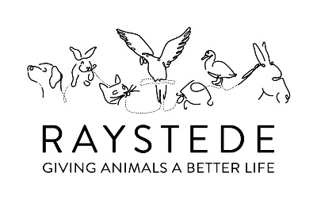
Raystede Learning

Enquiry Form

Name:

School/ group/organisation name (if applicable):

Contact email address:

Contact phone number:

Which of the Raystede education services are you interested in? Please note this is an enquiry form only, we will be in touch to discuss your booking.
Hosted visit
Guided tour
Activity pack
Outreach
Animal carer for a day

Which (if any) are your preferred date(s)?

Any additional information:

Please send this form to education@raystede.org and a member of the education team will be in touch shortly

