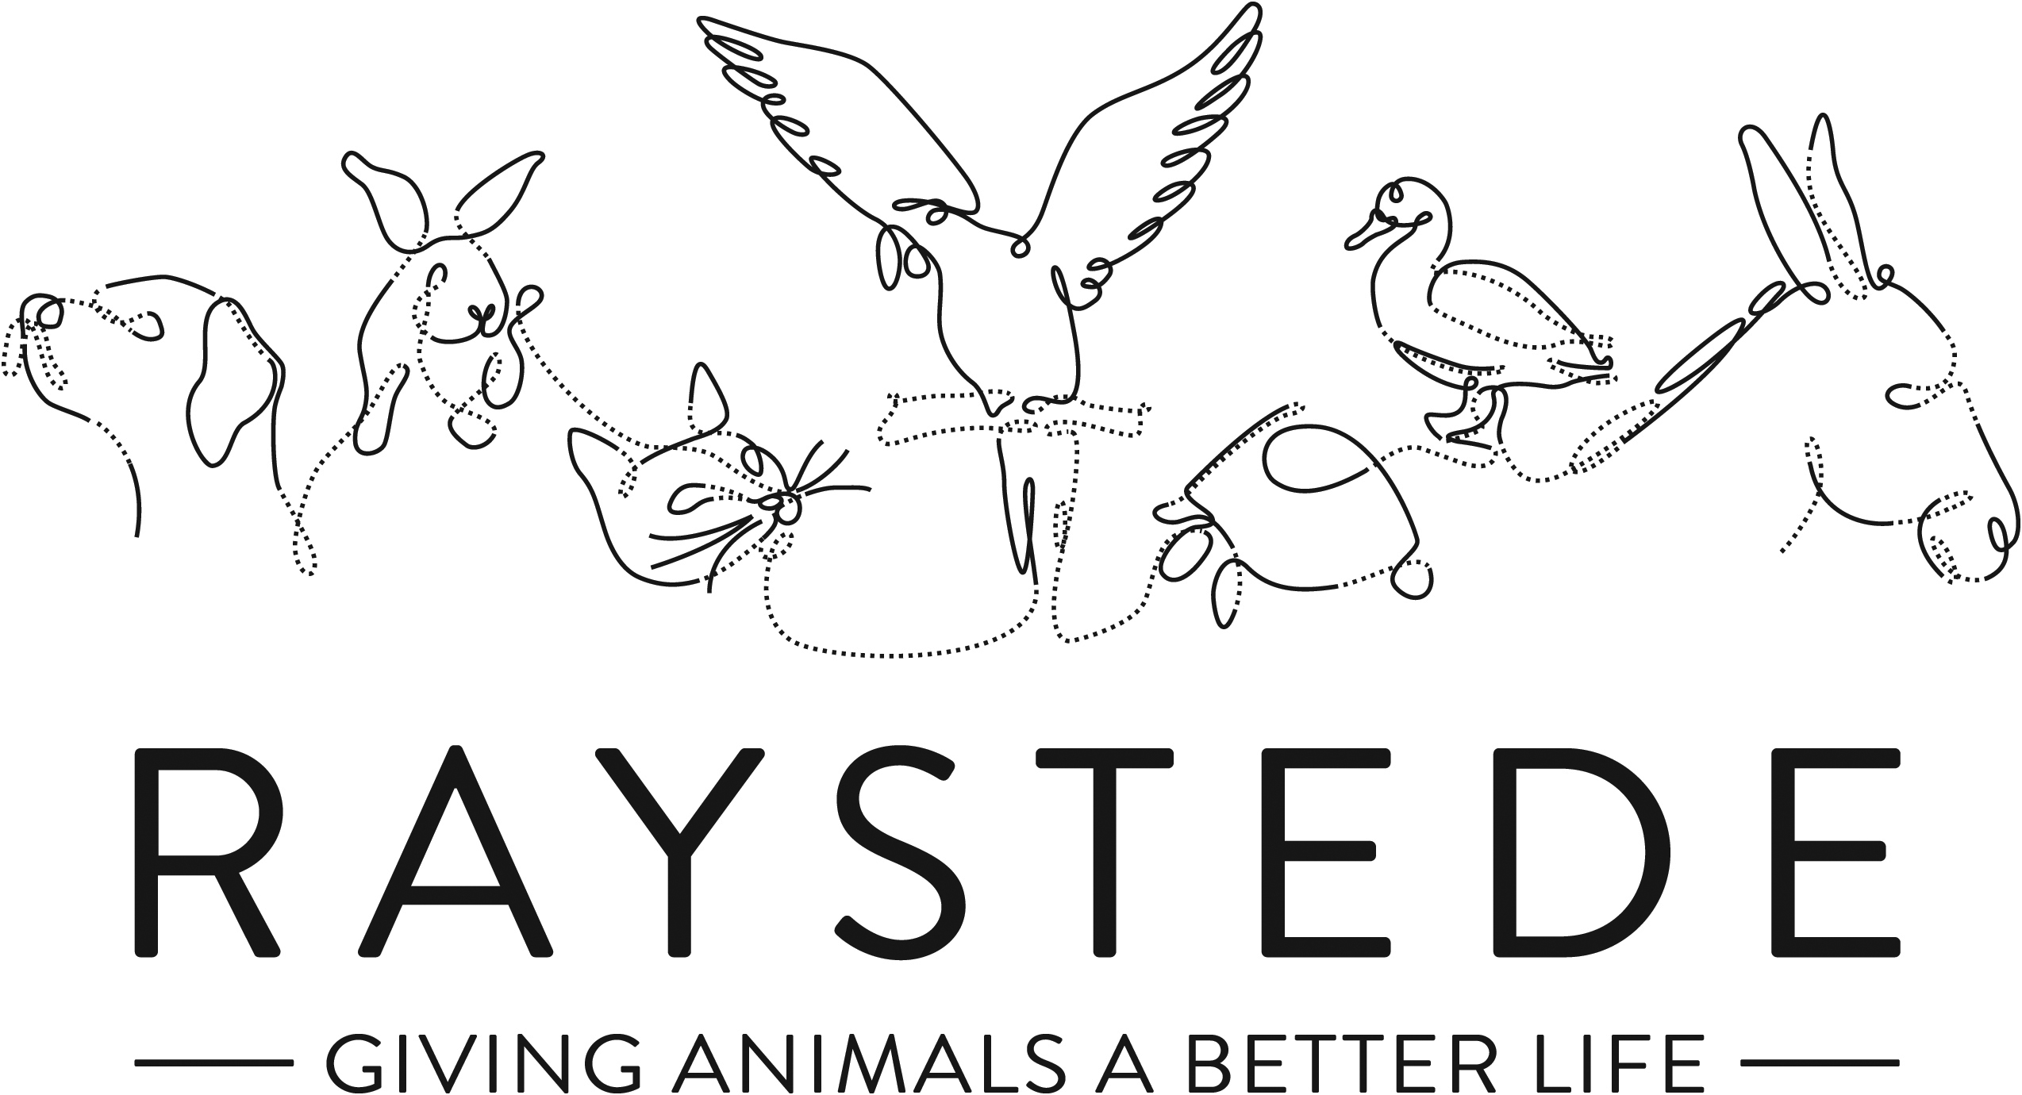
Raystede Centre for Animal Welfare

Job Description

Job Title: | Café Assistant
Responsible to: | Café Manager
Location: | Raystede Centre for Animal Welfare, The Broyle, Ringmer, East Sussex
Hours of work: | Various shifts, over 7-day trading
Holidays: | Pro rata 30 days per year including bank holidays.
Probationary period: | n/a
Contract Type: | Zero hours
Grade and Salary: | National Living Wage

Background information

Raystede Centre for Animal Welfare, established in 1952, is a charity that aims to give animals a better life through rehoming, rehabilitation and sanctuary, and give people the support and knowledge they need to treat animals with care and respect. We care for more than 400 animals every day, including cats, horses, dogs, rabbits, hens and exotic birds. We help most of the animals find new homes but also provide life-long sanctuary for those animals that cannot be rehomed. Our beautiful 43-acre site is open for visitors to get a unique glimpse into a working animal welfare centre.
Animals are at the heart of everything we do but we could not care for them without our expert and dedicated team of staff and volunteers. Surrounded by animals, lakes, trees and fields with a café, shops, parking and many other benefits, Raystede is an uplifting and rewarding place to work.

The café team are part of the Commercial and Visitor Operations department. Upholding high standards and a friendly caring approach we offer a broad range of food and drink to visitors onsite. Every penny of our profits go directly into helping the animals in Raystede’s care.

Main Purpose of the role:
To ensure customers’ expectations of all food, beverages and customer service are exceeded. This may include, but not limited to any aspect of the café operation including service, food preparation, cleaning, health and safety, along with any other reasonable task to be undertaken.
To maintain consistently high standards throughout the café and kitchen as directed by the manager or supervisor. To be aware of all allergens and dietary requirements and understand how to seek advice or clarification when needed.

Key Tasks
- Cafe Operations
  - Welcome, receive and care for visitors within Cafe
  - To deliver excellent customer service ensuring a positive experience for all customers
  - Take food and drink orders at the takeaway order point and through table service
  - Operating the till, maintaining accuracy with orders and payments
  - Accurate cash handling
  - Reprioritise tasks as service demands; is takeaway window vs table service / coffee machine vs till / cleaning spillages / seating new customers
  - Quick ticket food preparation to set menu items (kitchen staff only)
  - Cleaning the kitchen and café area to standards set by manager and supervisor
  - Preparing orders ready for service – drinks, cold food, pre-prepared food
  - Preparing coffees using the barista skills acquired in training
  - Courteous service of orders, ensuring customer is happy receives 1st class customer service
  - Being aware of customers and their needs
  - Clearing tables and cleaning ahead of next customer
  - Washing up and maintaining constant availability of clean crockery, cups and cutlery
  - Restocking fridges at end of each shift, alerting manager of anything running short in supply
  - Being aware of stock rotation and dates to minimise waste
  - Ensuring that the café environment is pleasant and welcoming

General
At all times ensure and maintain a compassionate, professional and efficient public image for the charity
  - Participate in supervision, appraisal, and learning and development and take personal responsibility for maintaining the knowledge and skills required for the role
  - Take responsibility for ensuring own health and safety and that of others who may be affected by your acts and omissions. Report any health and safety risks to your manager.
  - Work within the policy framework of Raystede Animal Centre and adhere to the terms laid out in the employee handbook

Key Working Relationships
General public, giving people the best experience in our café through excellent customer service
Colleagues, team working is essential
Commercial team, being part of a bigger team to maximise efficiencies and share best practice

Scope and Accountability

Decision making and limits of authority | - Daily modification of procedures, within H&S parameters, to ensure consistent positive service  - Defer to café manager, another commercial manager, or Head of Commercial for anything over and above normal daily tasks and service
Financial resources | - Accurate cash-handling and till operation
Material assets | - Accurate stock selection for orders and date rotation to minimize waste.
Information and communication resources | - None
People management | - None
Legal, regulatory and compliance responsibility | - Ensure all H&S instructions are followed at all times  - Adhere to all hygiene procedures  - Be aware of allergens and how to advise customers

Person Specification

 | Essential | Desirable
Education and Qualifications | - Good standard of English and Maths  - Food Hygiene level 2
Knowledge and Experience | - Well organised and able to work in a tidy manner  - Ability to work effectively within a team  - Good communication skills, ability to positively interact with different groups of people, both internal and external customers | - Experience of working in a café or retail environment  - Understanding of different diets, specifically vegetarian and vegan  - Basic H&S knowledge
Key Skills and Abilities | - Proven communication skills, written and oral.  - Ability to prioritise and multi-task  - Ability to reprioritise to ensure successful outcomes  - Excellent attention to detail. | - Basic cleaning skills
Personal Attributes | - Personal, sociable and people orientated  - Commitment to equality, diversity and inclusion and understanding of how it applies to own role  - Empathy and interest in animals and their welfare  - High standards of personal hygiene
Other | - To have a flexible approach to working hours.

