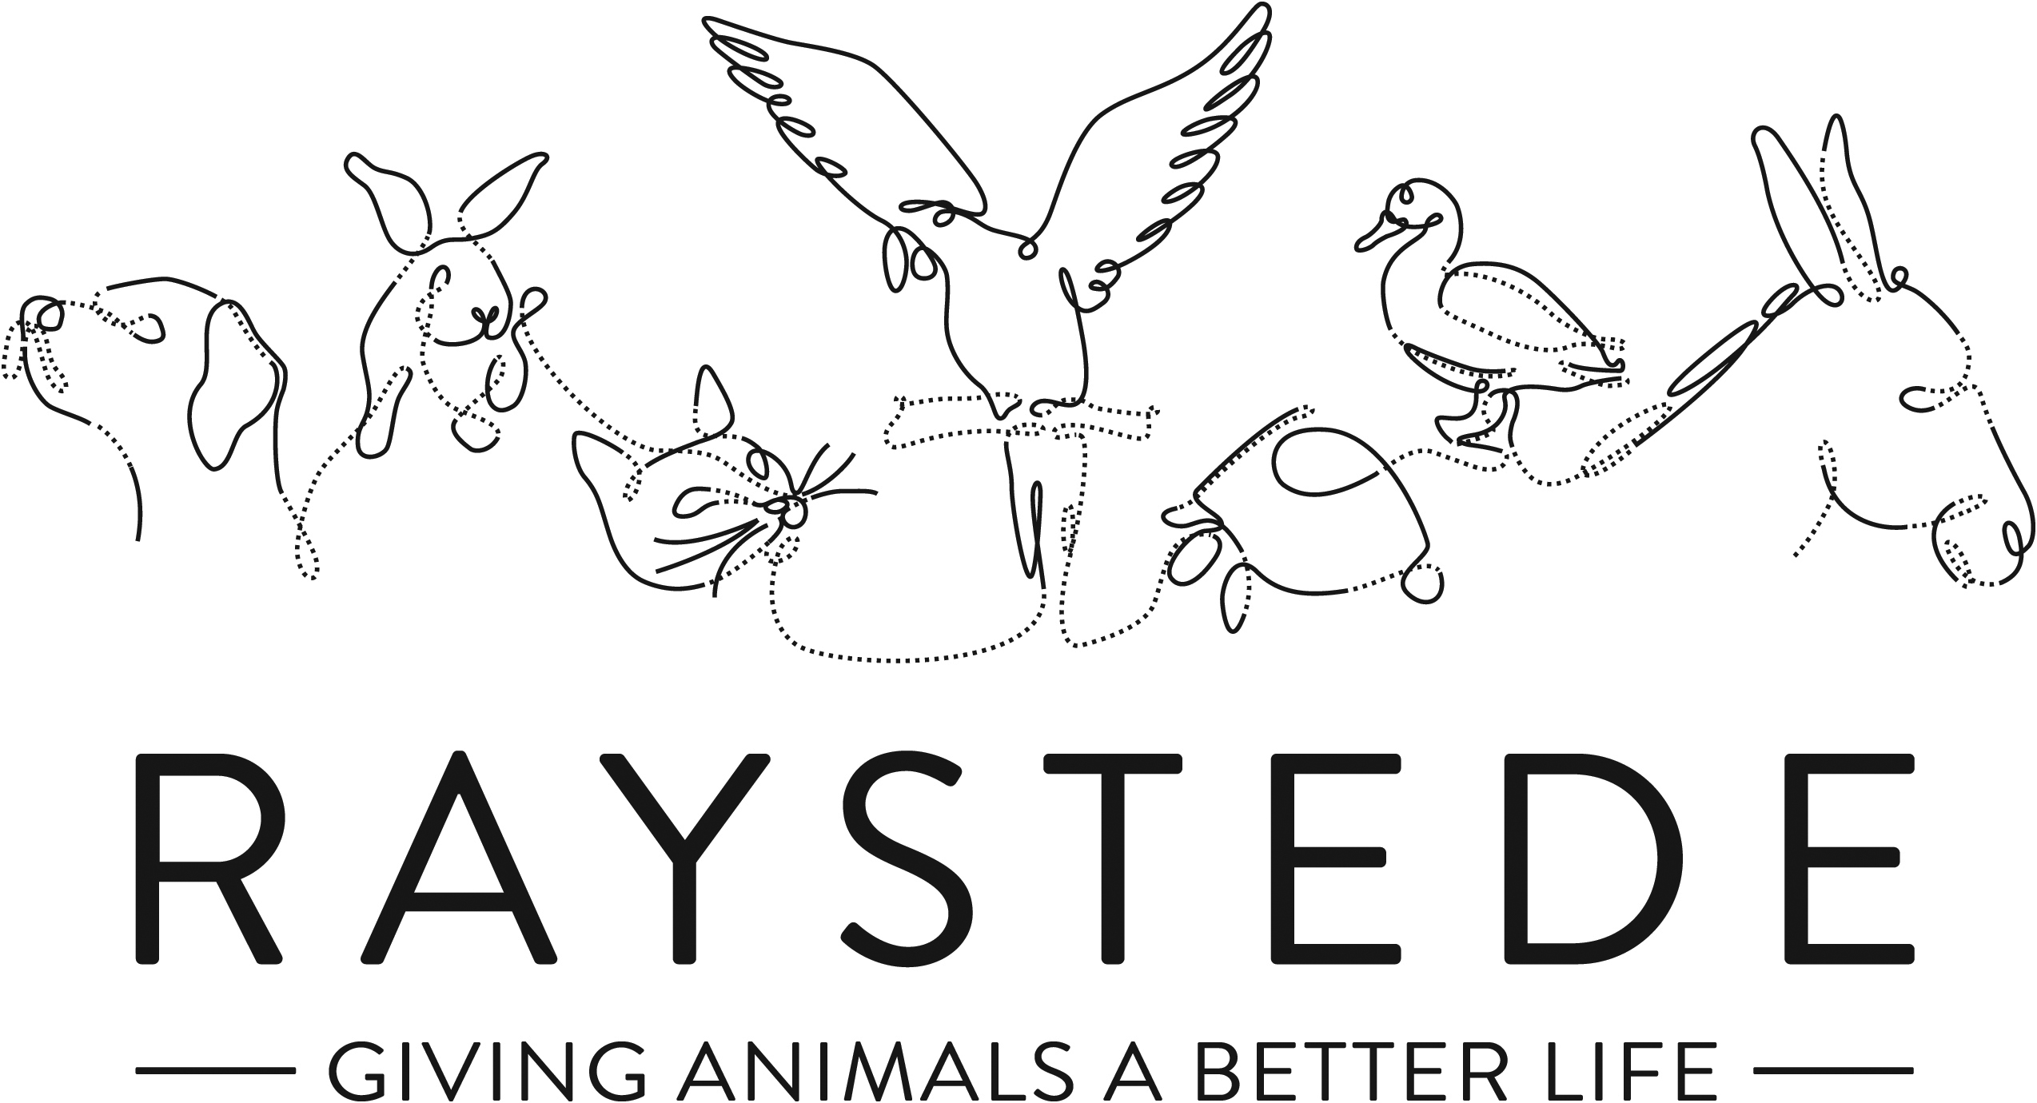
Raystede Centre for Animal Welfare

Job Description

Job Title: | Part time Cook
Responsible to: | Café manager / Head Cook
Location: | Raystede Centre for Animal Welfare
Hours of work: | 24 hours a week – inc. Alternate weekends
Holidays: | 30 days per year including bank holidays pro rata per annum
Probationary period: | 3 months
Contract Type: | Permanent
Grade and Salary: | £11,856 actual

Background information

Raystede Centre for Animal Welfare, established in 1952, is a charity that aims to give animals a better life through rehoming, rehabilitation and sanctuary, and give people the support and knowledge they need to treat animals with care and respect. We care for more than 400 animals every day, including cats, horses, dogs, rabbits, hens and exotic birds. We help most of the animals find new homes but also provide life-long sanctuary for those animals that cannot be rehomed. Our beautiful 43 acre site is open for visitors to get a unique glimpse into a working animal welfare centre.
Animals are at the heart of everything we do but we could not care for them without our expert and dedicated team of staff and volunteers. Surrounded by animals, lakes, trees and fields with a café, shops, parking and many other benefits, Raystede is an uplifting and rewarding place to work.

The café team are part of the Commercial and Visitor Operations department. Upholding high standards and a friendly caring approach we offer a broad range of food and drink to visitors onsite. Every penny of our profits go directly into helping the animals in Raystede’s care.

Main Purpose of the role:
To operate the kitchen in an efficient and effective way to agreed standards. Support and liaise with the Manager to maintain consistently high standards throughout the café and kitchen, including food preparation, cleaning and H & S. To maximise margins and produce varied, profitable and time-efficient menu while also making as much on site as possible. To be fully aware of all allergens and dietary requirements and produce a menu reflective of this.
Be positive about future change, be aware of the need to be conscious of using resources at Raystede and contribute to a one team feel at Raystede.

Key Tasks
To take day to day responsibility for operating the café kitchen on head cook days, weekends off
- To deliver the agreed menu
- To brief the café manager at regular agreed intervals (and immediately if urgent) on progress in the kitchen.
- To propose action to them for improvements in operations.
- Ensure consistency in standards are met in the kitchen at all times
- Provide and deliver a varied and extensive vegetarian and vegan specials menu which is available at all times
- Liaise with front of house on specials/ allergens/ dietary requirements
- To maintain an awareness of developments in local cafes
- To maintain an awareness of the work of Raystede and relevant local or national issues through press, media, and local views.

Stock management
Effective management of stock including with ability to maintain a well organised stockroom and minimising waste
- To maintain and deliver agreed portion size and control
- To meet display and presentation standards.
- To contribute to stock density and rotation.
- Ensure the full menu is available at all times whilst also being mindful of wastage
- To maximise on ingredients and stock, creating daily specials to add value to the menu and minimize waste

Staff
- To provide adequate supervision for the kitchen team when required
- Ensure hand overs are thorough between head cook and cook between shifts

Premises, security and safety
- To ensure all hygiene rules are adhered to with daily regimes implemented and monitored
- To ensure all café equipment is kept in good working order
- To request any necessary repairs and maintenance; to inform café manager if costs exceed agreed amount.
- To apply company Health & Safety regulations in accordance with guidelines by:
  - Maintaining Health & Safety records; general plus catering specific such as:
    - Temperature checks on deliveries and cold storage units
    - Temperature checks on cooked foods
    - Made on and use by dates
  - Undertaking required fire drills.
  - Implementing risk assessment procedures
  - To ensure that health and safety procedures are understood and implemented by all staff.
- To be fully aware of allergens complying with all relevant legislation and ensuring all staff are trained and able to communicate clearly any allergen in our menus

Physical requirements
- Frequent bending, lifting, reaching, kneeling, walking, and standing for 6 hours or more per day.
- Exposure to degreasers, sanitising and disinfectant solutions for cleaning.
- Exposure to heat; general cooking environment plus fryers
- Exposure to excessive heat and oil for daily cleaning of fryers

General
At all times ensure and maintain a compassionate, professional and efficient public image for the charity
  - Participate in supervision, appraisal, and learning and development and take personal responsibility for maintaining the knowledge and skills required for the role
  - Take responsibility for ensuring own health and safety and that of others who may be affected by your acts and omissions. Report any health and safety risks to your manager.
  - Work within the policy framework of Raystede Animal Centre and adhere to the terms laid out in the employee handbook

Key Working Relationships
General public, giving people the best experience in our café through excellent customer service
Colleagues, team working is essential
Commercial team, being part of a bigger team to maximise efficiencies and share best practice

Scope and Accountability

Decision making and limits of authority | - Adhere to all relevant catering hygiene and safety rules  - Advise on the operational needs to ensure smooth running of the kitchen  - Defer to café manager, another commercial manager, or Head of Commercial for anything over and above
Financial resources | - None
Material assets | - Accurate stock control and date rotation to minimize waste.
Information and communication resources | - None
People management | - None
Legal, regulatory and compliance responsibility | - Ensure H&S records are accurate and legally compliant  - Ensure the café retains level 5 rating with EHO by adhering to all hygiene procedures and therefore always ready for inspection  - Ensure full compliance with allergen laws, including but not limited to Natasha’s Law

Person Specification

 | Essential | Desirable
Education and Qualifications | - Good standard of English and Maths  - Food Hygiene level 3
Knowledge and Experience | - 5 years experience of working within a commercial kitchen environment  - Good knowledge of vegetarian/ vegan food  - Ability to work well under pressure and manage multi-ticket ordering  - Experience of stock handling including date rotation and maintaining cold chain (keeping appropriate records)  - Positive and supportive of new ideas and processes that help service and offer, looking to continually improve.  - Well organised and able to work in a tidy manner  - Ability to consistently prepare food to a high standard  - Ability to work effectively within a team  - Good communication skills, ability to positively interact with different groups of people, both internal and external customers  - High standards of personal hygiene  - Knowledge of health and safety best practice.  Good understanding of sales margin and cost management.
Key Skills and Abilities | • Proven communication skills, written and oral.  • Ability to prioritise and multi-task  • Excellent attention to detail.
Personal Attributes | - Personal, sociable and people orientated  - Commitment to equality, diversity and inclusion and understanding of how it applies to own role  - Empathy and interest in animals and their welfare
Other | • To have a flexible approach to working hours.

