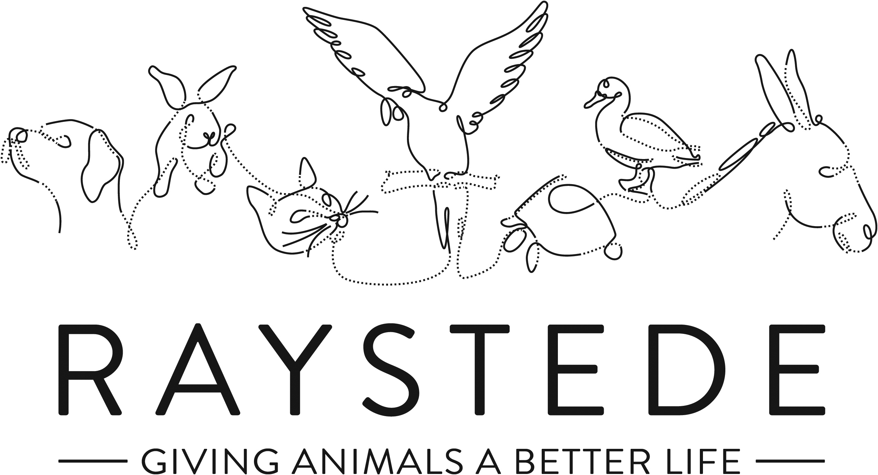
Raystede Centre for Animal Welfare

Job Description

Job Title: | Fundraising Partnerships Manager
Responsible to: | Head of Fundraising
Location: | Raystede Animal Welfare Centre, with option for hybrid remote working
Hours of work: | 37.5 hours per week worked flexibly within the needs of the business. Some evenings and weekend work may be required.
Holidays: | 28 days per year including bank holidays
Probationary period: | 6 months
Contract Type: | Permanent
Grade and Salary: | £28,000-£32,000

Background information

Raystede Centre for Animal Welfare was established as a charity in 1952. We now have a 43- acre site and we care for over 2,000 animals each year, rehoming 1,000 animals per year and providing sanctuary to even more. We are one of the most diverse rescue centres in the UK because we care for so many different species of animals. Our services and activities include the Peaceways pet crematorium, our teams of veterinary and animal care staff, education & learning activities and our commercial and visitor operations.

The Fundraising team generates income for Raystede through donations, legacies, events and many other sources and activities. The Fundraising Partnerships Manager is responsible for leading the Partnerships Team to develop innovative funding proposals, partnerships and financial support with Corporate supporters, major donors and Trusts.

Main Purpose of the role:
- Lead and develop the Partnerships Team, setting ambitious targets and goals.
- To secure financial and in-kind support from the corporate sector, major donors, Trusts and Foundations.
- Develop innovative funding proposals, packages, case for support and price points.
- Develop strategies for major giving, corporate partnerships and Trusts fundraising.
- Personally manage a selection of key fundraising relationships for Raystede.

Key Tasks

Strategy and Development
- Develop a long-term strategy to significantly grow income through corporate partnerships, major donors and Trusts, building lasting partnerships and enhancing the profile and reputation of the charity.
- Provide regular management reports, updates and reforecasts on these plans throughout the year.
- Leading the Fundraising Partnership Team to develop a strong fundraising programme and partnership opportunities for corporate supporters, major and mid-value donors.
- Set budgets and targets for the team. Develop and manage a number of meaningful and achievable KPIs for your team.
- Lead the development of a major donor, Trusts and corporate partner stewardship programme, including cultivation events.
- Responsible for an ambitious income and expenditure target for Corporates, major donors and Trusts.
- Working with key staff across the organisation, including the animal welfare and education teams, to develop innovative funding proposals, packages and price points to solicit capital, project and revenue funding.
- Work with the Marketing Team to develop marketing and promotional materials to support fundraising plans and campaigns.
Line Management
- Manage a small team of Major Donor, Corporate and Trust specialist staff.
- Provide excellent line management, mentoring and development support to the team. Support and motivate individual and team development and performance.
- Work with other fundraising managers and departments to work collaboratively putting the donor and animals at the front of everything we do.
- Working alongside senior staff, the CEO and Trustees you will play an integral part in identifying key donors, researching and matching them to our projects prior to organising peer to peer fundraising approaches.
- Ensure that the team meet income and performance targets and are able to achieve KPIs.

Major Donor, Corporate Partnerships and Trusts fundraising
- Lead the team to manage and develop new and existing relationships with a portfolio of individual donors capable of giving at a high/medium level.
- Develop a major donor stewardship programme including stewardship and cultivation events.
- Work alongside senior staff and Trustees to identify key donors and organise peer to peer fundraising approaches.
- Lead the team to research and develop the Trusts Pipeline, identify and network with key Trustees and match to funding projects.
- Lead the team to develop a corporate fundraising plan, including a range of corporate fundraising, employee engagement and volunteering products. Ensure the plans are well executed and promoted.
- Develop key corporate partnerships, sponsorship opportunities and charity of the year fundraising.
- Ensure that all fundraising activities are safe, legal and meet the Institute of Fundraising Code of Practice.
- Working with key staff across the organisation to develop innovative funding proposals, packages and price points to solicit both capital and revenue funding.
- Personally manage and develop a selection of key major donor and corporate relationships
- Ensure that policies and procedures are in place so that excellent record keeping, tracking relationships and income is achieved. Facilitate good reporting and data-led decision making.

General
- At all times ensure and maintain a compassionate, professional and efficient public image for the charity.
- Participate in supervision, appraisal, and learning and development and take personal responsibility for maintaining the knowledge and skills required for the role.
- Take responsibility for ensuring own health and safety and that of others who may be affected by your acts and omissions. Report any health and safety risks to your manager.
- Work within the policy framework of Raystede Animal Centre and adhere to the terms laid out in the employee handbook.
- To support the wider aims of the charity and from time-to-time carry out other general duties as may reasonably be required by the Head of Fundraising and/or Chief Executive.

Key Working Relationships

The Partnerships Team – provide excellent line management, mentoring, training and development to the team ensuring they have everything they need to achieve the organisation’s goals.

CEO and Senior Management Team – work closely with the CEO and Senior Management Team to identify key supporters and initiate peer to peer fundraising opportunities. Provide excellent briefing and background information.

Trustees, Honorary Officers – relationship building and networking at the highest level. Able to network, negotiate and influence at all levels, specifically focussing on influential networks in Sussex

Major Donors, Corporates and Trusts – proactively network and build relationships to represent Raystede at the highest level. Be a point of escalation to resolve complaints or concerns. Manage more complex or significant partnerships or relationships.

Fundraising Team – work with the fundraising team to ensure that cross-team fundraising and opportunities are supported and ensure that strategies and plans are in line with the wider fundraising teams goals.

Marketing – work closely with the marketing team to ensure that the team’s activities are planned, marketed and evaluated. Resolve conflicting demands.

Animal Welfare and Education Team – work closely with the team to develop an understanding of potential funding projects, set and gather impact reports, develop case studies and initiate exclusive behind the scenes tours and insights.

Suppliers – manage a small selection of suppliers. Ensure that they are selected in line with the organisation’s policy and are well managed and able to deliver against contract.

Finance, IT and Database Fundraising Manager – work with the finance team, database fundraising manager to agree timely and efficient processes and integrations between the departments to ensure that all Partnership income is coded and banked, thanked and administrated. Ensure that relationships are recorded on the Database.

Scope and Accountability
Decision making and limits of authority | - Recommend a strategy to grow income  - Recommend investment and staffing to achieve significant financial growth (from £100k to £600k), growing the major donor and trust programme and corporate partnerships.  - Make complex decisions, committing to communication, brand, reputational or staffing resource support, whilst meeting high level supporters and managing their expectations.  - Set budgets, targets and KPIs for the team.  - Responsible for managing high profile, senior and influential networks and high value relationships. Able to network at the highest level, including Honorary Officials, Trustee networks, local MPs and officials, CEOs and Directors. Able to make decisions about how to develop relationships with a range of individuals.
Financial resources | - Responsible for an income target of up to £600k per annum and an expenditure budget of up to £50k.  - Responsible for invoices up to £1000
Material assets | - Responsible for fundraising and promotional materials and leaflets, stocks, and supplies
Information and communication resources | - Sign off on Partnership Teams marketing materials and mass communication (more than 20 recipients).  - Responsible for ensuring the teams databases process are agreed with Database Fundraising Manager.
People management | - Line manages up to 5 members of specialist staff  - Line manages up to 5 office volunteers
Legal, regulatory and compliance responsibility | - Ensures that Corporate Volunteering is managed to meet all Health and Safety and Insurance requirements  - Ensure compliance with fundraising regulator, Health & Safety, Insurance, contracts, and Data protection  - Ensure that high level partnerships and in-kind agreements meet our brand and animal welfare standards. Manage potential risk to reputation and complex brand positioning.

Person Specification

 | Essential | Desirable
Education and Qualifications | - Access to car or able to travel around the area | - Member of the Institute of Fundraising.  - Fundraising or Marketing qualification
Knowledge and Experience | - At least 3 years relevant fundraising experience including major giving or Corporate Fundraising or senior business development roles  - Proven track record of meeting targets  - Experience of developing high level partnerships and influencing senior leaders and decision makers  - Understanding of charity related legislation and fundraising codes of practice.  - Experience of good record keeping and administration.  - Empathy for and knowledge of the issues regarding domestic animals in an animal welfare charity. | - Experience at managing a team  - Experience of setting targets and KPIs for others  - Demonstrable experience of developing fundraising strategies  - Knowledge of Sussex, Kent & Surrey, and the local communities.
Key Skills and Abilities | - Strong negotiation and influencing skills.  - Excellent written and presentation skills, communication skills.  - Good financial management skills and ability to interpret and produce financial data.  - Ability to devise new fundraising approaches which can secure both capital and revenue funding  - A thorough understanding of the principles of major donor fundraising and ability to develop and implement new activities.  - Excellent networking skills including online. Able to network at the highest level, including Honorary Officials, Trustee networks, local MPs and officials, CEOs and Directors. Able to make decisions about how to develop relationships with a range of individuals.  - Good at identifying and pursuing opportunities.  - Attention to detail whilst managing multiple projects and deadlines.  - Target and results orientated.  - Good IT skills including CRM databases, and MS Office applications. | - Project management skills
Personal Attributes | - Personable, sociable and people oriented.  - Proactive and self-motivated with the ability to think creatively.  - Empathy and understanding of the love for animals.  - A commitment to equal opportunities and anti-discriminatory practice. | - Pet owner
Other | - To have a flexible approach to working hours.  - Availability of own vehicle for work use and in possession of a current, clean driving licence plus own insurance with cover for business.  - Flexibility of circumstances and willingness to visit national and regional venues for meetings. This may involve some overnight stays and occasional work in the evenings and at weekends.

Raystede Centre for Animal Welfare

Health & Safety Functions

This section is to make you aware of any health & safety related functions you may be expected to either perform or to which may be exposed in relation to the post you are applying for. This information will help you if successful in your application identify any health-related condition which may impact on your ability to perform the job role, enabling us to support you in your employment by way of reasonable adjustments or workplace support.

Using display screen equipment | x
Working with children/vulnerable adults
Moving & handling operations
Vocational driving, driving light goods vehicles, people carrying vehicles or forklift trucks
Lone Working | x
Shift work
Night work | x
Climbing/Working at height
Working with hazardous substances, skin irritants, sensitisers, and/or with biological agents or chemical agents
Working with dangerous machinery
Exposure to noise and /or vibration
Handling animal food
Exposure to blood /body fluids
Providing animal care

