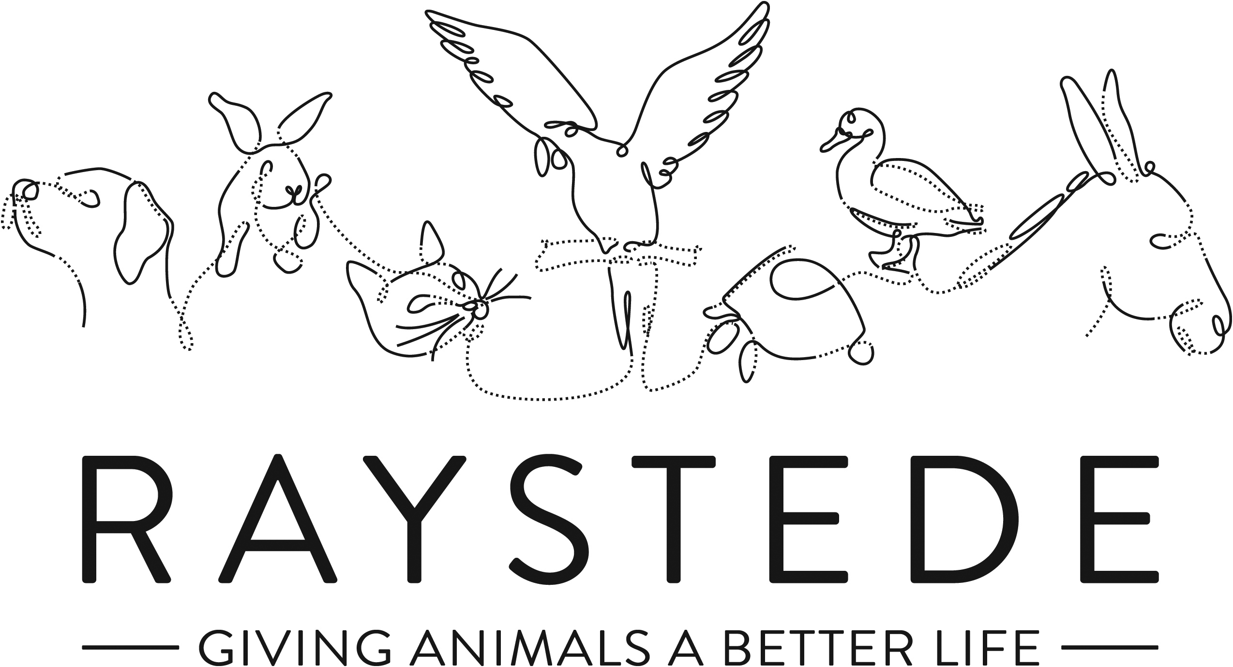
Raystede Centre for Animal Welfare

Job Description

Job Title: | Events and Community Fundraising Manager
Responsible to: | Head of Fundraising
Location: | Raystede Animal Centre, with regular opportunities to work from home
Hours of work: | 37.5 hours a week, including some weekends and evening which will be recompensated by TOIL.
Holidays: | 28 days per year including bank holidays
Probationary period: | 6 months
Contract Type: | Permanent
Grade and Salary: | £28,000 - £32,000 per annum

Background information

Raystede Centre for Animal Welfare, established in 1952, is a charity that aims to give animals a better life through rehoming, rehabilitation and sanctuary, and give people the support and knowledge they need to treat animals with care and respect. We care for more than 400 animals every day, including cats, horses, dogs, rabbits, hens and exotic birds. We help most of the animals find new homes but also provide life-long sanctuary for those animals that cannot be rehomed. Our beautiful 43 acre site is open for visitors to get a unique glimpse into a working animal welfare centre.

Animals are at the heart of everything we do but we could not care for them without our expert and dedicated team of staff and volunteers. Surrounded by animals, lakes, trees and fields with a café, shops, parking and many other benefits, Raystede is an uplifting and rewarding place to work.

The Fundraising team generates income for Raystede through donations, legacies, events and many other sources and activities. The Events and Community Fundraising Manager will work as part of the fundraising management team and will lead the development of the Community Fundraising and Events Fundraising strategy, focussing on growing net income, expanding fundraising off-site, building lasting relationships and increasing awareness.

Main Purpose of the role:

Working as part of the fundraising management team, develop an ambitious strategy to grow Community Fundraising and Events income, ensuring that this contributes to the wider fundraising strategy.

Line manage, mentor and develop a small growing team and advise on resourcing needs.

Working with the marketing team ensure that all fundraising events and community fundraising activity is planned, marketed and evaluated.

Ensure that systems, procedures and stewardship plans are in place to deliver excellent donor care, putting donors at the heart of everything we do.

To project manage a selection of Raystede flagship events.

Build lasting relationships with Raystede’s Community supporters, account managing a small number of key relationships.

Key Tasks

Strategy and Development
- Working with the Head of Fundraising develop a long-term strategy to significantly grow the Community Fundraising and Events Team income, focussing on net profit, taking Raystede into the community and raising awareness. Provide regular management reports, updates and reforecasts on these plans throughout the year.
- Leading the Events and Community Fundraising Team to develop really strong fundraising plans for community groups and individuals, local businesses, schools, volunteer groups and other support groups.
- Set budgets and targets for the team. Develop and manage a number of meaningful and achievable KPIs for your team.
- Lead the development of Events and Community Fundraising donor journeys based on excellent stewardship and donor care.
- Responsible for an ambitious and complex income and expenditure target for events and community fundraising.

Line Management
- Manage a small and growing team of Events Fundraising and Community Fundraising specialist staff, and also develop a team of volunteers.
- Provide excellent line management, mentoring and development support to the team. Support and motivate individual and team development and performance.
- Ensure that the team meet income and performance targets and are able to achieve KPIs.

Marketing
- Act as a point of expertise within the Events and Community Fundraising team. Mentoring and supporting the team to plan conversion marketing and evaluating results.
- Ensure that the website and all events and community fundraising marketing material are effective, up to date and on brand.
Events and Community Fundraising
- Lead the team to plan, project manage and deliver a growing portfolio of fundraising events. Ensuring that they are delivered on budget and meet their fundraising objectives.
- Plan, and project manage a small selection of major events.
- Develop plans, campaigns and initiatives to actively promote Raystede and all aspects of our work to local businesses, professional bodies, community organisations, Friends groups, volunteer groups (internal and external) and other support groups.
- Provide fundraising guidance and support with community activities and events when required including insurance liability, risk assessments and general Health & Safety issues relating to public events. Keep up to date with all legal implications.
- Select and manage external agencies and suppliers including designers, events suppliers and contractors, telephone appeals agencies and ensure that all legal and contractual arrangements are in place.

Stewardship and administration
- Ensure that excellent stewardship plans are in place for all events and community fundraising supporters and volunteers.
- Ensure that excellent policies and procedures are in place to ensure that all Events and Community Fundraising income is banked, thanked, coded and recorded accurately. Facilitate good reporting and data led decision making.
Volunteers

- Work with the Events and Community Fundraising team to plan fundraising volunteers needs, recruitment, induction and training.
- Ensure that all volunteers are well briefed, thanked and managed.
General
  - At all times ensure and maintain a compassionate, professional and efficient public image for the charity
  - Participate in supervision, appraisal, and learning and development and take personal responsibility for maintaining the knowledge and skills required for the role
  - Take responsibility for ensuring own health and safety and that of others who may be affected by your acts and omissions. Report any health and safety risks to your manager.
  - Work within the policy framework of Raystede Animal Centre and adhere to the terms laid out in the employee handbook
  - Build strong relationships with internal audiences, to ensure effective communication and understanding between other departments

Key Working Relationships
Events and Community Fundraising Team – provide excellent line management, mentoring, training and development to the team ensuring they have everything they need to achieve the organisation’s goals.

Fundraising Team – work with the fundraising team to ensure that cross-team fundraising and opportunities are supported and ensure that strategies and plans are in line with the wider fundraising teams goals.

Supporters and Participants – be a point of escalation to resolve complaints or concerns. Manage more complex or significant relationships.

Fundraising Volunteers – ensure that sufficient volunteers are recruited and trained. Act as point of escalation for complaints or concerns.

External Agencies and Suppliers – manage a number of external agencies and contractors. Ensure that they are selected in line with the organisation’s policy and are well managed and able to deliver against contract.

Marketing – work closely with the marketing team to ensure that the team’s activities are planned, marketed and evaluated. Resolve conflicting demands.

Finance, IT and Database Fundraising Manager – work with the finance team, database fundraising manager to agree timely and efficient processes and integrations between the departments to ensure that all community and events donations and registrations are banked, thanked and administrated.

Scope and Accountability

Decision making and limits of authority | - Recommend a strategy to rapidly grow events and community fundraising income.  - Recommend investment and staffing to achieve significant financial growth (from £100k to £800k), generate new contacts to database and raise awareness.  - Make decisions about the portfolio of Raystede fundraising events.  - Make recommendations in relation to event cancellation, risk management and health and safety plans for large-scale public events (100-5000 PAX and spectators).  - Set budgets, targets and KPIs for the team.
Financial resources | - Responsible for an income target of up to £500k per annum and an expenditure budget of up to £200k.  - Responsible for invoices up to £1000
Material assets | - Responsible for fundraising and event promotional materials and leaflets, stocks, and supplies
Information and communication resources | - Sign off on event and community fundraising marketing materials and mass communication (more than 20 recipients).  - Responsible for promotional materials that could be distributed to over 6000 recipients.  - Responsible for ensuring the teams databases process are agreed with Database Fundraising Manager.  - Responsible for marketing campaigns with budgets up to £20k
People management | - Line manages up to 5 members of specialist staff, 1 zero hours Meet and Greet Staff  - Line manages up to 5 office volunteers, 10 off site volunteers and responsible for up to 100 event volunteers.
Legal, regulatory and compliance responsibility | - Responsible for high profile physical and reputational risks associated with mass participation events.  - Ensure compliance with fundraising regulator, Health & Safety, Insurance, contracts, and Data protection  - Offer advice to community ambassador and community fundraisers ensuring all fundraising activity is legal, safe and compliant with our insurance.

Person Specification

 | Essential | Desirable
Education and Qualifications | - Full Driving License | - Member of the Institute of Fundraising.  - Fundraising or Marketing qualification.
Knowledge and Experience | - At least 3 years’ experience of working in fundraising, must include event management or project management experience.  - Demonstrable experience of results-driven marketing campaigns  - Line management experience and experience setting budgets and targets  - Experience working as or with volunteers  - Working with a CRM database and setting up processes.  - Experience of working in a measured and target-based environment.  - Customer service or donor stewardship experience.  - Empathy for and knowledge of the issues regarding domestic animals in an animal welfare charity.  - Confident and compelling public speaker, able to develop strong presentations. | - Experience of working in community fundraising or a sales role.
Key Skills and Abilities | - Good financial acumen, able to analyse and interpret financial data, manage and set complicated budgets and targets  - Project management or event management skills, confident at planning  - Proven communication skills, written and oral.  - Strong IT skills including CRM databases, and MS Office applications.  - Strong numeracy skills  - Ability to manage teams’ deadlines and priorities conflicting time pressures  - The ability to travel throughout the Southeast and occasionally beyond. | - Strategic thinking and planning  - Networking and relationship building skills
Personal Attributes | - Personable, sociable and people oriented.  - Proactive and self-motivated with the ability to think creatively.  - Change orientated approach to work  - Ability to make decisions when dealing with often constant and conflicting demands on time | - Pet owner.
Other | - Able to work regular evenings and weekends which will be recompensated with toil.  - Availability of vehicle for work use and in possession of a current, clean driving licence.  - Flexibility of circumstances and willingness to visit national and regional venues for meetings. This may involve some overnight stays and occasional work in the evenings and at weekends.

