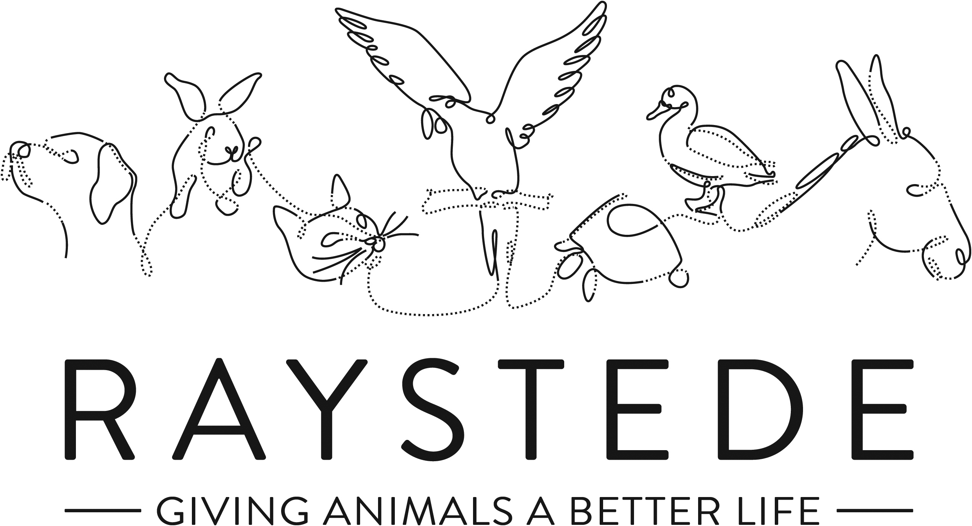
Raystede Centre for Animal Welfare

Job Description

Job Title: | Events Fundraiser
Responsible to: | Events and Community Fundraising Manager
Location: | Raystede Animal Centre, with opportunity
Hours of work: | 37.5 hours a week, including some weekends and evening which will be recompensated by TOIL.
Holidays: | 28 days per year including bank holidays
Probationary period: | 6 months
Contract Type: | Permanent
Grade and Salary: | £22,000-£25,000

Background information

Raystede Centre for Animal Welfare, established in 1952, is a charity that aims to give animals a better life through rehoming, rehabilitation and sanctuary, and give people the support and knowledge they need to treat animals with care and respect. We care for more than 400 animals every day, including cats, horses, dogs, rabbits, hens and exotic birds. We help most of the animals find new homes but also provide life-long sanctuary for those animals that cannot be rehomed. Our beautiful 43 acre site is open for visitors to get a unique glimpse into a working animal welfare centre.

Animals are at the heart of everything we do but we could not care for them without our expert and dedicated team of staff and volunteers. Surrounded by animals, lakes, trees and fields with a café, shops, parking and many other benefits, Raystede is an uplifting and rewarding place to work.

The Fundraising team generates income for Raystede through donations, legacies, events and many other sources and activities. The Events Fundraiser raises income through charity-led events, recruits new participants to database and develops lasting relationships through a planned portfolio of Challenge and Fundraising Events.

Main Purpose of the role:

- To plan, market and deliver a number of challenge and fundraising events and campaigns to maximise funds raised, recruit new donors, and build awareness.
- To provide excellent stewardship and administration for event participants to maximise funds raised.

Key Tasks

Fundraising Events
- Plan, project manage and deliver a selection of challenge and fundraising events from outset to completion and a programme of outsourced participation events. Ensure that events are delivered on budget and meet their fundraising objectives.
- Develop and deliver marketing plans for each event, ensuring that a full review is completed and that the organisational and event objectives are fulfilled.
- Manage the design and production for physical and digital promotional materials, including website content, social media ads, poster, flyers, t-shirts, etc.
- Carry out risk assessments relating to public events e.g. Health & Safety and insurance liability indemnities.
- Ensure that appropriate contractual arrangements, health and safety, and insurance cover are in place.
- Research and identify innovative events with the potential to deliver significant net income on an annual basis.
- Work with the fundraising department to develop suitable promotional campaigns within the field, securing the team’s promotional support and delivering events which support other teams’ objectives.
- Recruit, manage and develop volunteers to enable the delivery of fundraising events.
- Work with the Corporate Partnerships Fundraiser to develop and recruit corporate relationships as Event sponsors or corporate involvement in Raystede’s event activity.
- Identify, research and deliver fundraising events, campaigns and other initiatives to budget.
Stewardship and administration
- Prepare and administer all events-related documents, files, contracts and service level agreements. Ensure that appropriate administrative processes are set up across departments and within the events team in relation to the management of event participants, to support an excellent stewardship programme.
- Develop, plan and deliver excellent stewardship to all event participants, maximising average gift size and building lasting relationships with donors.
- Organise stewardship and cultivation events for event participants
- Thank and record all donations and sponsorship income, monitoring income to ensure fundraising targets are met and provide stewardship and support as needed.
- Provide financial updates on all activity and maintain monthly KPI activity reports.
Volunteers

- Set up a team of volunteers to represent the charity at a range of Raystede Challenge and other events.
- Supervise up to 3 office volunteers.
General
  - At all times ensure and maintain a compassionate, professional and efficient public image for the charity.
  - Participate in supervision, appraisal, and learning and development and take personal responsibility for maintaining the knowledge and skills required for the role.
  - Take responsibility for ensuring own health and safety and that of others who may be affected by your acts and omissions. Report any health and safety risks to your manager.
  - Work within the policy framework of Raystede Animal Centre and adhere to the terms laid out in the employee handbook.
  - Build strong relationships with internal audiences, to ensure effective communication and understanding between other departments.

Key Working Relationships
Fundraising Team – contribute to the teams plans and update on events fundraising activity.
Supporters and Participants – first point of contact, provide information, stewardship and seek to build lasting relationships.
Fundraising Volunteers – recruit, train and supervise up to 100 event volunteers and 3 office based volunteers.
Suppliers – manage event supplier relationships ensuring that all H&S, legal and contractual arrangements are in place.
Marketing – develop marketing plans, materials and communications for campaigns, collaborate with marketing and ensure signed off by Head of Marketing and Head of Fundraising.
Finance – work with finance to ensure that events income is correctly coded.

Scope and Accountability

Decision making and limits of authority | - Working with the Events and Community Fundraising Manager to propose a cohesive programme of event fundraising activity and contribute to planning.  - Able to take responsibility for overall management of a Raystede event on the day.
Financial resources | - Responsible for an income target of up to £400k and an expenditure budget of up to £150k.
Material assets | - Stocks of promotional materials and branded t-shirts, banners and gazebos.
Information and communication resources | - Responsible for ensuring event participant data is recorded in the best possible way on the database.  - Works to agreed processes.  - Updates website and provides content for social media posts.  - Briefs and designs promotional materials.  - Responsible for marketing campaigns with expenditure budgets up to £10k.  - All marketing activity and mass communications are signed off by Head of Fundraising and Head of Marketing.
People management | - Supervises up to 3 office volunteers and 100 event volunteers.
Legal, regulatory and compliance responsibility | - Completes Risk Assessments for all events activity  - Ensure that suppliers contractual arrangements, risk assessments, public liability insurance and health and safety measures are in place.  - Checks proposed events are covered by insurance policy and seeks advice from Events and Community Fundraising Manager about additional insurance cover.

Person Specification

 | Essential | Desirable
Education and Qualifications | - Full driving license | - Educated to degree level or equivalent, preferably in a related subject such as event management or marketing  - Member of the Institute of Fundraising.  - Fundraising or Marketing qualification.
Knowledge and Experience | - Events management experience  - Demonstrable experience of planning marketing and promotional campaigns  - Working with a CRM database.  - Customer service or donor stewardship experience  - Empathy for and knowledge of the issues regarding domestic animals in an animal welfare charity.  - Experience of public speaking and presentations. | - Fundraising experience  - Experience working as or with volunteers  - Knowledge of Sussex, Kent & Surrey, and the local communities.  - Experience of managing suppliers
Key Skills and Abilities | - Marketing skills – campaign planning, development and evaluation  - Organisational and event management and delivery skills  - Planning, implementing changes to and streamlining administration processes  - Excellent interpersonal and presentation skills and able to work with people from all walks of life  - Able to give clear verbal and written instructions  - Able to deliver on deadlines maintaining accuracy and attention to detail  - Strong organisational and time management skills and able to manage tasks simultaneously  - Results and targets orientated, with business acumen  - Able to interpret, produce and analyse financial data  - Strong IT skills including CRM databases, and MS Office applications.  - The ability to travel throughout the Southeast and occasionally beyond. | - Project management or event management skills  - Risk assessment skills  - Networking and relationship building skills  - Good copy and script writing skills.  - Able to manage volunteers
Personal Attributes | - Personable, sociable and people oriented.  - Proactive and self-motivated with the ability to think creatively.  - A positive outlook and a “can do” attitude.  - Dedication, commitment and tenacity.  - Change orientated approach to work  - A team player who enjoys collaborating and supporting peers | - Pet owner.
Other | - Able to work regular evenings and weekends which will be recompensated with toil.  - Availability of vehicle for work use and in possession of a current, clean driving licence.  - Flexibility of circumstances and willingness to visit national and regional venues for meetings. This may involve some overnight stays and occasional work in the evenings and at weekends.

