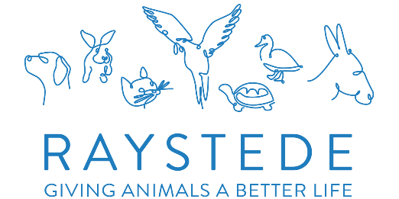
CUSTOMER SERVICE
VOLUNTEER

A bit about the role:
You will be volunteering with our small Customer Service team to provide information and help to our visitors.
Selling a large variety of pet goods, answering the telephone and generally assisting the team.

Team:
Commercial – Customer Services Manager

Time commitment:
Flexible hours and days, between 10am and 4pm

What you can expect to be doing:
Answering telephone and in person enquiries
Selling from the pet goods store
Using the till
Restocking shelves and rails
General tidying of the pet goods area

The role will suit you if:
You enjoy being part of a vibrant team.
You have a polite and engaging manner and are confident talking to people
Good IT skills, although training will be given
You have your own transport to get to and from Raystede

How you will make a difference:
Your support will directly help the Customer Service team, who in turn support every area of our Charity.
You will also be helping our animals at Raystede.

What’s in it for you:
- A welcoming and enjoyable experience and the chance to meet like-minded people
- Recognition and appreciation for your contribution
- Complimentary lunch and hot drink whilst volunteering
- 50% discount off food and drink in the Café whilst volunteering
- Uniform, induction and role specific training programme with ongoing support
- The option of reimbursement of local travel costs between home and Raystede

Volunteer role: Customer Services Volunteer Reviewed: August 2024

