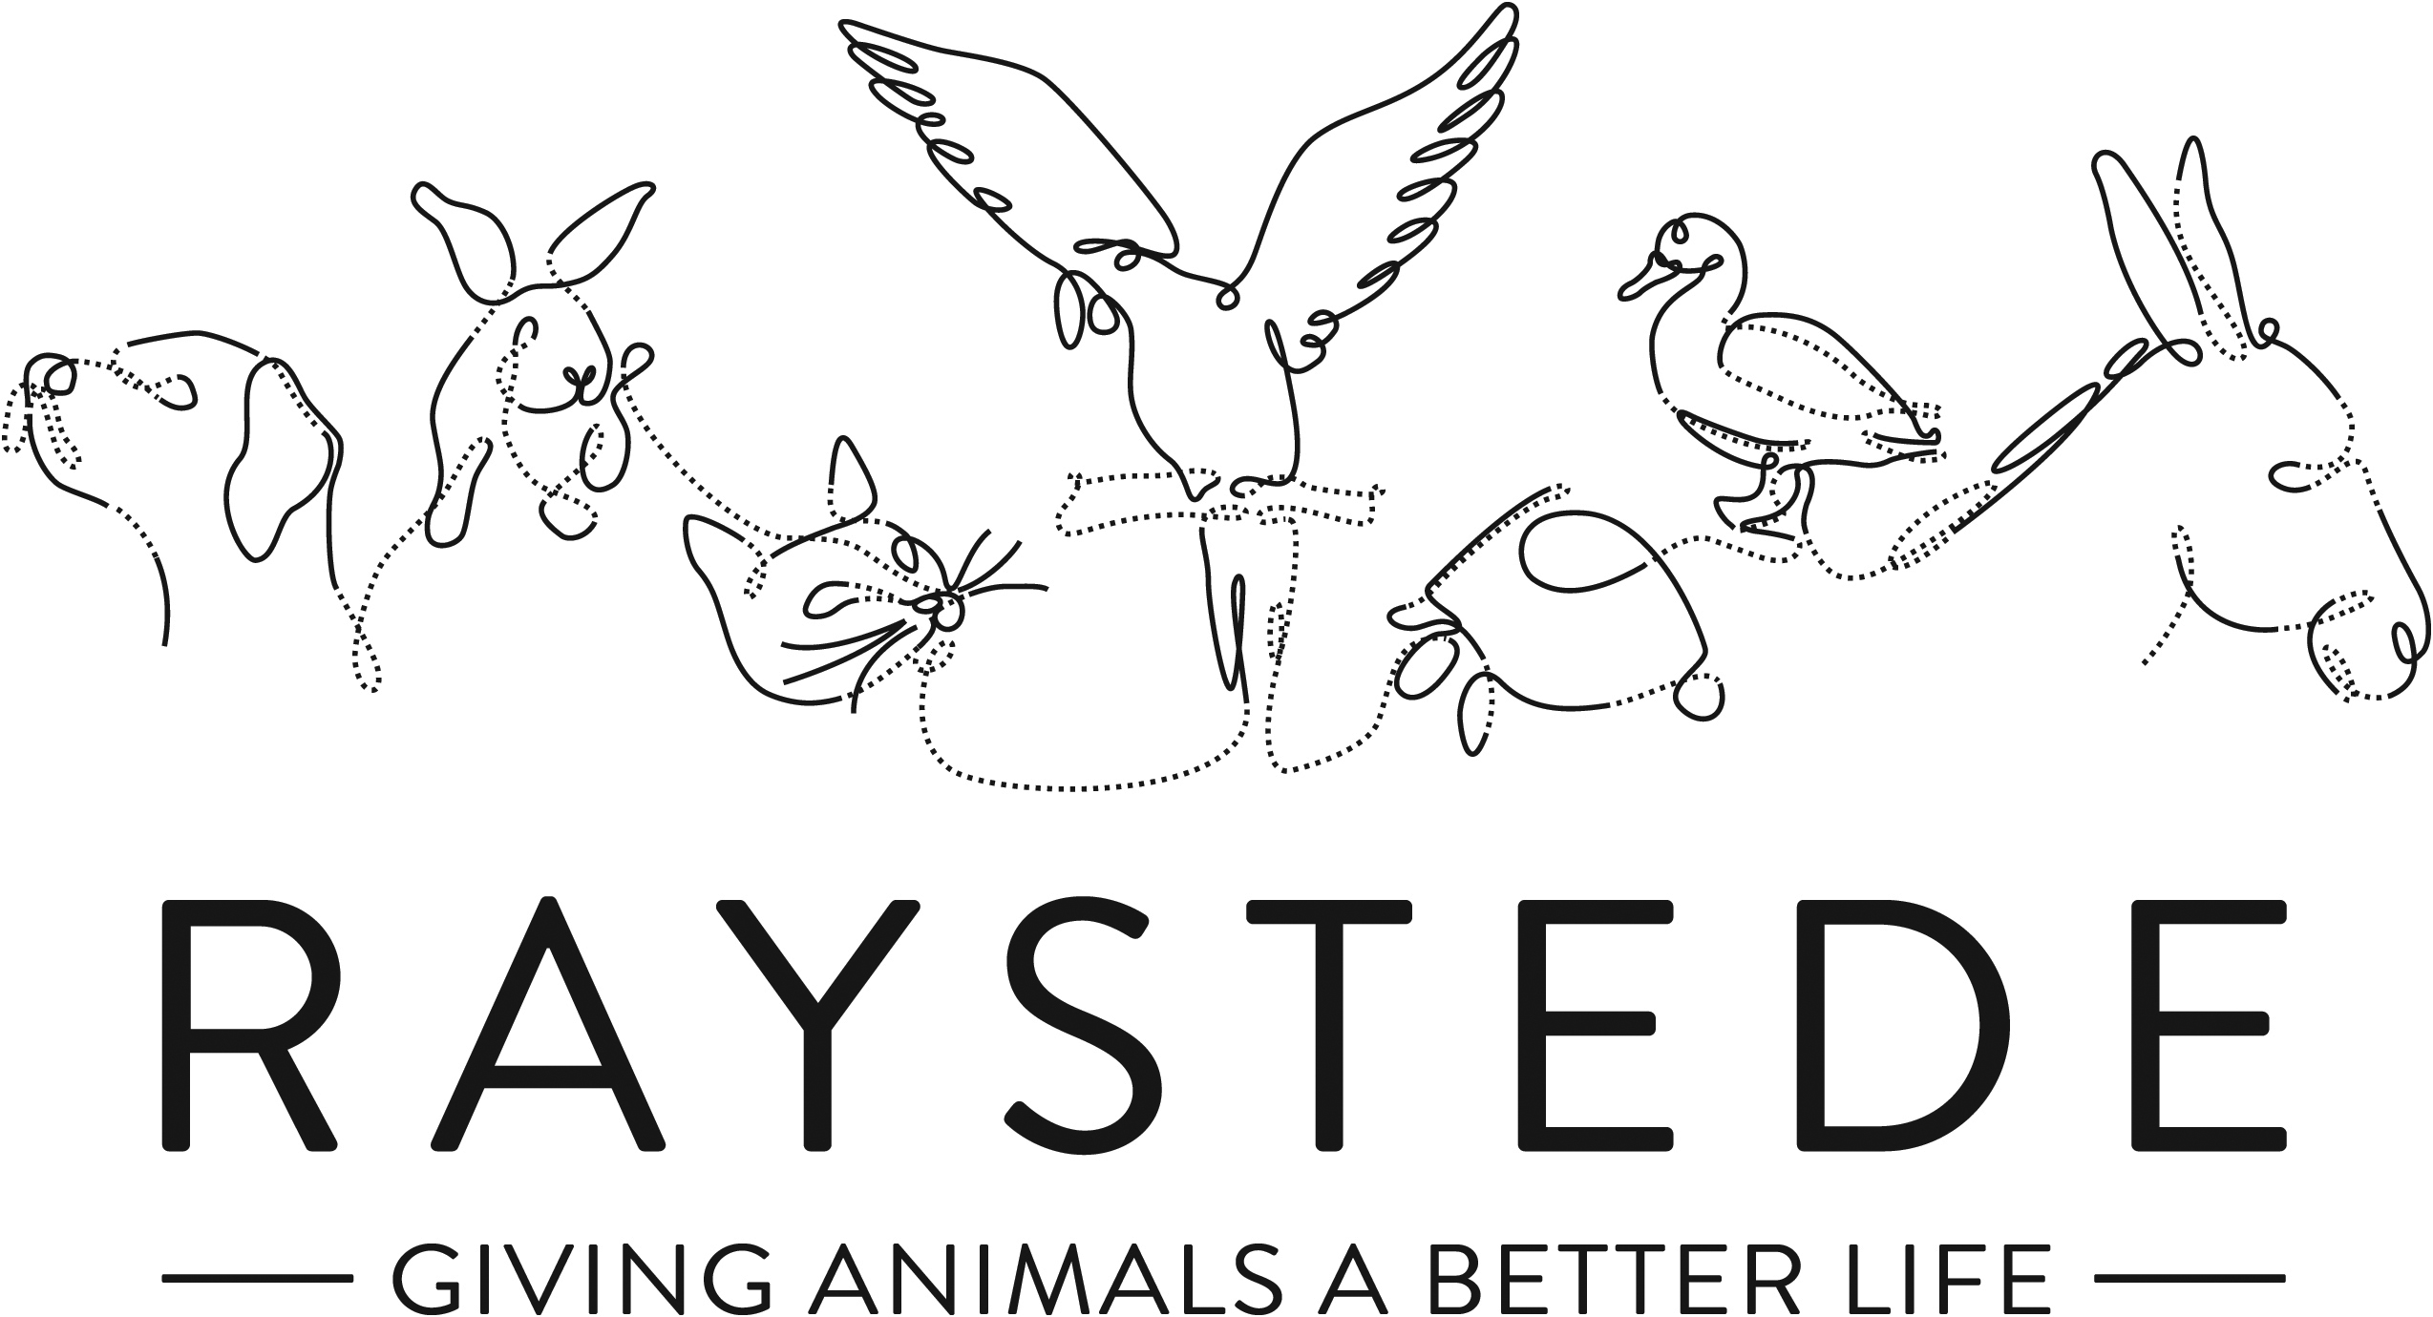
Raystede Centre for Animal Welfare

Job Description

Job Title: | Community Fundraiser
Responsible to: | Events and Community Fundraising Manager
Location: | Raystede Animal Centre, with some flexibility for regular home working
Hours of work: | 37.5 hours a week, including some weekends and evening which will be recompensated by TOIL.
Holidays: | 28 days per year including bank holidays
Probationary period: | 6 months
Contract Type: | Permanent
Grade and Salary: | Salary Range £24,125-£29,106, dependent on qualifications, experience, and achievements in post.

Background information

Raystede Centre for Animal Welfare, established in 1952, is a charity that aims to give animals a better life through rehoming, rehabilitation and sanctuary, and give people the support and knowledge they need to treat animals with care and respect. We care for more than 400 animals every day, including cats, horses, dogs, rabbits, hens and exotic birds. We help most of the animals find new homes but also provide life-long sanctuary for those animals that cannot be rehomed. Our beautiful 43 acre site is open for visitors to get a unique glimpse into a working animal welfare centre.

Animals are at the heart of everything we do but we could not care for them without our expert and dedicated team of staff and volunteers. Surrounded by animals, lakes, trees and fields with a café, shops, parking and many other benefits, Raystede is an uplifting and rewarding place to work.

The Fundraising team generates income for Raystede through donations, legacies, events and many other sources and activities. Our Community Fundraiser represents Raystede and supports individuals and groups within the community to maximise income, developing lasting relationships whilst raising awareness of Raystede.

Main Purpose of the role:

- To build lasting relationships with Raystede’s supporters in the community, maximising funds raised and long-term income.
- Responsible for growing and developing your portfolio of relationships and contacts and achieving ambitious growth targets.
- To develop new initiatives and plans to secure funding and new relationships in your area.
- To raise awareness, represent Raystede and develop new contacts, networks and supporters for the charity.
- To provide excellent stewardship and administration for community fundraising activity.
- To manage organised collections and the collecting tin programme.
- To develop a team of volunteers to raise funds and raise awareness in their own local communities.

Key Tasks

Community Fundraising
- Prepare community fundraising plans that will achieve ambitious income growth in your area. Report on progress of these plans throughout the year.
- Research and develop new and innovative ideas into proposals, developing new fundraising opportunities and campaigns.
- Prepare and deliver individualised communications and presentations to community groups, networks and other audiences.
- Contribute to the development of the overall community fundraising budget and strategy.
- Actively promote Raystede and all aspects of our work to local businesses, professional bodies, community organisations, volunteer groups, other support groups and individuals.
- Become the main point of contact at Raystede for those organising fundraising activities on the charity’s behalf.
- Offer advice and support to ensure that fundraising activities are legal, safe and acceptable to Raystede’s policies and positioning.
- Research, identify and then manage opportunities for collections at locations throughout the region.
- Work with the Marketing Team on the production of materials for events and fundraising activity in the community.
- Identify new fundraising opportunities and initiatives in the community.
- Work with the Events and Community Fundraising Manager to develop and deliver Community Fundraising campaigns.
- Facilitating partnership opportunities, store collections and in-kind event sponsorship with small local businesses.
- Speaking and presenting to diverse audiences of various sizes, may involve large conferences.
- Develop beneficial and lasting networks within the community, continually raising Raystede’s profile and championing all aspects of its work.
- Ensure that workload and deadlines are managed effectively.
Stewardship and administration
- Provide excellent stewardship to all community fundraising supporters and volunteers through emails, correspondence, calls and attending events.
- Organise stewardship and cultivation events for community participants and provide talks and tours.
- Administer all community activity on the database and ensure that welcome calls, welcome packs, income chases and thank you letters are all completed in a timely manner.
- Keep accurate records of all community fundraising activity within common agreed systems.
- Keep records of meetings, follow-up actions and community fundraising diary activity.
- Provide financial updates on all activity and maintain monthly KPI activity reports.

Volunteers

- Recruit new fundraising volunteers, ensuring they are supported and receive any training required.
- Set up a team of volunteers to replace and service Raystede collecting tins throughout the region.
- Set up a team of volunteers to represent the charity at a range of Raystede community events and collections.
- Supervise up to 3 office volunteers.
General
  - At all times ensure and maintain a compassionate, professional and efficient public image for the charity.
  - Participate in supervision, appraisal, and learning and development and take personal responsibility for maintaining the knowledge and skills required for the role.
  - Take responsibility for ensuring own health and safety and that of others who may be affected by your acts and omissions. Report any health and safety risks to your manager.
  - Work within the policy framework of Raystede Animal Centre and adhere to the terms laid out in the employee handbook.
  - Build strong relationships with internal audiences, to ensure effective communication and understanding between other departments.

Key Working Relationships

Fundraising Team – contribute to the teams plans and update on community fundraising activity.
Supporters and Participants – first point of contact, provide information, stewardship and seek to build lasting relationships. Able to engage with a very wide range of people from all walks of life and in many different settings.
Fundraising Volunteers – recruit, train and supervise up to 20 community volunteers and 3 office based volunteers.
Suppliers – order materials from suppliers.
Marketing – work closely with the Events and Community Fundraising Manager and the marketing team to produce marketing and promotional materials and planned community campaigns.
Finance – work with finance to ensure that community income is correctly coded.

Scope and Accountability

Decision making and limits of authority | - Prepare Community Fundraising plans and work with the Events and Community Fundraising Manager to contribute to the strategy.  - Delegated responsibility for managing own portfolio of supporters, plans and decision making during fundraising delivery.  - Make complex decisions, committing to communication, brand, reputational or staffing resource support, whilst meeting with influential donors and managing their expectations.  - Able to resolve conflict and manage supporters and volunteers’ expectations, often in un-known venues whilst facing conflicting time pressures  - Able to credibly represent the charity.
Financial resources | - Responsible for a growth income target of up to £250k per annum and an expenditure budget of up to £40k per annum.
Material assets | - Stocks of promotional materials and branded t-shirts, banners and gazebos.
Information and communication resources | - Responsible for inputting data on to database  - Works to agreed processes  - Updates website and provides content for social media posts  - Works with marketing to produce materials and posters  - Writes individual presentations and communications  - All marketing activity and mass communications are signed off by Head of Fundraising and Head of Marketing  - Able to persuade and influence people to take action in support of Raystede
People management | - Supervises up to 3 office volunteers and 10 community fundraising volunteers
Legal, regulatory and compliance responsibility | - Completes Risk Assessments for all event and community fundraising activity.  - Ensure that suppliers risk assessments, public liability insurance and health and safety measures are in place.  - Advises groups in the community on legal, health and safety and compliance issues.

Person Specification – Community Fundraiser

 | Essential | Desirable
Education and Qualifications |  | - Educated to GCSE or equivalent  - Member of the Institute of Fundraising.  - Fundraising qualification.
Knowledge and Experience | - Two years’ experience of working in a fundraising or sales role, ideally in Community Fundraising.  - Experience of developing relationships with individuals.  - Experience of developing costed proposals.  - Proven experience of meeting income targets  - Experience of public speaking and presentations.  - Experience of sound record keeping and administration.  - Empathy for and knowledge of the issues regarding domestic animals in an animal welfare charity.  - Computer literate, ideally with experience of working with a CRM database. | - Knowledge of Sussex, Kent & Surrey, and the local communities.  - Experience working as or with volunteers  - Working with a CRM database
Key Skills and Abilities | - Able to confidently communicate to a wide range of people  - Networking and relationship building skills  - Creative and compelling presentation skills  - Strong IT skills including CRM databases, and MS Office applications  - Ability to manage personal deadlines and prioritise a demanding workload  - Able to work effectively in a sometimes-uncertain environment and respond positively to change.  - Able to deliver on deadlines, maintaining accuracy and attention to detail  - Able to be professional and credible when representing Raystede  - The ability to travel throughout the Southeast and occasionally beyond | - Results orientated with business acumen  - Able to interpret, produce and analyse financial data
Personal Attributes | - Personable, sociable and people oriented  - Proactive and self-motivated with the ability to think creatively  - A positive outlook and a “can do” attitude  - Dedication, commitment, and tenacity  - Change orientated approach to work  - Ability to make decisions when dealing with often constant and conflicting demands on time  - A team player who enjoys collaborating and supporting peers | - Pet owner.
Other | - Able to work regular evenings and weekends which will be recompensated with toil.  - Availability of vehicle for work use with business insurance and in possession of a current, clean driving licence.  - Flexibility of circumstances and willingness to visit national and regional venues for meetings. This may involve some overnight stays and occasional work in the evenings and at weekends.

