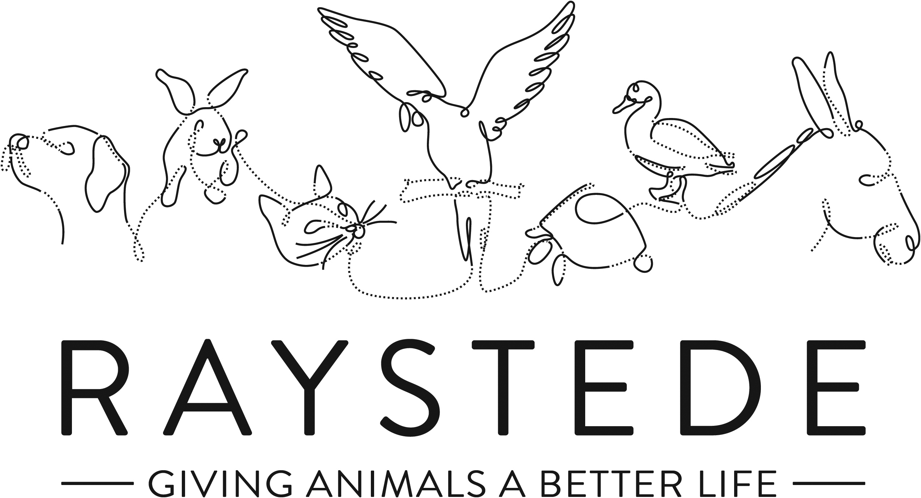
Raystede Centre for Animal Welfare

Job Description

Job Title: | Fundraiser
Responsible to: | Events and Community Fundraising Manager
Location: | Raystede Animal Centre, with some flexibility for regular home working
Hours of work: | 37.5 hours a week, including some weekends and evening which will be recompensated by TOIL.
Holidays: | 28 days per year including bank holidays
Probationary period: | 6 months
Contract Type: | Permanent
Grade and Salary: | £22,000 to £25,000

Background information

Raystede Centre for Animal Welfare, established in 1952, is a charity that aims to give animals a better life through rehoming, rehabilitation and sanctuary, and give people the support and knowledge they need to treat animals with care and respect. We care for more than 400 animals every day, including cats, horses, dogs, rabbits, hens and exotic birds. We help most of the animals find new homes but also provide life-long sanctuary for those animals that cannot be rehomed. Our beautiful 43 acre site is open for visitors to get a unique glimpse into a working animal welfare centre.

Animals are at the heart of everything we do but we could not care for them without our expert and dedicated team of staff and volunteers. Surrounded by animals, lakes, trees and fields with a café, shops, parking and many other benefits, Raystede is an uplifting and rewarding place to work.

The Fundraising team generates income for Raystede through donations, legacies, events and many other sources and activities. The Fundraiser represents Raystede and supports individuals and groups within the community to maximise income, developing lasting relationships whilst raising awareness of Raystede.

Main Purpose of the role:

- To build lasting relationships with Raystede’s supporters in the community, maximising funds raised and long-term income.
- To raise awareness, represent Raystede and develop new contacts, networks and supporters for the charity.
- To provide excellent stewardship and administration for community fundraising activity.
- To manage organised collections and the collecting tin programme.
- To develop a team of volunteers to raise funds and raise awareness in their own local communities.

Key Tasks

Community Fundraising
- Prepare community fundraising plans which link into the agreed overall budget and targets. Report on progress of these plans throughout the year.
- Prepare and deliver individualised communications and presentations to community groups, networks and other audiences.
- Actively promote Raystede and all aspects of our work to local businesses, professional bodies, community organisations, volunteer groups, other support groups and individuals.
- Offer advice and support to ensure that fundraising activities are legal, safe and acceptable to Raystede’s policies and positioning.
- Identify new fundraising opportunities and initiatives in the community.
- Work with the Events and Community Fundraising Manager to develop and deliver Community Fundraising campaigns.
- Develop beneficial and lasting networks within the community, continually raising Raystede’s profile and championing all aspects of its work.
- Ensure that workload and deadlines are managed effectively.
Stewardship and administration
- Provide excellent stewardship to all community fundraising supporters and volunteers through emails, correspondence, calls and attending events.
- Organise stewardship and cultivation events for community participants and provide talks and tours.
- Administer all community activity on the database and ensure that welcome calls, welcome packs, income chases and thank you letters are all completed in a timely manner.
- Provide financial updates on all activity and maintain monthly KPI activity reports.
Volunteers

- Recruit new fundraising volunteers, ensuring they are supported and receive any training required.
- Set up a team of volunteers to replace and service Raystede collecting tins and at a range of Raystede community events and collections.
- Supervise up to 3 office volunteers.
General
  - At all times ensure and maintain a compassionate, professional and efficient public image for the charity.
  - Participate in supervision, appraisal, and learning and development and take personal responsibility for maintaining the knowledge and skills required for the role.
  - Take responsibility for ensuring own health and safety and that of others who may be affected by your acts and omissions. Report any health and safety risks to your manager.
  - Work within the policy framework of Raystede Animal Centre and adhere to the terms laid out in the employee handbook.
  - Build strong relationships with internal audiences, to ensure effective communication and understanding between other departments.

Person Specification – Community Fundraiser

 | Essential | Desirable
Education and Qualifications | - Full driving license | - Educated to GCSE or equivalent  - Member of the Institute of Fundraising.  - Fundraising qualification.
Knowledge and Experience | - Two years’ experience of working in a fundraising or sales role.  - Experience of developing relationships with individuals.  - Experience of public speaking and presentations.  - Experience of sound record keeping and administration.  - Empathy for and knowledge of the issues regarding domestic animals in an animal welfare charity. | - Knowledge of Sussex, Kent & Surrey, and the local communities.  - Community Fundraising experience  - Experience working as or with volunteers  - Working with a CRM database
Key Skills and Abilities | - Able to confidently communicate to a wide range of people  - Networking and relationship building skills  - Creative and compelling presentation skills  - Strong IT skills including CRM databases, and MS Office applications  - Ability to manage personal deadlines and prioritise a demanding workload  - Able to work effectively in a sometimes-uncertain environment and respond positively to change.  - Able to deliver on deadlines, maintaining accuracy and attention to detail  - Able to be professional and credible when representing Raystede  - The ability to travel throughout the Southeast and occasionally beyond | - Results orientated with business acumen  - Able to interpret, produce and analyse financial data
Personal Attributes | - Personable, sociable and people oriented  - Proactive and self-motivated with the ability to think creatively  - A positive outlook and a “can do” attitude  - Dedication, commitment, and tenacity  - Change orientated approach to work  - Ability to make decisions when dealing with often constant and conflicting demands on time  - A team player who enjoys collaborating and supporting peers | - Pet owner.
Other | - Able to work regular evenings and weekends which will be recompensated with toil.  - Availability of vehicle for work use and in possession of a current, clean driving licence.  - Flexibility of circumstances and willingness to visit national and regional venues for meetings. This may involve some overnight stays and occasional work in the evenings and at weekends.

