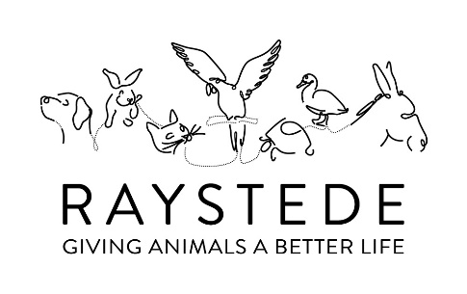
volunteer role description

Chair of trustees

The Chairman is responsible for effectively and accurately communicating the decisions of the Board in:

- Ensuring the CEO understands the strategic priorities, policies and plans agreed by the Board;

- Developing RCAWL’s key relationships with major stakeholders;

- Ensuring RCAWL effectively fulfils its objectives, general functions and duties and appropriately exercises its legal powers in concert with the Board;

- Ensure the Board’s strategies are communicated to the CEO;

- Steers the delivery of its services in line with agreed targets and performance indicators;

- Jointly with the Chief Executive, communicating the RCAWL’s plans and achievements to stakeholders, and the public

- Ensuring that Board Members operate in accordance with governance best practice standards;

- Ensuring the Company Secretary advises Companies House on the appointment of Board Members and ensuring their effective induction and support in line with Board decisions;

- Ensuring compliance and maximizing Board effectiveness, individually and collectively; with Board members, establishing, monitoring and reviewing governance structures, systems and processes;

- Directing, supporting and managing the Chief Executive including agreeing personal objectives and undertaking an annual written appraisal of their performance.

- Recommending compensation reviews to the board or sub-committee as appropriate.

- Monitoring and approving the expenses of the chief executive on a monthly basis.

- Creating and disbanding advisory groups and committees (in discussion with the Chief Executive where appropriate).

- Initiate annual trustee self-assessments and one to one meetings between the Chairman and Board members

- Deputize responsibilities to the Vice Chairman or a nominated Board Member on occasions of prolonged absence or unavailability.

- Maintain a record of board attendance by Trustees.

- Initiate skills audits of the Board from time to time as the needs of the Charity Change.

- Initiating a review of the articles of association at regular intervals.

In the first instance applicants should request an application form and person specification from Jonathan Vine-Hall at chairman@raystede.org

