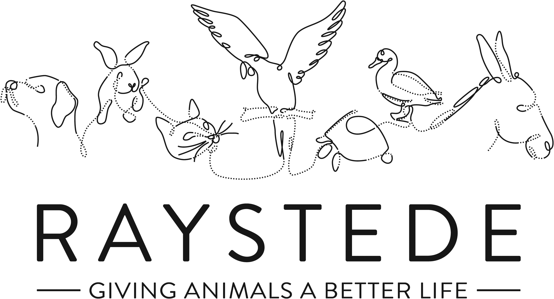
Raystede Centre for Animal Welfare

Job Description

Job Title: | Cattery Manager
Responsible to: | Head of Animal Welfare
Location: | Raystede Centre for Animal Welfare
Hours of work: | 37.5 hours a week, worked across shifts between 7am and 7pm including alternate weekends
Holidays: | 30 days pro rata per year including bank holidays
Probationary period: | 3 months
Contract Type: | Permanent
Grade and Salary: | £22,174.20 p.a

Background Information

Raystede Centre for Animal Welfare, established in 1952, is a charity that aims to give animals a better life through rehoming, rehabilitation and sanctuary, and give people the support and knowledge they need to treat animals with care and respect. We care for more than 400 animals every day, including cats, horses, dogs, rabbits, hens and exotic birds. We help most of the animals find new homes but also provide life-long sanctuary for those animals that cannot be rehomed. Our beautiful 43 acre site is open for visitors to get a unique glimpse into a working animal welfare centre.
Animals are at the heart of everything we do but we could not care for them without our expert and dedicated team of staff and volunteers. Surrounded by animals, lakes, trees and fields with a café, shops, parking and many other benefits, Raystede is an uplifting and rewarding place to work.

The Cattery team is responsible for the care, rehabilitation, intake, and rehoming of cats on site and forms a key part of our animal welfare service.

Main Purpose of the Role

- Management of and responsibility for all aspects of the operation of an animal care team which admits, cares for, rehabilitates and, where appropriate, rehomes unwanted and stray animals. This includes responsibility for the learning and development of staff and volunteers within the animal care team.
- To provide the highest standards of animal care and welfare for the animals.
- To work as part of a team delivering sector leading customer service, answering queries, and matching animals to adopters to ensure successful rehoming.
- To educate potential new owners and the general public in the care and welfare of their animals.
- To promote Raystede services and maximise adoption opportunities.

Key Tasks

- Animal care and welfare
  - Implement, monitor and evaluate plans for the health and welfare of animals.
  - Co-ordinating the care of animals within section.
  - Evaluate a match between adopters and animals and support other staff through the process as appropriate.
  - Provide advice and guidance on the choice and care of animals to prospective owners.
  - Clean, disinfect and maintain to a high standard of cleanliness and bio-security set by management, all animal accommodation, isolation units, outside and inside exercise areas, food preparation areas, laundry, storage, stores and treatment facilities.
  - Prepare and provide species and individually appropriate feed and water.
  - Plan, supervise and control the movement of animals between locations safely.
  - Assist with the inspection and or treatment of animals by a Veterinary Surgeon, or other authorised person at the Centre, including the administration of first aid and medication and assistance in euthanasia procedures.
  - Recognise, report, record, and where appropriate address any signs of illness, disease, injury, unusual condition, unusual activity, or abnormal behaviour of animals.
  - Provide animals with effective opportunities to exercise and maintain good physical and behavioural functioning and where appropriate provide opportunities to exercise freely.
  - Promote the health and welfare of animals through grooming and coat care, as appropriate to species.
  - Ensure our animal husbandry demonstrates best practice, and continually assess this within the animal welfare sector calling upon up to date research.
- Enrichment
  - Provide information on how to maintain the behaviour, health, and welfare of animals to staff and volunteers.
  - Design integrated training and enrichment programmes for animals to realise their potential. These may be animal specific or complex programmes applied to a species as a whole.
  - Train animals through designed training programmes and continually evaluate their success evolving them to enhance outcomes.
  - Conduct, facilitate, perform, and develop centre enrichment protocols.
- People Management
- Take responsibility for the management of all resources operating within section including staff, volunteers, and contractors in accordance with standard procedures.
- Plan team workload across an array of complex tasks rapidly responding to changing demands.
- To recruit and train new section staff with the support of the Head of Animal Welfare.
- To ensure staffing levels that support the effective running of the section
- Regular review and performance management of section team
- Design integrated training programmes for staff to realise their potential.
- Responsible for the proper implementation of HR policies and procedures relating to staff, in discussion with the Head of Animal Welfare or Head of HR where necessary.
- Required to become involve with complex HR issues including disciplinary matters.
- Lead and inspire section team and volunteers to achieve Raystede’s values each day.
- Customer Service
  - Welcome, receive, and care for visitors within animal sections and on site.
  - Attend to the needs of the adopters/general public face to face, via electronic communication or via the telephone providing a caring and non-judgemental service in what may be difficult circumstances. Dealing with emotional situations should be expected in this role.
  - Provide adopters and members of the public with comprehensive often complex advice about how to care for an animal. This may require visiting the home of a member of public or other site.
  - Attend to the needs of the adopters/general public, face to face, via electronic communication, and via the telephone.
  - Liaise with colleagues in other departments to ensure accurate, timely and relevant information is disseminated to customers.
- Contribute to fundraising, educational and commercial activities
  - Assist with educational talks, tours, and activities.
  - Contribute to and attend fundraising and commercial events.
  - Actively promote Raystede services on-site.
- Administration
  - Complete and maintain all standard and electronic files and documentation relating to the animals; including documents regarding the surrender and adoption of animals, microchip and vaccination records, ensuring records are accurate, up to date, legible and comply with any legislative requirements.
  - Maintain and monitor daily animal records.
  - Develop and where necessary design standard procedures aligned with best practice and all relevant legislation.
  - Management of section spending in line with budgets agreed at the beginning of each financial year. Input into setting section budget.
  - Responsible for section ordering, stock rotation, and stock taking.
  - Responsible for ensuring cost savings are achieved where possible when sourcing section supplies and stock.
  - Ensure section operates in a legally compliant manner reporting any issues to the Head of Animal Welfare.
  - Presentation of information both internally and externally. This may take numerous forms including face to face presentation and formal report writing.
  - General admin duties.
- Personal development
  - Maintain and develop personal performance.
  - Participate in all training as required.
  - Establish and maintain effective working relationships and good working practices with colleagues and volunteers.
- Physical requirements
  - Frequent bending, lifting, reaching, kneeling, walking, and standing for 4 to 6 hours or more per day.
  - Exposure to disinfectant solutions for cleaning.
  - Exposure to various weather conditions.
  - Potential exposure to animal bites and scratches.
  - Continual exposure to animals and animal allergens.
  - Ability to work with animals of all sizes including some in excess of 900kg.
- Other
  - Tactical management of section to achieve the Charity’s strategic aims and chosen targets with the support of the Head of Animal Welfare.
  - Responsible for the day-to-day health and safety of staff and volunteers and general public within own animal section and for the initiation of reports in accordance with the Charity’s Health and Safety procedures.
  - Expected to deal with often harrowing animal welfare issues.
  - To ensure the Charity’s designated health and safety representative is made aware of any health and safety incidents/concerns.
  - Ensure, so far as is reasonably practical, the health, safety and well-being of their staff and others who may be affected by the Charity’s activities.
  - Maintain to a standard of cleanliness set by management all offices and staff facilities including toilets within your section.
  - Ensure buildings, exercise areas, and all other facilities as appropriate are secure at all times.
  - Regularly assess the condition of all assets belonging to or used by the section and report defects or issues as they are recognised. Ensure that regular maintenance is carried out or managed as appropriate.
- General
- At all times ensure and maintain a compassionate, professional and efficient public image for the charity
- Participate in supervision, appraisal, and learning and development. Take personal responsibility for maintaining the knowledge and skills required for the role.
- Take responsibility for ensuring own health and safety and that of others who may be affected by your acts and omissions. Report any health and safety risks to your manager.
- Work within the policy framework of Raystede Animal Centre and adhere to the terms laid out in the employee handbook.

Key Working Relationships

- Immediate and all other animal care teams to ensure collaborative team working on site.
- Rehoming team to arrange and enable rehoming appointments facilitating intake and adoption of animals.
- Raystede veterinary team to ensure the health and welfare of animals in our care.
- General public to liaise with and match people to animals to achieve successful rehoming outcomes. Also to provide information and guidance on Raystede and its activities.
- External veterinary services to enable out of hours and specialist veterinary care where applicable.
- Specialist external groups, bodies, and organisations to further knowledge of husbandry and care at Raystede, and to promote our reputation.
- Other organisations to grow and improve our external network in order to further benefit more animals.
- All other departments within Raystede to assist with and facilitate the successful and efficient operation of Raystede and its services.

Scope and Accountability

Decision making and limits of authority | - Decisions re health and welfare of animals must be taken to tailor husbandry methods and decide on the correct course of action if there is any concern about animal health or overall wellbeing.  - Rehoming decisions to ensure the ongoing welfare of animals in our care will be taken.  - Animal intake decisions are a key part of this role.  - Financial authority in this role is up to £250.
Financial resources | - Responsible for spending in line with agreed section budget.  - Expected to achieve cost savings where possible.  - Occasional cash handling and taking of payments.
Material assets | - Responsible for ensuring the cleanliness and security of departmental and wider assets where necessary.  - Expected to report issues and defects with material assets, equipment, buildings, fixtures, and fittings to Estates team or senior management as appropriate.  - Required to rectify issues recognized with stocks or supplies.
Information and communication resources | - Expected to use the Anilog database and other departmental filing systems.  - Responsible for using databases and filing systems in a secure manner compliant with all applicable data protection legislation.  - Responsible for ensuring all management information is treated with confidentiality as necessary.
People management | - Operational management of immediate team and others which may work in section temporarily including all matters that arise from this.  - Management of volunteers.  - Ensuring effective staffing levels.  - Carrying out recruitment as required.  - Oversight of contractors when working within section.
Legal, regulatory and compliance responsibility | - Responsible for ensuring all tasks carried out in section and personally are done so in accordance with applicable animal welfare legislation and regulations.  - Responsible for ensuring own health and safety following set procedures and using equipment provided.

Person Specification

 | Essential | Desirable
Education and Qualifications | - Full, clean, manual driving licence.  - Minimum Level 3 Certificate in Animal Care. | - Specialist animal welfare qualifications relevant to role.  - Management qualification or training.
Knowledge and Experience | - Working with members of the public or within a visitor environment.  - Evidence of the advanced care and welfare of animals.  - Experience of making critical animal welfare decisions.  - Proven application of sound and effective customer care skills.  - Experience of managing or supervising direct reports.  - Administrative skills including confidence using IT. | - Experience in an animal welfare environment.  - Experience of managing change within a team.  - Experience of adapting animal care procedures based on new evidence.  - Implementation of new practices within an organisation.  - Charity fund raising e.g. on/off-site events.  - Experience of working professionally with the animal types related to this role.  - Experience of exposure to unpleasant odours and noises.
Key Skills and Abilities | - Proven communication skills, written and oral.  - Ability to work within a diverse team, and build excellent working relationships.  - Ability to manage personal deadlines and prioritise a demanding workload.  - Ability to manage relationships with tact and diplomacy.  - Ability to objectively assess and respond to emotive situations based upon resource available.  - Able to deal with difficult and emotional animal welfare issues.  - Excellent attention to detail.  - Proven ability to handle the animals associated with this role.  - Practical flair to develop “Do It Yourself” projects, with a focus on enrichment. | - Able to handle a variety of animals.
Personal Attributes | - Personable, sociable and people oriented.  - Proactive and self-motivated with the ability to think creatively.  - A positive outlook and a “can do” attitude.  - Dedication, commitment, and tenacity.  - Change orientated approach to work.  - Ability to make decisions when dealing with often constant and conflicting demands on time.  - Highly committed and able to work flexibly to achieve performance targets.  - Able to assist the wider team when required taking a flexible approach to occasionally unplanned organisational demands.  - Commitment to equality, diversity and inclusion and understanding of how it applies to own role.  - Empathy and interest in animals and their welfare.
Other | - To have a flexible approach to working hours.  - Availability of a vehicle for work use. Flexibility of circumstances and willingness to visit national and regional venues for CPD. This may involve some overnight stays, occasional work in the evenings, and at weekends.

