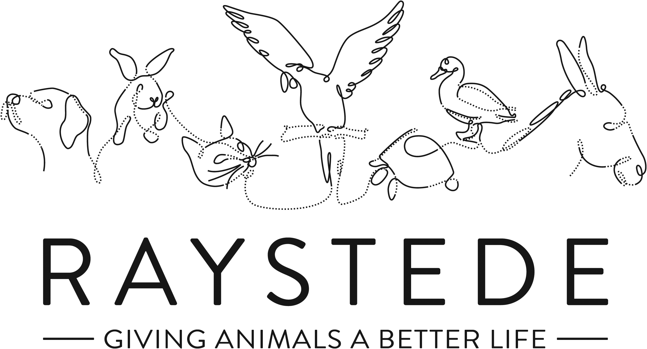
Raystede Centre for Animal Welfare

Job Description

Job Title: | Café Supervisor (front of house) – part time
Responsible to: | Café Manager
Location: | Raystede Animal Centre
Hours of work: | 16 or 24 hours a week including weekends, worked flexible within the needs of the business
Holidays: | Pro rata on 30 days per year including bank holidays.
Probationary period: | 3 months
Contract Type: | Permanent
Grade and Salary: | £19,801.60 pro rata per annum

Background information

Raystede Centre for Animal Welfare, established in 1952, is a charity that aims to give animals a better life through rehoming, rehabilitation and sanctuary, and give people the support and knowledge they need to treat animals with care and respect. We care for more than 400 animals every day, including cats, horses, dogs, rabbits, hens and exotic birds. We help most of the animals find new homes but also provide life-long sanctuary for those animals that cannot be rehomed. Our beautiful 43 acre site is open for visitors to get a unique glimpse into a working animal welfare centre.
Animals are at the heart of everything we do but we could not care for them without our expert and dedicated team of staff and volunteers. Surrounded by animals, lakes, trees and fields with a café, shops, parking and many other benefits, Raystede is an uplifting and rewarding place to work.

The cafe team are part of the Commercial and Visitor Operations department who provide essential services to our daily visitors. Upholding high standards and a friendly caring approach we help people enjoy their visit and encourage our customers to engage with Raystede a Charity and understand about the work we do. Every penny of our profits go directly into helping the animals in Raystede’s care.

Main Purpose of the role:
Support the Manager across the Café operation, maintaining consistently high standards throughout the café. Deliver excellent customer service to internal and external customers. Proactively deliver a profitable Café operation that continues to develop & make a significant contribution to the Raystede centre and guest experience.
Deputise in Manager’s absence. Lead and instruct the team. Able to work flexibly across all café tasks.

Key Tasks
To take day to day responsibility for managing the charity onsite café in the manager’s absence for days and weekends off, holidays and sickness
- Implement agreed plans for the safe and profitable running of the café.
- Be creative in thinking and actions to ensure a successful daily service in a fast-changing environemnt
- To take control of the front of house operation ensuring 1st class customer service
- To ensure all agreed hygiene standards are met and maintained daily
- To brief the café manager at regular agreed intervals (and immediately if urgent) on progress in the café.
- To propose action to them for improvements in operations.
- To work with the Head Cook to help deliver an inclusive menu

Sales.
Achieve and exceed agreed income targets through encouraging both dine-in and takeaway sales
- To ensure all staff maintain a high standard of customer care through training and development

Stock management
Effective management of stock with ability to maintain a well organised stockroom and minimising waste
- To maintain agreed portion size control
- To ensure agreed display and presentation standards are met
- To accept deliveries and ensure stock rotation.
- To participate in and promote any agreed sales promotions.

Staff
Supervise a team of casual staff
- To provide adequate supervision for the the wider team
- To devise and deliver training for all staff
- To take part in the regular review and performance management of the team
- Ensure hand overs are thorough between manager and supervisor between shifts

Admin
- To meet agreed cash management and security procedures.
- To take action when needed to ensure the cafe is adequately staffed
- To bank takings using agreed banking procedures

Premises, security and safety
- To ensure all hygiene rules are adhered to with daily regimes implemented and monitored
- To ensure all café equipment is kept in good working order
- To advise on any necessary repairs and maintenance
- To ensure the security of café takings.
- To ensure that security procedures are understood and implemented by all staff
- To apply company Health & Safety regulations in accordance with guidelines by:
  - Maintaining Health & Safety records; general plus catering specific such as:
    - Temperature checks on deliveries and cold storage units
    - Temperature checks on cooked foods
    - Made on and use by dates
  - Attending required fire drills.
  - Implementing risk assessment procedures
  - To ensure that health and safety procedures are understood and implemented by all staff.
- To maintain a detailed understanding of allergens complying with all relevant legislation and ensuring all staff are trained and able to communicate clearly any allergen in our menus

Physical requirements
- Frequent bending, lifting, reaching, kneeling, walking, and standing for 4 to 6 hours or more per day.
- Exposure to sanitising and disinfectant solutions for daily cleaning.

General
At all times ensure and maintain a compassionate, professional and efficient public image for the charity
  - Participate in supervision, appraisal, and learning and development and take personal responsibility for maintaining the knowledge and skills required for the role
  - Take responsibility for ensuring own health and safety and that of others who may be affected by your acts and omissions. Report any health and safety risks to your manager.
  - Work within the policy framework of Raystede Animal Centre and adhere to the terms laid out in the employee handbook

Key Working Relationships
General public, giving people the best experience in our café through excellent customer service
Colleagues, team working is essential
Commercial and Visitor Ops team, being part of a bigger team to encourage visitors to use the commercial areas and enjoy the site

Scope and Accountability

Decision making and limits of authority | - Deputise in the café manager’s absence for day to day operational needs to ensure smooth running of café, be creative to ensure successful day’s service  - Defer to one of the Commercial managers for anything over and above
Financial resources | - Cash handling, cashing up tills and daily banking. Security of daily takings.
Material assets | - Accurate stock control and date rotation to minimize waste  - Cleanliness and hygiene standards to EHO 5* rating
Information and communication resources | - Use of department PC and email to be conducted in line with policy and procedure
People management | - Supervise up to 6 zero hours staff per shift
Legal, regulatory and compliance responsibility | - Comply with all relevant catering hygiene and allergen laws  - Maintain accurate catering records
Person Specification

 | Essential | Desirable
Education and Qualifications | - Full Driving Licence  - Food Hygiene Level 2
Knowledge and Experience | - Experience or working within a café environment  - Ability to work well under pressure.  - Experience of stock handling including date rotation and maintaining cold chain (keeping appropriate records)  - Good customer service skills  - Well organised and able to work in a tidy manner  - Accurate till operation and cash handling procedures  - Good numeracy and literacy skills  - Ability to work effectively within a team  - Good communication skills, ability to positively interact with different groups of people, both internal and external customers  - • High standards of personal hygiene
Key Skills and Abilities | - Ability to work within a diverse team, and build excellent working relationships.  - Ability to manage personal deadlines and prioritise a demanding workload.  - Ability to reprioritise when circumstances demand  - Ability to manage relationships with tact and diplomacy.  - • Excellent attention to detail
Personal Attributes | - Personal, sociable and people orientated  - Commitment to equality, diversity and inclusion and understanding of how it applies to own role  - Empathy and interest in animals and their welfare
Other | • To have a flexible approach to working hours.  • Availability of vehicle for work use and in possession of a current, clean driving licence.

