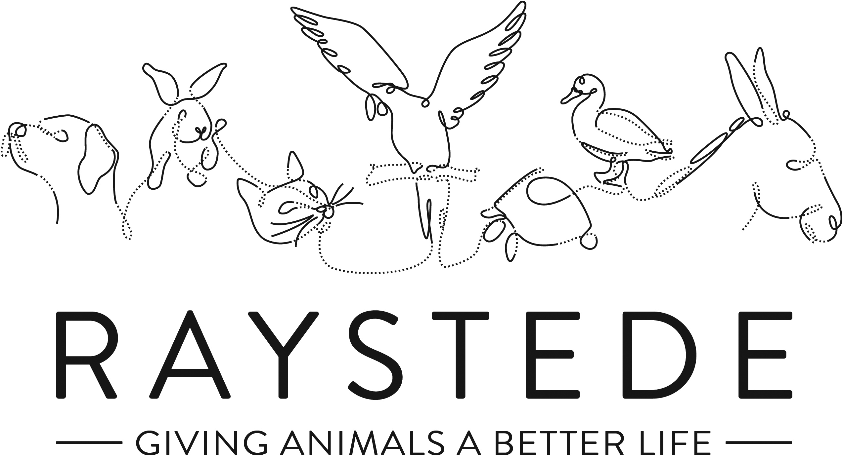
Raystede Centre for Animal Welfare

Job Description

Job Title: | Animal Care Assistant
Responsible to: | Equine Manager
Hours of work: | 37.5 hours, worked on a rota basis to include alternate weekends
Holidays: | 30 days per year including bank holidays pro rata
Probationary period: | 3 months
Contract Type: | Permanent
Salary: | £17,790.72 p.a

Main Purpose of the role:

To admit, care for, rehabilitate and, where appropriate, ready for adoption unwanted and stray animals. Provide the highest standards of animal care and welfare for the animals. Educate potential new owners and the general public in the care and welfare of animals.
To work as part of a team delivering a first-class customer service in every part of your role, answering queries and matching and re-homing animals effectively when required. To promote Raystede services and maximise adoption opportunities.

Key Tasks

- Animal care and welfare
  - Clean, disinfect and maintain to a standard of cleanliness and bio-security set by management, all animal accommodation, isolation units, outside and inside exercise areas, food preparation areas, laundry, storage, stores and treatment facilities.
  - Prepare and provide feed and water.
  - Control and restrain animals and move them between locations safely if required.
  - Assist with the inspection and or treatment of animals by a Veterinary Surgeon, or other authorised person at the Centre including the administration of first aid and medication and assistance in euthanasia procedures.
  - Recognise, report and record any signs of illness, disease, injury, unusual condition, unusual activity or abnormal behaviour of animals.
  - Provide animals with effective opportunities to exercise and maintain good physical and behavioural functioning and where appropriate provide opportunities to exercise freely.
  - Promote the health and welfare of animals through grooming and coat care, as appropriate to species.
  - In conjunction with section manager, provide advice and guidance on the choice and care of animals to prospective owners.

- Enrichment
  - Train animals through our basic training programmes and contribute to the evaluation and implementation of these where appropriate.
  - Conduct, facilitate and perform centre enrichment protocols.
- Customer Service
  - Welcome, receive and care for visitors within animal sections and Rehoming and on site.
  - Attend to the needs of the adopters/public, face to face, via electronic communication or via the telephone.
  - Liaise with colleagues in other departments to ensure accurate, timely and relevant information is disseminated to customers.
  - Attend to visitors who are adopting and surrendering animals, including preparation of all necessary paperwork and liaise with animal sections to ensure a smooth process of animal handover.
- Contribute to Fundraising, Educational and commercial activities
  - Assist with Educational talks, tours and activities.
  - Contribute to and attend fundraising and commercial events.
  - Actively promote Raystede services onsite.
- Administration
  - Complete and maintain all standard and electronic files and documentation relating to the animals; including documents on the surrender and adoption of animals, microchip and vaccination records, ensuring records are accurate, up to date, legible and comply with any legislative requirements.
  - Maintain and monitor daily animal records.
  - Assist with ordering, stock rotation and stock taking.
  - General admin duties.
- Personal development
  - Maintain and develop personal performance.
  - Establish and maintain effective working relationships and good working practices with colleagues and volunteers.
- Physical requirements
  - Frequent bending, reaching, kneeling, walking and standing for 4 to 6 hours or more per day.
  - Exposure to disinfectant solutions for cleaning.
  - Exposure to various weather conditions.
  - Potential exposure to animal bites and scratches.
  - Continual exposure to animals and animal allergens.
  - Ability to work with animals of all sizes including some in excess of 900kg.
- Other
  - Take care of own health and safety and that of others who may be affected by your acts and omissions.
  - At all times to ensure and maintain a compassionate, professional and efficient public image for the charity.
  - Co-operate with Raystede policies and procedures for health and safety.
  - Maintain to a standard of cleanliness set by management all offices, staff facilities including toilets within your section.
  - Ensure buildings/exercise areas are secure at all times.

Raystede Centre for Animal Welfare

Person Specification

Post Title: Animal Care Assistant

 | Essential | Desirable | Method of Assessment/  Source of Information
Education and Qualifications | - Full Driving Licence.  - Minimum equine Level 2 Certificate in Animal Care or BHS Stage 2. | - Level 3 Certificate in Animal Care.  - Specialist animal care qualifications. | Application  Certificates
Knowledge and Experience | - Working with members of the public or within a visitor environment.  - Evidence of care and welfare of animals including equines.  - Proven application of sound and effective customer care skills.  - Administrative skills including confidence using IT, databases, Office Suite, Word, Excel and Outlook. | - Experience in an animal welfare environment.  - Charity fund raising e.g., on/off-site events.  - Evidence of care and welfare of sheep, goats, or alpaca. | Application  Interview
Key Skills and Abilities | - Proven communication skills, written and oral.  - Ability to work within a diverse team and build excellent working relationships.  - Ability to manage personal deadlines and prioritise a demanding workload.  - Ability to manage relationships with tact and diplomacy.  - Excellent attention to detail.  - Proven experience of handling animals. | - Experience of dealing with difficult and emotional animal welfare.  - Experience of handling a variety of animals.  - Experience of exposure to unpleasant odours and noises.  - Practical flair to develop “Do It Yourself” projects, with a focus on enrichment. | Application  Interview
Personal Attributes | - Personable, sociable and people oriented.  - Proactive and self-motivated with the ability to think creatively.  - A positive outlook and a “can do” attitude.  - Dedication, commitment and tenacity.  - A commitment to equal opportunities and anti-discriminatory practice.  - Change orientated approach to work.  - Ability to make decisions when dealing with often constant and conflicting demands on time.  - Highly committed and able to work flexibly to achieve performance targets.  - Able to “muck in” with the wider team when necessary.  - Empathy and interest in animals and their welfare. | - Pet owner.  - An ability to remain calm and polite in challenging and emotional situations. | Application  Interview
Other | - To have a flexible approach to working hours.  - Availability of vehicle for work use and in possession of a current, clean driving licence.  - Flexibility of circumstances and willingness to visit national and regional venues for CPD. This may involve some overnight stays and occasional work in the evenings and at weekends. |  | Application  Interview
You should be aware of the confidential nature of the some of the work carried out at Raystede, details of which must not be divulged to any unauthorised person.

Raystede Centre for Animal Welfare

Health & Safety Functions

This section is to make you aware of any health & safety related functions you may be expected to either perform or to which may be exposed in relation to the post you applying for. This information will help you if successful in your application identify any health related condition which may impact on your ability to perform the job role, enabling us to support you in your employment by way of reasonable adjustments or workplace support.

Using display screen equipment
Working with children/vulnerable adults
Moving & handling operations
Vocational driving, driving light goods vehicles, people carrying vehicles or forklift trucks
Lone Working
Shift work inc weekends
Night work
Climbing/Working at height
Working with hazardous substances, skin irritants, sensitisers, and/or with biological agents or chemical agents
Working with dangerous machinery
Exposure to noise and /or vibration
Handling animal food
Exposure to blood/body fluids
Providing animal care

