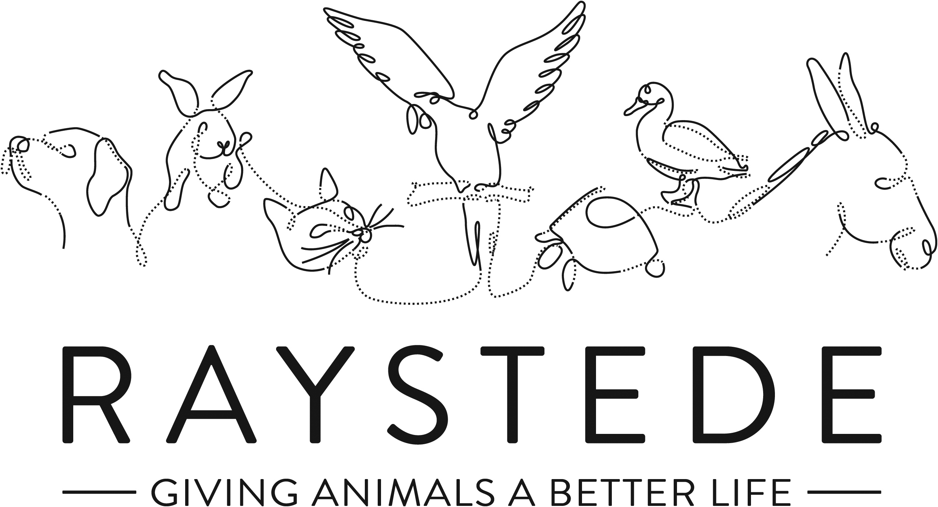
Raystede Centre for Animal Welfare

Job Description

Job Title: | Accounts Assistant
Responsible to: | Senior Accounts Assistant and Head of Finance
Hours of work: | 37.5 hours per week Monday to Friday. Occasional weekend working will be required.
Holidays: | 28 days per year including bank holidays.
Probationary period: | 3 months
Contract Type: | Permanent on completion of 3-month probationary period
Salary: | £20,100 - £21,300

Main Purpose of the role:

Various duties as a member of the Finance team using Sage 50 Accounts Professional, in particular maintenance of the purchase ledger and supplier payments, cash management and banking.

Key Tasks

- Managing the purchase ledger, including coding and posting of purchase invoices, checking that all invoices are correctly authorised in accordance with agreed limits.
- Dealing with supplier queries.
- Reconciling supplier accounts to statements.
- Producing bank payment runs.
- Processing and posting transactions made on company credit cards.
- Assisting with collection of cash from donation points around our site, and preparation for banking.
- Preparation of other banking as necessary.
- Raising and e-mailing sales invoices.
- Assisting with accounting for weekend events (mainly the Summer and Christmas fairs).
- Assisting in other areas of the Finance department’s work, including reconciliations, as required.
- Supporting the wider aims of the Charity and from time to time carrying out other general duties as may reasonably be required by the Senior Accounts Assistant, Head of Finance or Chief Executive.

Raystede Centre for Animal Welfare

Person Specification

Post Title: Accounts Assistant

 | Essential | Desirable | Method of Assessment/  Source of Information
Education and Qualifications | - Full Driving Licence | - AAT level 3 | Application  Certificates
Knowledge and Experience | - Knowledge and experience of finance procedures, especially purchase ledger, cash handling and banking.  - Proven application of sound and effective customer care skills including face to face, on the phone, social media and written communications.  - Working with members of the public or within a visitor environment.  - Good working knowledge of accounts software.  - Administrative skills including IT (Microsoft Office).  - Attention to detail and high level of accuracy. | - Experience in a Charity environment.  - Charity fund raising e.g. on/off-site events.  - Good working knowledge of Sage 50 Accounts Professional. | Application  Interview
Key Skills and Abilities | - Proven communication skills, written and oral.  - Ability to work within a diverse team, and build excellent working relationships.  - Ability to manage personal deadlines and prioritise a demanding workload.  - Ability to manage relationships with tact and diplomacy.  - Excellent attention to detail. |  | Application  Interview
Personal Attributes | - Personable, sociable and people oriented.  - Proactive and self-motivated with the ability to think creatively.  - A positive outlook and a “can do” attitude.  - Dedication, commitment and tenacity.  - Empathy and understanding of the love for animals.  - A commitment to equal opportunities and anti-discriminatory practice.  - Change orientated approach to work  - Ability to make decisions when dealing with often constant and conflicting demands on time | - Awareness of animal welfare issues | Application  Interview
Other | - To have a flexible approach to working hours.  - Availability of vehicle for work use and in possession of a current, clean driving licence.  - An excellent health and attendance record.  - Flexibility of circumstances and willingness to visit national and regional venues for CPD. This may involve some overnight stays and occasional work in the evenings and at weekends. |  | Application  Interview
You should be aware of the confidential nature of the some of the work carried out at Raystede, details of which must not be divulged to any unauthorised person.

Raystede Centre for Animal Welfare

Health & Safety Functions

This section is to make you aware of any health & safety related functions you may be expected to either perform or to which may be exposed in relation to the post you applying for. This information will help you if successful in your application identify any health related condition which may impact on your ability to perform the job role, enabling us to support you in your employment by way of reasonable adjustments or workplace support.

Using display screen equipment | X
Working with children/vulnerable adults
Moving & handling operations
Vocational driving, driving light goods vehicles, people carrying vehicles or forklift trucks
Lone Working
Shift work
Night work
Climbing/Working at height
Working with hazardous substances, skin irritants, sensitisers, and/or with biological agents or chemical agents
Working with dangerous machinery
Exposure to noise and /or vibration
Handling animal food
Exposure to blood /body fluids
Providing animal care

