Peacehaven Abseil Risk Assessment- 25th September 2021

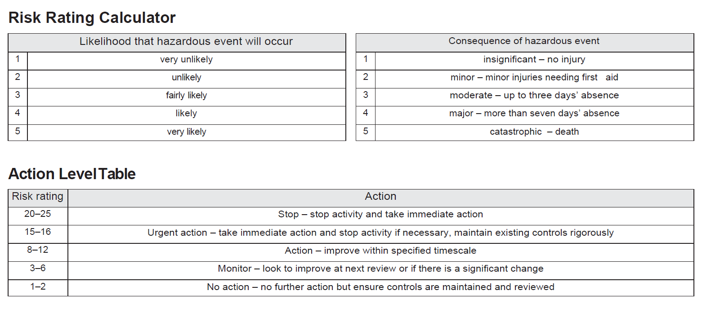

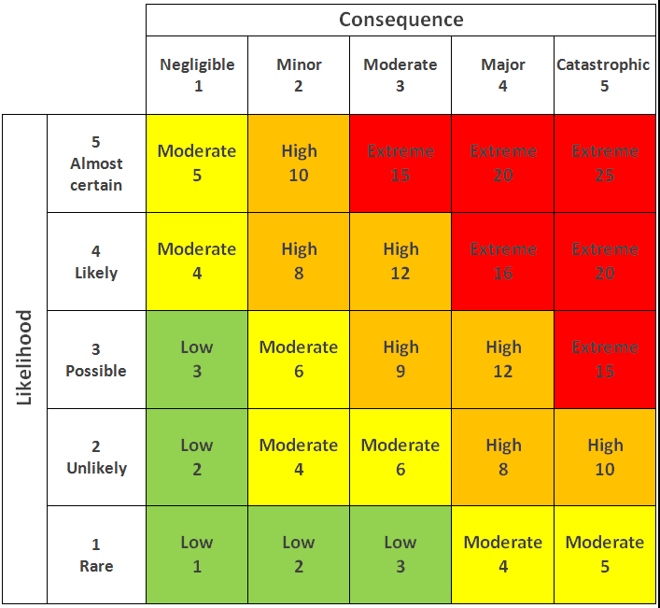
Raystede Risk Assessment Forms

Name of Assessor | Raystede Centre For Animal Welfare | Date of Assessment | 01.07.2021

Time |  | Work Area | Fundraising

Task Being Assessed | Peacehaven Cliffs Abseil  (The abseil company have their own risk assessment form for the actual activity.)

What is the hazard? | Who might be harmed? | How might people be harmed? | Existing risk control measures | Risk Rating |  |  | Additional Controls | New risk rating (Residual) |  |  | Action/monitored by whom? | Action/monitored by when?
 |  |  |  | L | C | R
Covid19 (The Pandemic) | Supporters, volunteers, staff, spectators | Spreading the virus, having to self-isolate or contracting Covid | Sticking to government Guidelines. Having a ‘Covid Promise’ so that if the event needed to be cancelled due to Covid supporters would be entitled to a refund, or will be offered an alternative date | 3 | 3 | 9 | Having participants staggered throughout the day. Sticking to social distancing still. Limiting the number of spectators to 2 people per person. Handwash on the table. Any food individually wrapped. Abseil equipment wiped down between participants. | 2 | 2 | 4 | Jeanette/Fundraising Team | 25th September 2021
Rubbish being left at the event and littering the area | local residents. Raystede, Wildlife. | Not nice for local residents. Raystede’s reputation. Wildlife. | Have bin bags in place at the event and clear up any rubbish before leaving the site | 1 | 1 | 1 | Allocate a volunteer this particular duty | 1 | 1 | 1 | Jeanette/Fundraising Team | 25th September 2021
Injuries from doing the challenge/people feeling unwell on the day | Participants/supporters | If any participant felt unwell on the day or got a scrape after taking part in the abseil | The abseil company are fully first aid trained  Having bottles of water there and hot drinks to keep people hydrated. | 2 | 3 | 6 | Having extra medics there and a treatment area | 2 | 2 | 4 | Jeanette/ Fundraising | 25th September 2021
People finding where the abseil location is | Participants  Volunteers  Staff  Raystede | Would hinder supporter’s enjoying of the event.  Raystede’s reputation | Send out clear Communications before the event, with a map on it, and nearest postcode to park- directing people to where the abseil is | 2 | 2 | 4 | Having a few signs put up in the local area on the day | 2 | 1 | 2 | Jeanette/Fundraising | 25th September 2021

