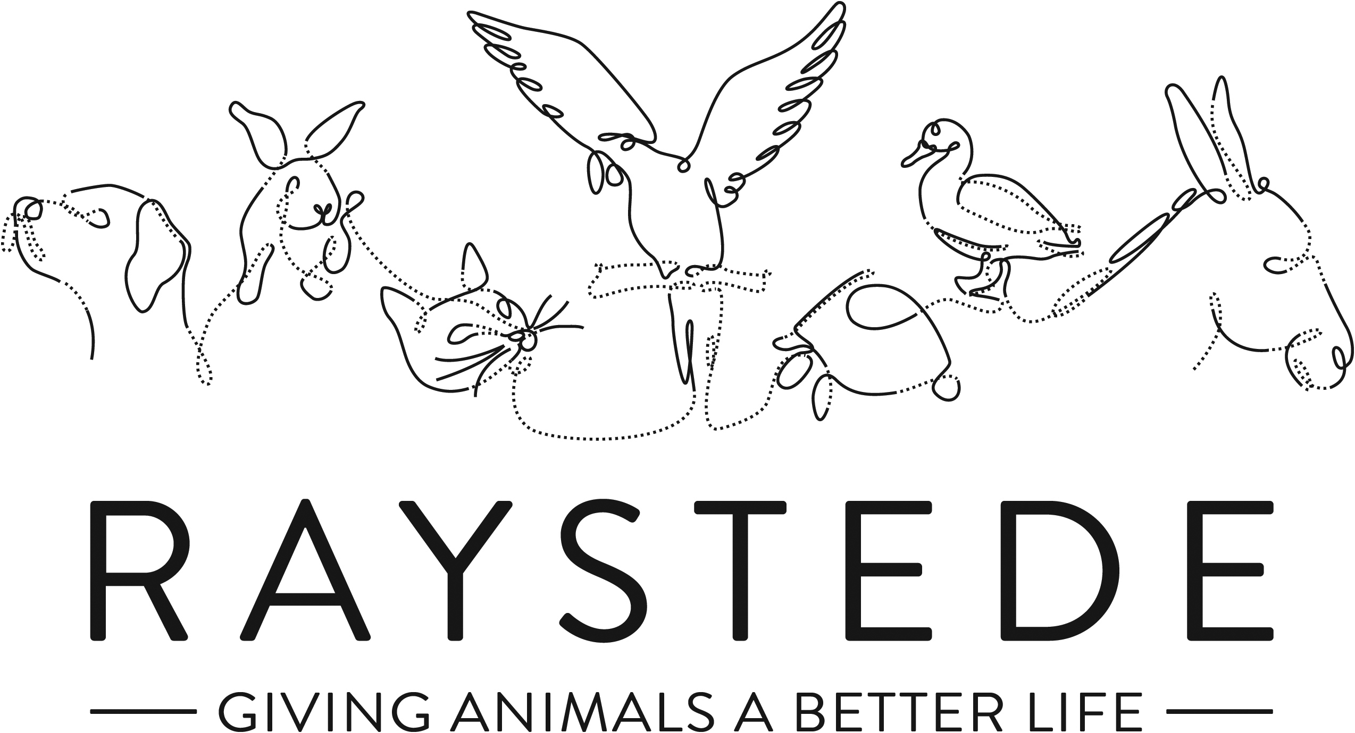
Raystede Centre for Animal Welfare

Job Description

Job Title: | Animal Care Assistant
Responsible to: | Section Manager
Location: | Raystede Centre for Animal Welfare
Hours of work: | 37.5 a week worked across a 7 day rosta to include alternate weekends
Holidays: | 34 days including Bank Holidays
Probationary period: | 3 months
Contract Type: | Permanent
Grade and Salary: | Grade B - £20,885 per annum

Background Information

Raystede Centre for Animal Welfare, established in 1952, is a charity that aims to give animals a better life through rehoming, rehabilitation and sanctuary, and give people the support and knowledge they need to treat animals with care and respect. We care for more than 400 animals every day, including cats, horses, dogs, rabbits, hens and exotic birds. We help most of the animals find new homes but also provide life-long sanctuary for those animals that cannot be rehomed. Our beautiful 43-acre site is open for visitors to get a unique glimpse into a working animal welfare centre.
Animals are at the heart of everything we do but we could not care for them without our expert and dedicated team of staff and volunteers. Surrounded by animals, lakes, trees and fields with a café, shops, parking and many other benefits, Raystede is an uplifting and rewarding place to work.

The Animal Care teams are responsible for the care, rehabilitation, intake, and rehoming of the animals on site and forms a key part of our animal welfare service.

Main Purpose of the Role

- To admit, care for, rehabilitate and, where appropriate, rehome unwanted and stray animals.
- To provide the highest standards of animal care and welfare for the animals.
- To work as part of a team delivering sector leading customer service, answering queries, and matching animals to adopters to ensure successful rehoming.
- To educate potential new owners and the general public in the care and welfare of their animals.
- To promote Raystede services and maximise adoption opportunities.

Key Tasks

- Animal care and welfare
  - Clean, disinfect and maintain to a high standard of cleanliness and bio-security set by management, all animal accommodation, isolation units, outside and inside exercise areas, food preparation areas, laundry, storage, stores and treatment facilities.
  - Prepare and provide species and individually appropriate feed and water.
  - Control and restrain animals and move them between locations safely if required.
  - Assist with the inspection and or treatment of animals by a Veterinary Surgeon, or other authorised person at the Centre, including the administration of first aid and medication and assistance in euthanasia procedures.
  - Recognise, report, and record any signs of illness, disease, injury, unusual condition, unusual activity, or abnormal behaviour of animals.
  - Provide animals with effective opportunities to exercise and maintain good physical and behavioural functioning and where appropriate provide opportunities to exercise freely.
  - Promote the health and welfare of animals through grooming and coat care, as appropriate to species.
  - In conjunction with Section Manager or supervisor, provide advice and guidance on the choice and care of animals to prospective owners.
- Enrichment
  - Train animals through our basic training programmes and contribute to the evaluation and implementation of these where appropriate.
  - Conduct, facilitate, perform, and assist Section Manager in developing centre enrichment protocols.
- Customer Service
  - Welcome, receive, and care for visitors within animal sections and on site.
  - Home or site visits may be required to members of the public.
  - Attend to the needs of the adopters/general public, face to face, via electronic communication, and via the telephone.
  - Liaise with colleagues in other departments to ensure accurate, timely and relevant information is disseminated to customers.
- Contribute to fundraising, educational, and commercial activities
  - Assist with educational talks, tours, and activities.
  - Contribute to and attend fundraising and commercial events.
  - Actively promote Raystede services on-site.
- Administration
  - Complete and maintain all standard and electronic files and documentation relating to the animals; including documents regarding the surrender and adoption of animals, microchip and vaccination records, ensuring records are accurate, up to date, legible and comply with any legislative requirements.
  - Maintain and monitor daily animal records.
  - Assist with stock rotation, stock taking, and ensuring stock levels.
  - Maintain the cost effective and efficient running of the section with the support of Section Manager.
  - General admin duties.
- Personal development
  - Maintain and develop personal performance.
  - Participate in all training as required.
  - Establish and maintain effective working relationships and good working practices with colleagues and volunteers.
- Physical requirements
  - Frequent bending, lifting, reaching, kneeling, walking, and standing for 4 to 6 hours or more per day.
  - Exposure to disinfectant solutions for cleaning.
  - Exposure to various weather conditions.
  - Potential exposure to animal bites and scratches.
  - Continual exposure to animals and animal allergens.
  - Ability to work with animals of all sizes including some in excess of 900kg.
- Other
  - Expected to deal with often harrowing animal welfare issues.
  - Maintain to a standard of cleanliness set by management all offices and staff facilities including toilets within your section.
  - Ensure buildings, exercise areas, and all other facilities as appropriate are secure at all times.
  - Occasional involvement in the Break Away fostering scheme. Involving, liaising with owners, foster carers and social/refuge workers.
  - Taking payment and donations and using a point-of-sale terminal during admissions, adoptions, and events

- General
- At all times ensure and maintain a compassionate, professional and efficient public image for the charity
- Participate in supervision, appraisal, and learning and development. Take personal responsibility for maintaining the knowledge and skills required for the role.
- Take responsibility for ensuring own health and safety and that of others who may be affected by your acts and omissions. Report any health and safety risks to your manager.
- Work within the policy framework of Raystede Animal Centre and adhere to the terms laid out in the employee handbook.

Key Working Relationships

- Immediate and all other animal care teams to ensure collaborative team working on site.
- Rehoming team to arrange and enable rehoming appointments facilitating intake and adoption of animals.
- Raystede veterinary team to ensure the health and welfare of animals in our care.
- General public to liaise with and match people to animals to achieve successful rehoming outcomes. Also, to provide information and guidance on Raystede and its activities.
- External veterinary services to enable out of hours and specialist veterinary care where applicable.
- All other departments within Raystede to assist with and facilitate the successful and efficient operation of Raystede and its services.

Scope and Accountability

Decision making and limits of authority | - Decisions re health and welfare of animals must be taken to tailor husbandry methods and decide whether to refer to Supervisor or Section Manager if there is any concern about animal health or overall wellbeing.  - Rehoming decisions to ensure the ongoing welfare of animals in our care may be taken.  - Animal intake decisions may be referred to Supervisor or Section Manager or taken when this role is delegated.  - There is no financial authority in this role.
Financial resources | - No responsibility for financial resources.  - Occasional cash handling and taking of payments upon request.
Material assets | - Responsible for ensuring the cleanliness and security of departmental and wider assets where necessary.  - Expected to report issues and defects with material assets, equipment, buildings, fixtures, and fittings to Section Manager when recognised.  - Expected to report perceived issues with stocks or supplies to Supervisor or Section Manager.
Information and communication resources | - Expected to use the Anilog database and other departmental filing systems.  - Responsible for using databases and filing systems in a secure manner compliant with all applicable data protection legislation.
People management | - There is no management responsibility in this role.  - Oversight of volunteers and contractors may be required when operating in section.
Legal, regulatory and compliance responsibility | - Responsible for ensuring all tasks carried out are done so in accordance with applicable animal welfare legislation and regulations.  - Responsible for ensuring own health and safety following set procedures and using equipment provided.

Person Specification

 | Essential | Desirable
Education and Qualifications | - Full, clean, manual driving licence.  - Minimum Level 2 Certificate in Animal Care | - Level 3 Certificate in Animal Care.  - Specialist animal care qualifications relevant to role.
Knowledge and Experience | - Working with members of the public or within a visitor environment.  - Evidence of care and welfare of animals.  - Proven application of sound and effective customer care skills.  - Administrative skills including confidence using IT. | - Experience in an animal welfare environment.  - Charity fund raising e.g. on/off-site events.  - Experience of working professionally with the animal types related to this role.  - Experience of exposure to unpleasant odours and noises.
Key Skills and Abilities | - Proven communication skills, written and oral.  - Ability to work within a diverse team, and build excellent working relationships.  - Ability to manage personal deadlines and prioritise a demanding workload.  - Ability to manage relationships with tact and diplomacy.  - Excellent attention to detail.  - Proven ability to handle the animals associated with this role.  - Practical flair to develop “Do It Yourself” projects, with a focus on enrichment. | - Able to deal with difficult and emotional animal welfare issues.  - Ability to handle a variety of animals.
Personal Attributes | - Personable, sociable and people oriented.  - Proactive and self-motivated with the ability to think creatively.  - A positive outlook and a “can do” attitude.  - Dedication, commitment, and tenacity.  - Change orientated approach to work.  - Ability to make decisions when dealing with often constant and conflicting demands on time.  - Highly committed and able to work flexibly to achieve performance targets.  - Able to assist the wider team when required taking a flexible approach to occasionally unplanned organisational demands.  - Commitment to equality, diversity and inclusion and understanding of how it applies to own role.  - Empathy and interest in animals and their welfare.
Other | - To have a flexible approach to working hours.  - Availability of a vehicle for work use.  - Flexibility of circumstances and willingness to visit national and regional venues for CPD. This may involve some overnight stays, occasional work in the evenings, and at weekends.

